
Reference Architecture Foundation for Service Oriented Architecture
Version 1.0
Committee Draft 02
14 October 2009
Specification URIs:
This Version:
http://docs.oasis-open.org/soa-rm/soa-ra/v1.0/soa-ra-cd-02.html
http://docs.oasis-open.org/soa-rm/soa-ra/v1.0/soa-ra-cd-02.doc
http://docs.oasis-open.org/soa-rm/soa-ra/v1.0/soa-ra-cd-02.pdf (Authoritative)
Previous Version:
http://docs.oasis-open.org/soa-rm/soa-ra/v1.0/soa-ra-pr-01.html
http://docs.oasis-open.org/soa-rm/soa-ra/v1.0/soa-ra-pr-01.doc
http://docs.oasis-open.org/soa-rm/soa-ra/v1.0/soa-ra-pr-01.pdf
Latest Version:
http://docs.oasis-open.org/soa-rm/soa-ra/v1.0/soa-ra.html
http://docs.oasis-open.org/soa-rm/soa-ra/v1.0/soa-ra.doc
http://docs.oasis-open.org/soa-rm/soa-ra/v1.0/soa-ra.pdf (Authoritative)
Technical Committee:
OASIS Service Oriented Architecture Reference Model TC
Chair(s):
Ken Laskey, MITRE Corporation
Editor(s):
Jeff A. Estefan, Jet Propulsion Laboratory, jeffrey.a.estefan@jpl.nasa.gov
Ken Laskey, MITRE Corporation, klaskey@mitre.org
Francis G. McCabe, Individual, fmccabe@gmail.com
Danny Thornton, Northrop Grumman, danny.thornton@ngc.com
Related work:
This specification is related to:
OASIS Reference Model for Service Oriented Architecture
Abstract:
This document specifies the OASIS Reference Architecture for Service Oriented Architecture. It follows from the concepts and relationships defined in the OASIS Reference Model for Service Oriented Architecture. While it remains abstract in nature, the current document describes one possible template upon which a SOA concrete architecture can be built.
Our focus in this architecture is on an approach to integrating business with the information technology needed to support it. The issues involved with integration are always present, but, we find, are thrown into clear focus when business integration involves crossing ownership boundaries.
This architecture follows the recommended practice of describing architecture in terms of models, views, and viewpoints, as prescribed in ANSI/IEEE 1471-2000 and ISO/IEC 42010-2007 Standards. This Reference Architecture is principally targeted at Enterprise Architects; however, Business and IT Architects as well as CIOs and other senior executives involved in strategic business and IT planning should also find the architectural views and models described herein to be of value.
The Reference Architecture has three main views: the Service Ecosystem view which focuses on the way that participants are part of a Service Oriented Architecture ecosystem; the Realizing Services view which addresses the requirements for constructing a Service Oriented Architecture; and the Owning Service Oriented Architecture view which focuses on the governance and management of SOA-based systems.
Status:
This document was last revised or approved by the SOA Reference Model TC on the above date. The level of approval is also listed above. Check the “Latest Version” or “Latest Approved Version” location noted above for possible later revisions of this document.
Technical Committee members should send comments on this specification to the Technical Committee’s email list. Others should send comments to the Technical Committee by using the “Send A Comment” button on the Technical Committee’s web page at http://www.oasis-open.org/committees/tc_home.php?wg_abbrev=soa-rm.
For information on whether any patents have been disclosed that may be essential to implementing this specification, and any offers of patent licensing terms, please refer to the Intellectual Property Rights section of the Technical Committee web page http://www.oasis-open.org/committees/soa-rm/ipr.php.
The non-normative errata page for this specification is located at http://www.oasis-open.org/committees/tc_home.php?wg_abbrev=soa-rm.
Notices
Copyright © OASIS® 1993–2009. All Rights Reserved.
All capitalized terms in the following text have the meanings assigned to them in the OASIS Intellectual Property Rights Policy (the "OASIS IPR Policy"). The full Policy may be found at the OASIS website.
This document and translations of it may be copied and furnished to others, and derivative works that comment on or otherwise explain it or assist in its implementation may be prepared, copied, published, and distributed, in whole or in part, without restriction of any kind, provided that the above copyright notice and this section are included on all such copies and derivative works. However, this document itself may not be modified in any way, including by removing the copyright notice or references to OASIS, except as needed for the purpose of developing any document or deliverable produced by an OASIS Technical Committee (in which case the rules applicable to copyrights, as set forth in the OASIS IPR Policy, must be followed) or as required to translate it into languages other than English.
The limited permissions granted above are perpetual and will not be revoked by OASIS or its successors or assigns.
This document and the information contained herein is provided on an "AS IS" basis and OASIS DISCLAIMS ALL WARRANTIES, EXPRESS OR IMPLIED, INCLUDING BUT NOT LIMITED TO ANY WARRANTY THAT THE USE OF THE INFORMATION HEREIN WILL NOT INFRINGE ANY OWNERSHIP RIGHTS OR ANY IMPLIED WARRANTIES OF MERCHANTABILITY OR FITNESS FOR A PARTICULAR PURPOSE.
OASIS requests that any OASIS Party or any other party that believes it has patent claims that would necessarily be infringed by implementations of this OASIS Committee Specification or OASIS Standard, to notify OASIS TC Administrator and provide an indication of its willingness to grant patent licenses to such patent claims in a manner consistent with the IPR Mode of the OASIS Technical Committee that produced this specification.
OASIS invites any party to contact the OASIS TC Administrator if it is aware of a claim of ownership of any patent claims that would necessarily be infringed by implementations of this specification by a patent holder that is not willing to provide a license to such patent claims in a manner consistent with the IPR Mode of the OASIS Technical Committee that produced this specification. OASIS may include such claims on its website, but disclaims any obligation to do so.
OASIS takes no position regarding the validity or scope of any intellectual property or other rights that might be claimed to pertain to the implementation or use of the technology described in this document or the extent to which any license under such rights might or might not be available; neither does it represent that it has made any effort to identify any such rights. Information on OASIS' procedures with respect to rights in any document or deliverable produced by an OASIS Technical Committee can be found on the OASIS website. Copies of claims of rights made available for publication and any assurances of licenses to be made available, or the result of an attempt made to obtain a general license or permission for the use of such proprietary rights by implementers or users of this OASIS Committee Specification or OASIS Standard, can be obtained from the OASIS TC Administrator. OASIS makes no representation that any information or list of intellectual property rights will at any time be complete, or that any claims in such list are, in fact, Essential Claims.
The name "OASIS" is a trademark of OASIS, the owner and developer of this specification, and should be used only to refer to the organization and its official outputs. OASIS welcomes reference to, and implementation and use of, specifications, while reserving the right to enforce its marks against misleading uses. Please see http://www.oasis-open.org/who/trademark.php for above guidance.
Unified Modeling Language™, UML®, Object Management Group™, and OMG™ are trademarks of the Object Management Group.

Table of Contents
1 Introduction 9
1.1 Context for Reference Architecture for SOA 9
1.1.1 What is a Reference Architecture? 9
1.1.2 What is this Reference Architecture Foundation? 9
1.1.3 Relationship to the OASIS Reference Model for SOA 10
1.1.4 Relationship to other Reference Architectures 10
1.1.5 Relationship to other SOA Open Standards 10
1.1.6 Expectations set by this Reference Architecture 12
1.2 Service Oriented Architecture – An Ecosystems Perspective 12
1.3 Viewpoints, Views and Models 13
1.3.1 ANSI/IEEE 1471-2000::ISO/IEC 42010-2007 13
1.3.2 UML Modeling Notation 14
1.4 Viewpoints of this Reference Architecture 15
1.4.1 Service Ecosystem Viewpoint 16
1.4.2 Realizing Service Oriented Architectures Viewpoint 16
1.4.3 Owning Service Oriented Architectures Viewpoint 17
1.5 Terminology 17
1.5.1 Usage of Terms 17
1.6 References 17
1.6.1 Normative References 17
1.6.2 Non-Normative References 18
2 Architectural Goals and Principles 19
2.1 Goals and Critical Success Factors of this Reference Architecture 19
2.1.1 Goals 20
2.1.2 Critical Success Factors 20
2.2 Principles of this Reference Architecture 21
3 Service Ecosystem View 24
3.1 Acting in a SOA Ecosystem Model 25
3.1.1 Actors, Delegates and Participants 26
3.1.2 Action and Joint Action 27
3.1.3 Communication as Joint Action 30
3.1.4 Using Communication for Service Action 32
3.2 Social Structure Model 33
3.2.1 Roles in Social Structures 35
3.2.2 Shared State and Social Facts 36
3.3 Acting in a Social Context Model 39
3.3.1 Service Providers and Consumers 40
3.3.2 Needs and Capabilities 41
3.3.3 Resources 42
3.3.4 Ownership 43
3.3.5 Trust, Risk and Willingness 44
3.3.6 Transactions and Exchanges 46
4 Realizing Service Oriented Architectures View 48
4.1 Service Description Model 48
4.1.1 The Model for Service Description 49
4.1.2 Use Of Service Description 57
4.1.3 Relationship to Other Description Models 62
4.1.4 Architectural Implications 63
4.2 Service Visibility Model 64
4.2.1 Visibility to Business 64
4.2.2 Visibility 65
4.2.3 Architectural Implications 70
4.3 Interacting with Services Model 71
4.3.1 Interaction Dependencies 71
4.3.2 Actions and Events 71
4.3.3 Message Exchange 72
4.3.4 Composition of Services 74
4.3.5 Architectural Implications of Interacting with Services 79
4.4 Policies and Contracts Model 80
4.4.1 Policy and Contract Principles 80
4.4.2 Policy Metrics 83
4.4.3 Automating Support for Policies and Contracts 83
4.4.4 Architectural Implications 84
5 Owning Service Oriented Architectures View 85
5.1 Governance Model 85
5.1.1 Understanding Governance 85
5.1.2 A Generic Model for Governance 87
5.1.3 Governance Applied to SOA 91
5.1.4 Architectural Implications of SOA Governance 95
5.2 Security Model 96
5.2.1 Secure Interaction Concepts 96
5.2.2 Where SOA Security is Different 99
5.2.3 Security Threats 99
5.2.4 Security Responses 100
5.2.5 Architectural Implications of SOA Security 101
5.3 Management Model 102
5.3.1 Management and Governance 105
5.3.2 Management Contracts and Policies 105
5.3.3 Management Infrastructure 105
5.3.4 Service Life-cycle 106
5.4 SOA Testing Model 106
5.4.1 Traditional Software Testing as Basis for SOA Testing 106
5.4.2 Testing and the SOA Ecosystem 108
5.4.3 Elements of SOA Testing 109
5.4.4 Testing SOA Services 113
5.4.5 Architectural Implications for SOA Testing 116
6 Conformance 117
A. Acknowledgements 118
B. Critical Factors Analysis 119
B.1 Goals 119
Critical Success Factors 119
Requirements 119
CFA Diagrams 119
Table of Figures
Figure 1 SOA Reference Architecture Positioning [ERA]. 12
Figure 2 Example UML class diagram—Resources. 15
Figure 3 Critical Factors Analysis of the Reference Architecture 19
Figure 4 Model elements described in the Service Ecosystem view 25
Figure 5 Actors, Participants and Delegates 26
Figure 6 Actions, Real World Effect and Events 27
Figure 7 Joint Action 28
Figure 8 Communication as Joint Action 30
Figure 9 Communicative actions as Service Actions 32
Figure 10 Social Structure 33
Figure 11 Enterprise as a Social Structure 34
Figure 12 Roles, Rights and Responsibilities 35
Figure 13 Shared State and Social Facts 37
Figure 14 Propositions 38
Figure 15 Assertions and Promises 39
Figure 16 Acting within Social Structures 40
Figure 17 Service Participants 40
Figure 18 Needs and Capabilities 41
Figure 19 Resources 42
Figure 20 Resource Ownership 43
Figure 21 Trusting Actor and Willingness 44
Figure 22 Assessing Trust and Risk 45
Figure 23 Business Transaction 46
Figure 24 Model Elements Described in the Realizing a Service Oriented Architecture View 48
Figure 25 General Description 50
Figure 26 Representation of a Description 51
Figure 27 Service Description 53
Figure 28 Service Interface 54
Figure 29 Service Functionality 55
Figure 30 Model for Policies and Contracts as related to Service Participants 56
Figure 31 Action-Level and Service-Level Policies 56
Figure 32 Policies and Contracts, Metrics, and Compliance Records 57
Figure 33 Relationship Between Action and Service Description Components 58
Figure 34 Execution Context 61
Figure 35 Interaction Description 62
Figure 36 Visibility to Business 65
Figure 37 Mediated Service Awareness 67
Figure 38 Awareness In a SOA Ecosystem 68
Figure 39 Business, Description and Willingness 69
Figure 40 Service Reachability 69
Figure 41 Interaction dependencies. 71
Figure 42 A ''message'' conveys either an action or an event. 72
Figure 43 Fundamental SOA message exchange patterns (MEPs) 73
Figure 44 Simple model of service composition ("public” composition). 75
Figure 45 Abstract example of orchestration of service-oriented business process. 77
Figure 46 Abstract example of choreography of service-oriented business collaboration. 78
Figure 47 Policies and Contracts 81
Figure 48 Model Elements Described in the Owning Service Oriented Architectures View 85
Figure 49 Motivating governance model 87
Figure 50 Setting up governance model 88
Figure 51 Carrying out governance model 89
Figure 52 Ensuring governance compliance model 90
Figure 53 Relationship among types of governance 92
Figure 54 Confidentiality and Integrity 97
Figure 55 Authentication 97
Figure 56 Authorization 98
Figure 57 Managing resources in a SOA 103

Introduction
Service Oriented Architecture (SOA) is an architectural paradigm that has gained significant attention within the information technology (IT) and business communities. The SOA ecosystem described in this document occupies the boundary between business and IT. It is neither wholly IT nor wholly business, but is of both worlds. Neither business nor IT completely own, govern and manage this SOA ecosystem. Both sets of concerns must be accommodated for the SOA ecosystem to fulfill its purposes.
The OASIS Reference Model for SOA [SOA-RM] provides a common language for understanding the important features of SOA but does not address the issues involved in constructing, using or owning a SOA-based system. This document focuses on these aspects of SOA.
The intended audiences of this document and expected benefits to be realized include non-exhaustively:
- Enterprise Architects - will gain a better understanding when planning and designing enterprise systems of the principles that underlie Service Oriented Architecture;
- Standards Architects and Analysts - will be able to better position specific specifications in relation to each other in order to support the goals of SOA;
- Decision Makers - will be better informed as to the technology and resource implications of commissioning and living with a SOA-based system; in particular, the implications following from multiple ownership domains; and
- Users - will gain a better understanding of what is involved in participating in a SOA-based system.

Context for Reference Architecture for SOA

What is a Reference Architecture?
A reference architecture models the abstract architectural elements in the domain independent of the technologies, protocols, and products that are used to implement the domain. It differs from a reference model in that a reference model describes the important concepts and relationships in the domain focusing on what distinguishes the elements of the domain; a reference architecture elaborates further on the model to show a more complete picture that includes showing what is involved in realizing the modeled entities.
It is possible to define reference architectures at many levels of detail or abstraction, and for many different purposes. A reference architecture need not be a concrete architecture; i.e., depending on the requirements being addressed by the reference architecture, it may not be necessary to completely specify all the technologies, components and their relationships in sufficient detail to enable direct implementation.

What is this Reference Architecture Foundation?
This Reference Architecture Foundation is an abstract realization of SOA, focusing on the elements and their relationships needed to enable SOA-based systems to be used, realized and owned; while avoiding reliance on specific concrete technologies.
While requirements are addressed more fully in Section 2, the key assumptions that we make in this Reference Architecture is that SOA-based systems involve:
- resources that are distributed across ownership boundaries;
- people and systems interacting with each other, also across ownership boundaries;
- security, management and governance that are similarly distributed across ownership boundaries; and
- interaction between people and systems that is primarily through the exchange of messages with reliability that is appropriate for the intended uses and purposes.
Even in contexts that apparently have no ownership boundaries, such as within a single organization, the reality is that different groups and departments often behave as though they had ownership boundaries between them. This reflects organizational practice; as well as reflecting the real motivations and desires of the people running those organizations.
Below, we talk about such an environment as a service ecosystem. Informally, our goal in this Reference Architecture is to show how Service Oriented Architecture fits into the life of users and stakeholders, how such systems may be realized effectively, and what is involved in owning and managing them. We believe that this approach will serve two purposes: to ensure that service ecosystems can be realized using appropriate technology, and to permit the audience to focus on the important issues without becoming over-burdened with the details of a particular implementation technology.

Relationship to the OASIS Reference Model for SOA
The primary contribution of the OASIS Reference Model for Service Oriented Architecture is that it identifies the key characteristics of SOA, and it defines many of the important concepts needed to understand what SOA is and what makes it important. This Reference Architecture Foundation takes the Reference Model as its starting point in particular in relation to the vocabulary of important terms and concepts.
The Reference Architecture Foundation goes a step further than the Reference Model in that it shows how SOA-based systems can be realized – albeit in an abstract way. As noted above, SOA-based systems are better thought of as ecosystems rather than stand-alone software products. Consequently, how they are used and managed is at least as important architecturally as how they are constructed.
In terms of approach, the primary difference between the Reference Model and this Reference Architecture Foundation is that the former focuses entirely on a common language of the distinguishing features of SOA; whereas this document introduces concepts and architectural elements as needed in order to fulfill the core requirement of using, realizing and owning SOA-based systems.

Relationship to other Reference Architectures
It is fully recognized that other SOA reference architectures have emerged in the industry, both from the analyst community and the vendor/solution provider community. Some of these reference architectures are quite abstract in relation to specific implementation technologies, while others are based on a solution or technology stack. Still others use emerging middleware technologies such as the Enterprise Service Bus (ESB) as the architectural foundation.
As with the Reference Model for SOA, this Reference Architecture Foundation for SOA is primarily focused on large-scale distributed IT systems where the participants may be legally separate entities. It is quite possible for many aspects of this Reference Architecture to be realized on quite different platforms.
In addition, this Reference Architecture Foundation, as the title illustrates, is intended to provide foundational concepts on which to build other reference architectures and eventual concrete architectures. The relationship to other industry reference architectures for SOA and related SOA open standards is described below in Section 1.1.5

Relationship to other SOA Open Standards
The “Navigating the SOA Open Standards Landscape Around Architecture” joint white paper from OASIS, OMG, and The Open Group [SOA-NAV] was written to help the SOA community at large navigate the myriad of overlapping technical products produced by these organizations with specific emphasis on the “A” in SOA; i.e., Architecture.
This joint white paper explains and positions standards for SOA reference models, ontologies, reference architectures, maturity models, modeling languages, and standards work on SOA governance. It outlines where the works are similar, highlights the strengths of each body of work, and touches on how the work can be used together in complementary ways.. It is also meant as a guide to users of these specifications for selecting the technical products most appropriate for their needs, consistent with where they are today and where they plan to head on their SOA journeys.
While the understanding of SOA and SOA Governance concepts provided by these works is similar, the evolving standards are written from different perspectives. Each specification supports a similar range of opportunity, but has provided different depths of detail for the perspectives on which they focus. Therefore, although the definitions and expressions may differ somewhat, there is agreement on the fundamental concepts of SOA and SOA Governance.
The following is a summary of the positioning and guidance on the specifications:
- The OASIS Reference Model for SOA (SOA RM) is the most abstract of the specifications positioned. It is used for understanding of core SOA concepts
- The Open Group SOA Ontology extends, refines, and formalizes some of the core concepts of the SOA RM. It is used for understanding of core SOA concepts and facilitate a model-driven approach to SOA development.
- The OASIS Reference Architecture Foundation for SOA (this document) is an abstract, foundation reference architecture addressing the ecosystem viewpoint for building and interacting within the SOA paradigm. It is used for understanding different elements of SOA, the completeness of SOA architectures and implementations, and considerations for cross ownership boundaries where there is no single authoritative entity for SOA and SOA governance.
- The Open Group SOA Reference Architecture is a layered architecture from consumer and provider perspective with cross cutting concerns describing these architectural building blocks and principles that support the realizations of SOA. It is used for understanding the different elements of SOA, deployment of SOA in enterprise, basis for an industry or organizational reference architecture, implication of architectural decisions, and positioning of vendor products in a SOA context
- The Open Group SOA Governance Framework is a governance domain reference model and method. It is for understanding SOA governance in organizations. The OASIS Reference Architecture for SOA Foundation contains an abstract discussion of governance principles as applied to SOA across boundaries
- The Open Group SOA Integration Maturity Model (OSIMM) is a means to assess an organization’s maturity within a broad SOA spectrum and define a roadmap for incremental adoption. It is used for understanding the level of SOA maturity in an organization
- The Object Management Group SoaML Specification supports services modeling UML extensions. It can be seen as an instantiation of a subset of the Open Group RA used for representing SOA artifacts in UML.
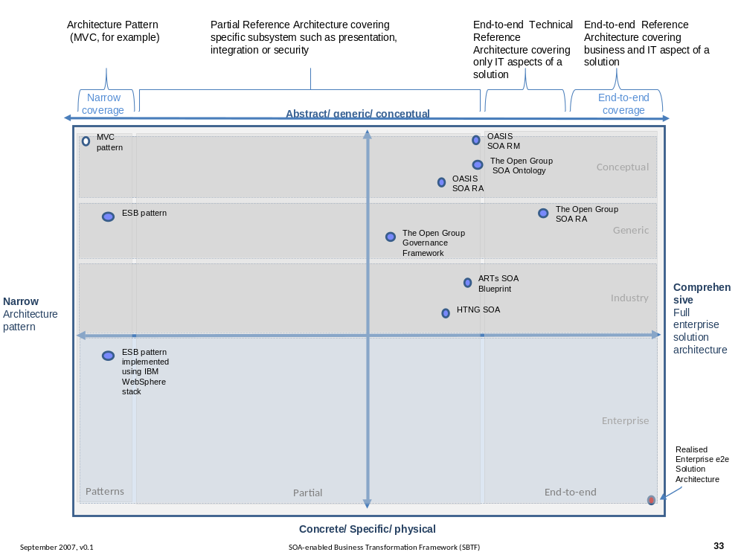
Figure 1 SOA Reference Architecture Positioning [ERA].
Fortunately, there is a great deal of agreement on the foundational core concepts across the many independent specifications and standards for SOA. This could be best explained by broad and common experience of users of SOA and its maturity in the marketplace. It also provides assurance that investing in SOA-based business and IT transformation initiatives that incorporate and use these specifications and standards helps to mitigate risks that might compromise a successful SOA solution.
It is anticipated that future work on SOA standards may consider the positioning in this paper to reduce inconsistencies, overlaps, and gaps between related standards and to ensure that they continue to evolve in as consistent and complete a manner as possible.

Expectations set by this Reference Architecture
This Reference Architecture Foundation is not a complete blueprint for realizing SOA-based systems. Nor is it a technology map identifying all the technologies needed to realize SOA-based systems. It does identify many of the key aspects and components that will be present in any well designed SOA-based system. In order to actually use, construct and manage SOA-based systems, many additional design decisions and technology choices will need to be made.

Service Oriented Architecture – An Ecosystems Perspective
Many systems cannot be understood by a simple decomposition into parts and subsystems – in particular when there are many interactions between the parts. For example, a biological ecosystem is a self-sustaining association of plants, animals, and the physical environment in which they live. Understanding an ecosystem often requires a holistic perspective rather than one focusing on the system's individual parts.
From a holistic perspective, a SOA-based system is a network of independent services, machines, the people who operate, affect, use, and govern those services as well as the suppliers of equipment and personnel to these people and services. This includes any entity, animate or inanimate, that may affect or be affected by the system. With a system that large, it is clear that nobody is really "in control" or "in charge" of the whole ecosystem; although there are definite stakeholders involved, each of whom has some control and influence over the community.
Instead of visualizing a SOA as a single complex machine, this Reference Architecture Foundation views it as an ecosystem: a space people, machines and services inhabit in order to further both their own objectives and the objectives of the larger community.
This view of SOA as ecosystem has been a consistent guide to the development of this architecture.
Taking an ecosystems perspective often means taking a step back: for example, instead of specifying an application hierarchy, we model the system as a network of peer-like entities; instead of specifying a hierarchy of control, we specify rules for the interactions between participants.
The three key principles that inform our approach to a SOA ecosystem are:
- a SOA is a medium for exchange of value between independently acting participants;
- participants (and stakeholders in general) have legitimate claims to ownership of resources that are made available via the SOA; and
- the behavior and performance of the participants are subject to rules of engagement which are captured in a series of policies and contracts.

Viewpoints, Views and Models

ANSI/IEEE 1471-2000::ISO/IEC 42010-2007
This Reference Architecture Foundation follows the ANSI/IEEE 1471-2000 and ISO/IEC 42010-2007 standard. Recommended Practice for Architectural Description of Software-Intensive Systems [ANSI/IEEE 1471, ISO/IEC 42010]. An architectural description conforming to the ANSI/IEEE 1471-2000::ISO/IEC 42010-2007 recommended practice is described by a clause that includes the following six (6) elements:
- Architectural description identification, version, and overview information
- Identification of the system stakeholders and their concerns judged to be relevant to the architecture
- Specifications of each viewpoint that has been selected to organize the representation of the architecture and the rationale for those selections
- One or more architectural views
- A record of all known inconsistencies among the architectural description’s required constituents
- A rationale for selection of the architecture (in particular, showing how the architecture supports the identified stakeholders’ concerns).
The ANSI/IEEE 1471-2000::ISO/IEC 42010-2007 defines the following terms:
Architecture
The fundamental organization of a system embodied in its components, their relationships to each other, and to the environment, and the principles guiding its design and evolution.
Architectural Description
A collection of products that document the architecture.
System
A collection of components organized to accomplish a specific function or set of functions.
System Stakeholder
A system stakeholder is an individual, team, or organization (or classes thereof) with interests in, or concerns relative to, a system.
A stakeholder’s concern should not be confused with a formal requirement. A concern is an area or topic of interest. Within that concern, system stakeholders may have many different requirements. In other words, something that is of interest or importance is not the same as something that is obligatory or of necessity [TOGAF v9].
When describing architectures, it is important to identify stakeholder concerns and associate them with viewpoints to insure that those concerns will be addressed in some manner by the models that comprise the views on the architecture. The ANSI/IEEE 1471-2000::ISO/IEC 42010-2007 defines views and viewpoints as follows:
View
A representation of the whole system from the perspective of a related set of concerns.
Viewpoint
A specification of the conventions for constructing and using a view. A pattern or template from which to develop individual views by establishing the purposes and audience for a view and the techniques for its creation and analysis.
In other words, a view is what the stakeholders see whereas the viewpoint defines the perspective from which the view is taken.
It is important to note that viewpoints are independent of a particular system. In this way, the architect can select a set of candidate viewpoints first, or create a set of candidate viewpoints, and then use those viewpoints to construct specific views that will be used to organize the architectural description. A view, on the other hand, is specific to a particular system. Therefore, the practice of creating an architectural description involves first selecting the viewpoints and then using those viewpoints to construct specific views for a particular system or subsystem. Note that ANSI/IEEE 1471-2000::ISO/IEC 42010-2007 requires that each view corresponds to exactly one viewpoint. This helps maintain consistency among architectural views; a normative requirement of the standard.
A view is comprised of one or more architectural models, where model is defined as:
Model
An abstraction or representation of some aspect of a thing (in this case, a system)
Each architectural model is developed using the methods established by its associated architectural viewpoint. An architectural model may participate in more than one view.

UML Modeling Notation
To help visualize structural and behavioral architectural concepts, it is useful to depict them using an open standard visual modeling language. Although many architecture description languages exist in practice, we have adopted the Unified Modeling Language™ 2 (UML® 2) [UML 2] as the primary viewpoint modeling language. It should be noted that while UML 2 is used in this Reference Architecture, formalization and recommendation of a UML Profile for SOA is beyond the scope of this specification. Every attempt is made to utilize normative UML unless otherwise noted.
Figure 1 illustrates an annotated example of a UML class diagram that is used to represent a visual model depiction of the Resources Model in the Service Ecosystem View (Section 3). The figure caption describes the UML semantics of this diagram.
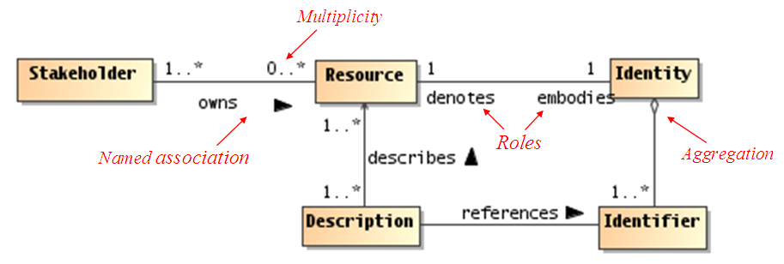
Figure 2 Example UML class diagram—Resources.
Lines connecting boxes (classifiers) represent associations between things. An association has two roles (one in each direction). A role can have multiplicity, for example, one or more (“1..*”) Stakeholders own zero or more (“0..*) Resources. The role from classifier A to B is labeled closest to B, and vice versa, for example, the role between Resource to Identity can be read a Resource embodies Identity, and Identity denotes a Resource.
Mostly, we use named associations, which are denoted with a verb or verb phrase associated with an arrowhead. A named association reads from classifier A to B, for example, one or more Stakeholders owns zero or more Resources. Named associations are a very effective way to model relationships between concepts.
An open diamond (at the end of an association line) denotes an aggregation, which is a part-of relationship, for example, Identifiers are part of Identity (or conversely, Identity is made up of Identifiers).
A stronger form of aggregation is known as composition, which involves using a filled-in diamond at the end of an association line (not shown in above diagram). For example, if the association between Identity and Identifier were a composition rather than an aggregation as shown, deleting Identity would also delete any owned Identifiers. There is also an element of exclusive ownership in a composition relationship between classifiers, but this usually refers to specific instances of the owned classes (objects).
This is by no means a complete description of the semantics of all diagram elements that comprise a UML class diagram, but rather is intended to serve as an illustrative example for the reader. It should be noted that this Reference Architecture utilizes additional class diagram elements as well as other UML diagram types such as sequence diagrams and component diagrams. The reader who is unfamiliar with the UML is encouraged to review one or more of the many useful online resources and book publications available describing UML (see, for example, www.uml.org).

Viewpoints of this Reference Architecture
This Reference Architecture Foundation is partitioned into three views that conform to three primary viewpoints, reflecting the main division of concerns noted above: the Service Oriented Architecture – An Ecosystems Perspective viewpoint focuses on how people conduct their business using SOA-based systems; the Realizing Service Oriented Architecture viewpoint focuses on the salient aspects of building a SOA, and the Owning Service Oriented Architectures viewpoint focuses on those aspects that relate to owning, managing and controlling a SOA.
The viewpoint specifications for each of the primary viewpoints of this Reference Architecture are summarized in Table 1. Additional detail on each of the three viewpoints is further elaborated in the following subsections. For this Reference Architecture, there is a one-to-one correspondence between viewpoints and views.
Viewpoint Element | Viewpoint
Viewpoint Element | Service Ecosystem | Realizing Service Oriented Architectures | Owning Service Oriented Architecture
Main concepts | Captures what SOA means for people to participate in a service ecosystem. | Deals with the requirements for constructing a SOA. | Addresses issues involved in owning and managing a SOA.
Stakeholders | People using SOA, Decision Makers, Enterprise Architects, Standards Architects and Analysts. | Standards Architects, Enterprise Architects, Business Analysts, Decision Makers. | Service Providers, Service Consumers, Enterprise Architects, Decision Makers.
Concerns | Conduct business safely and effectively. | Effective construction of SOA-based systems. | Processes for engaging in a SOA are effective, equitable, and assured.
Modeling Techniques | UML class diagrams | UML class, sequence,, component, activity, communication, and composite structure diagrams | UML class and communication diagrams
Table 1 Viewpoint specifications for the OASIS Reference Architecture Foundation for SOA

Service Ecosystem Viewpoint
The Service Ecosystem viewpoint is intended to capture what using a SOA-based system means for people using it to conduct their business. We do not limit the applicability of SOA-based systems to commercial and enterprise systems. We use the term business to include any activity of interest to a user; especially activities shared by multiple users.
From this viewpoint, we are concerned with how SOA integrates with and supports the service model from the perspective of the people who perform their tasks and achieve their goals as mediated by Service Oriented Architectures. The Service Ecosystem viewpoint also sets the context and background for the other viewpoints in the Reference Architecture.
The stakeholders who have key roles in or concerns addressed by this viewpoint are decision makers and people. The primary concern for people is to ensure that they can use a SOA to conduct their business in a safe and effective way. For decision makers, their primary concern revolves around the relationships between people and organizations using systems for which the decision makers are responsible.
Given the public nature of the Internet, and the intended use of SOA to allow people to access and provide services that cross ownership boundaries, it is necessary to be able to be somewhat explicit about those boundaries and what it means to cross an ownership boundary.

Realizing Service Oriented Architectures Viewpoint
The Realizing Service Oriented Architectures Viewpoint focuses on the infrastructure elements that are needed to support the construction of SOA-based systems. From this viewpoint, we are concerned with the application of well-understood technologies available to system architects to realize the vision of a SOA that may cross ownership boundaries. In particular, we are aware of the importance and relevance of other standard specifications that may be used to facilitate the building of a SOA.
The stakeholders are essentially anyone involved in designing, constructing and deploying a SOA-based system.

Owning Service Oriented Architectures Viewpoint
The Owning Service Oriented Architectures Viewpoint addresses the issues involved in owning a SOA as opposed to using one or building one. Many of these issues are not easily addressed by automation; instead, they often involve people-oriented processes such as governance bodies.
Owning a SOA-based system involves being able to manage an evolving system. In our view, SOA-based systems are more like ecosystems than conventional applications; the challenges of owning and managing SOA-based systems are the challenges of managing an ecosystem. Thus, in this view, we are concerned with how systems are managed effectively, how decisions are made and promulgated to the required end points, and how to ensure that people may use the system effectively and that malicious people cannot easily corrupt it for their own gain.

Terminology
The key words “MUST”, “MUST NOT”, “REQUIRED”, “SHALL”, “SHALL NOT”, “SHOULD”, “SHOULD NOT”, “RECOMMENDED”, “MAY”, and “OPTIONAL” in this document are to be interpreted as described in [RFC2119].
References are surrounded with [square brackets and are in bold text].
Terms such as this “Reference Architecture” refer to this document, and “the Reference Model” refer to the OASIS Reference Model for Service Oriented Architecture”. [SOA-RM].

Usage of Terms
Certain terms are used throughout this document, such as model, action, and rule, which are regular concepts and which have formal definitions within the Reference Architecture. Where a reference to the formally defined concept is intended, we use a capitalized form such as Model, Action and Rule. Where the more colloquial and informal meaning is intended, words are used without special capitalization.

References

Normative References
[ANSI/IEEE 1471] IEEE Recommended Practice for Architectural Description of Software-Intensive Systems, American National Standards Institute/Institute for Electrical and Electronics Engineers, September 21, 2000.
[ISO/IEC 42010] International Organization for Standardization and International Electrotechnical Commission, System and software engineering — Recommended practice for architectural description of software-intensive systems, July 15, 2007.
[RFC2119] S. Bradner, Key words for use in RFCs to Indicate Requirement Levels, http://www.ietf.org/rfc/rfc2119.txt, IETF RFC 2119, March 1997.
[SOA-RM] OASIS Standard, "Reference Model for Service Oriented Architecture 1.0, 12 October 2006. http://docs.oasis-open.org/soa-rm/v1.0/soa-rm.pdf
[UML 2] Unified Modeling Language: Superstructure, Ver. 2.1.1, OMG Adopted Specification, OMG document formal/2007-02-05, Object Management Group, Needham, MA, February 5, 2007.
[WA] Architecture of the World Wide Web, W3C, 2004. http://www.w3.org/TR/webarch.
[WSA] David Booth, et al., ''Web Services Architecture'', W3C Working Group Note, World Wide Web Consortium (W3C) (Massachusetts Institute of Technology, European Research Consortium for Informatics and Mathematics, Keio University), February, 2004. http://www.w3.org/TR/2004/NOTE-ws-arch-20040211/

Non-Normative References
[BLOOMBERG/SCHMELZER] Jason Bloomberg and Ronald Schmelzer, Service Orient or Be Doomed!, John Wiley & Sons: Hoboken, NJ, 2006.
[COX] D. E. Cox and H. Kreger, “Management of the service-oriented architecture life cycle,” ''IBM Systems Journal'' '''44''', No. 4, 709-726, 2005
[ERA] A. Fattah, “Enterprise Reference Architecture,” paper presented at 22nd Enterprise Architecture Practitioners Conference, London, UK, April 2009.
[ITU-T Rec. X.700 | ISO/IEC 10746-3:1996(E)] Information processing systems—Open Systems Interconnection—Basic Reference Model—Part 4: Management Framework'', International Telecommunication Union, International Organization for Standardization and International Electrotechnical Commission, Geneva, Switzerland, 1989.
[NEWCOMER/LOMOW] Eric Newcomer and Greg Lomow, Understanding SOA with Web Services, Addison-Wesley: Upper Saddle River, NJ, 2005.
[OECD] Organization for Economic Cooperation and Development, Directorate for Financial, Fiscal and Enterprise Affairs, OECD Principles of Corporate Governance, SG/CG(99) 5 and 219, April 1999.
[TOGAF v9] The Open Group Architecture Framework (TOGAF) Version 9 Enterprise Edition, The Open Group, Doc Number: G091, February 2009.
[WEILL] Harvard Business School Press, IT Governance: How Top Performers Manage IT Decision Rights for Superior Results, Peter Weill and Jeanne W. Ross, 2004
[DAMIANOU] Nicodemos C. Damianou , Thesis - A Policy Framework for Management of Distributed Systems, University of London, Department of Computing, 2002.
[LEVESON] Nancy G. Leveson, Safeware: System Safety and Computers, Addison-Wesley Professional, Addison-Wesley Publishing Company, Inc.: Boston, pg. 181, 1995.
[STEEL/NAGAPPAN/LAI] Christopher Steel and Ramesh Nagappan and Ray Lai, core Security Patterns:Best Practices and Strategies for J2EE, Web Services and Identity Management, Prentice Hall: 2005
[ISO/IEC 27002] International Organization for Standardization and International Electrotechnical Commission, Information technology –- Security techniques – Code of practice for information security management, 2007
[SOA NAV] Heather Kreger and Jeff Estefan (Eds.), “Navigating the SOA Open Standards Landscape Around Architecture,” Joint Paper, The Open Group, OASIS, and OMG, July 2009. http://www.opengroup.org/projects/soa/uploads/40/20044/W096.pdf

Architectural Goals and Principles
In this section, we identify both the goals of this Reference Architecture and the architectural principles that underlie our approach to the Reference Architecture.

Goals and Critical Success Factors of this Reference Architecture
There are three principal goals of this Reference Architecture:
- that it shows how SOA-based systems can effectively enable participants with needs to interact with services with appropriate capabilities;
- that participants can have a clearly understood level of confidence as they interact using SOA-based systems; and
- SOA-based systems can be scaled for small or large systems as needed.
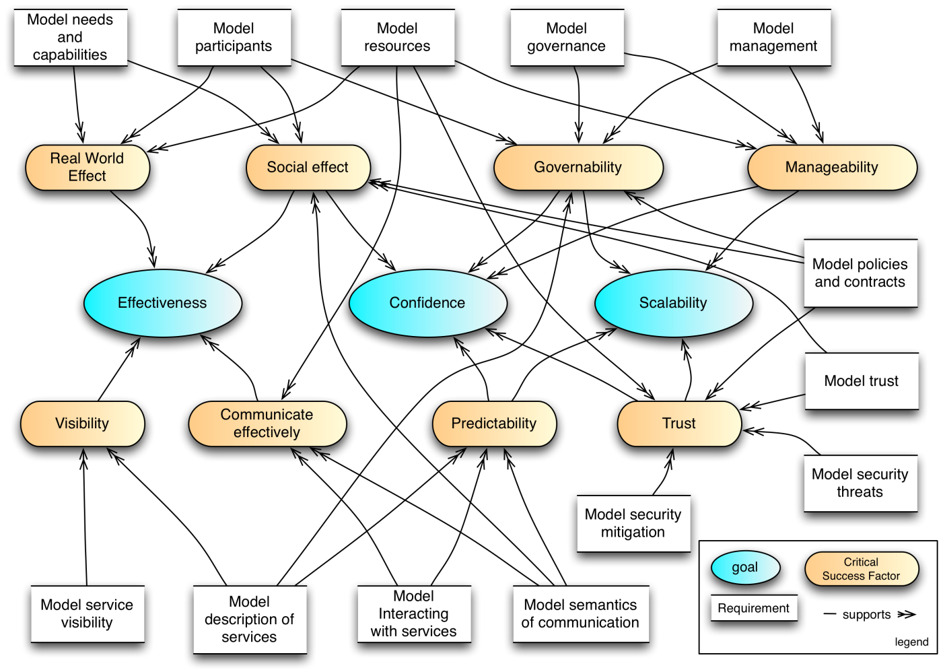
Figure 3 Critical Factors Analysis of the Reference Architecture
Figure 3 represents a Critical Factors Analysis (CFA) diagram demonstrating the relationship between the primary goals of this reference architecture, critical factors that determine the success of the architecture and individual elements that need to be modeled.
A CFA is a structured way of arriving at the requirements for a project, especially the quality attribute (non-functional) requirements; as such, it forms a natural complement to other requirements capture techniques such as use-case analysis, which are oriented more toward functional requirements capture. The CFA requirement technique and the diagram notation are summarized in Appendix B.

Goals

Effectiveness Goal
A primary purpose of this architecture is to show what is involved in SOA-based systems to ensure that participants can use the facilities of the system to meet their needs. This does not imply that every need has a SOA solution, but for those needs that can benefit from a SOA approach, we look at what is needed to use the SOA paradigm effectively.
The critical factors that determine effectiveness are visibility between the participants, that they can communicate effectively, and that actual real world effects and social effects can be realized. In addition, the overall system must be manageable and governable.

Confidence Goal
SOA-based systems should enable service providers and consumers to conduct their business with the appropriate level of confidence in the interaction. Confidence is especially important in situations that are high-risk; this includes situations involving multiple ownership domains as well as situations involving the use of sensitive resources.
In addition to ensuring that social effects are properly captured, other critical factors that are important for ensuring confidence are trust, predictability, manageability and proper governance.

Scalability Goal
The third goal of this Reference Architecture is scalability. In architectural terms, we determine scalability in terms of the smooth growth of complexity of systems as the number and complexity of services and interactions between participants increases. Another measure of scalability is the ease with which interactions can cross ownership boundaries.
The critical factors that determine scalability, particularly in the context of multiple domains of ownership are predictability, trust, governability and manageability. This is in addition to more traditional measures of scalability such as performance of message exchange.

Critical Success Factors
A critical success factor (CSF) is a property of the intended system, or a sub-goal that directly supports a goal and there is strong belief that without it the goal is unattainable. CSFs are not necessarily measurable in themselves. As illustrated in Figure 3, CSFs can be associated with more than one goal.

Real World Effect
It is of the essence that participants can use a SOA-based system to realize actual effects in the world. This implies that the capabilities that are accessed as a result of service interaction are embedded in and backed by the real world.
We identify three models that address how service interactions can result in real world effects: a needs and capabilities model, a participants model and a resources model.

Social Effect
Effects that are desired in the use of SOA-based systems may be social effects as well as physical effects. For example, opening a bank account is primarily about the relationship between a customer and a bank – the effect of the opened account is a change in the relationship between the customer and the bank.
The models that are important in addressing this critical factor are similar to the more general real world effect: the participants model, the needs and capabilities model, the resources model. In addition, the semantics of communication model and the policy and contracts model directly support the objective of realizing the appropriate social effect.

Visibility
Ensuring that participants can see each other is clearly also a critical factor in ensuring effectiveness of interaction. Enabling visibility requires addressing the visibility of services and the correct descriptions of services and related artifacts.

Communicate effectively
In order for there to be effective uses of capabilities and meeting of needs, it is critical that participants can see and interact with each other. The models that address this are the Interacting with Services model, the Resources model and the Semantics of Communication model.

Manageability and Governability
Given that a large-scale SOA-based system may be populated with many services, and used by large numbers of people; managing SOA-based systems properly is a critical factor for engendering confidence in them. This involves both managing the services themselves and managing the relationships between people and the SOA-based systems they are utilizing; the latter being more commonly identified with governance.
The governance of SOA-based systems requires an ability for decision makers to be able to set policies about participants, services, and their relationships. It requires an ability to ensure that policies are effectively described and enforced. It also requires an effective means of measuring the historical and current performances of services and participants.
The scope of management of SOA-based systems is constrained by the existence of multiple ownership domains. Management may include setting policies such as technology choices but may not, in some cases, include setting policies about the services that are offered.

Trust
Trust is a critical factor in ensuring confidence. Trust can be analyzed in terms of trust in infrastructure facilities (otherwise known as reliability), trust in the relationships and effects that are realized by interactions with services, and trust in the integrity and confidentiality of those interactions particularly with respect to external factors (otherwise known as security).
The threat model in Section 5.2.3 captures what is meant by trust; the security models capture how external entities might attempt to corrupt that trust and how SOA-based systems can mitigate against those risks.
Note that there is a distinction between trust in a SOA-based system and trust in the capabilities accessed via the SOA-based system. The former focuses on the role of SOA-based systems as a medium for conducting business, the latter on the trustworthiness of participants in such systems. This architecture focuses on the former, while trying to encourage the latter.

Predictability
A factor that engenders confidence in any system is predictability. By predictability, we principally mean that the expectations of participants of SOA-based systems can be tied to the actual performance of those systems (what you see is what you get).
The primary means of ensuring predictability is effective descriptions: service descriptions document services, the interacting with services model addresses expectations relating to how services are used and the semantics of communications model addresses how meaning and intent can be exchanged between participants.

Principles of this Reference Architecture
The following principles serve as core tenets that guide the evolution of this Reference Architecture. The ordered numbering of these principles does not imply priority order.
Principle 1: Technology Neutrality
Statement: Technology neutrality refers to independence from particular technologies.
Rationale: We view technology independence as important for three main reasons: technology specific approach risks confusing issues that are technology specific with those that are integrally involved with realizing SOA-based systems; and we believe that the principles that underlie SOA-based systems have the potential to outlive any specific technologies that are used to deliver them. Finally, a great proportion of this architecture is inherently concerned with people, their relationships to services on SOA-based systems and to each other.
Implications: This Reference Architecture must be technology neutral, meaning that we assume that technology will continue to evolve, and that over the lifetime of this architecture that multiple, potentially competing technologies will co-exist. Another immediate implication of technology independence is that greater effort on the part of architects and other decision makers to construct systems based on this architecture is needed.
Principle 2: Parsimony
Statement: Parsimony refers to economy of design, avoiding complexity where possible and minimizing the number of components and relationships needed.
Rationale: The hallmark of good design is parsimony, or “less is better.” It promotes better understandability or comprehension of a domain of discourse by avoiding gratuitous complexity, while being sufficiently rich to meet requirements.
Implications: Occam’s (or Ockham’s) Razor applies, which states that the explanation of any phenomenon should make as few assumptions as possible, eliminating those that make no difference in the observable predictions of the explanatory hypothesis or theory. With respect to this Reference Architecture, this is made apparent by avoiding the elaboration of certain details which though that may be required for any particular solution, are likely to vary substantially from application to application. The complement of a parsimonious design is a feature-rich design. Parsimoniously designed systems tend to have fewer features. This, in turn, means that people attempting to use such a system may have to work harder to ensure that their application requirements have been met.
Principle 3: Separation of Concerns
Statement: Separation of Concerns refers to the ability to cleanly delineate architectural models in such a way that an individual stakeholder or a set of stakeholders that share common concerns only see those models that directly address their respective areas of interest. This principle could just as easily be referred to as the Separation of Stakeholder Concerns principle, but the focus here is predominantly on loose coupling of models.
Rationale: As SOA-based systems become more mainstream, and as they start to become increasingly complex, it will be extremely important for the architecture to be able to scale. Trying to maintain a single, monolithic architecture that incorporates all models to address all possible system stakeholders and their associated concerns will not only rapidly become unmanageable with rising system complexity, but it will become unusable as well.
Implications: This is a core tenet that drives this Reference Architecture to adopt the notion of architectural viewpoints and corresponding views. A viewpoint provides the formalization of the groupings of models representing one set of concerns relative to an architecture, while a view is the actual representation of a particular system. The ability to leverage an industry standard that formalizes this notion of architectural viewpoints and views helps us better ground these concepts for not only the developers of this Reference Architecture but also for its readers. Fortunately, such a standard exists in the IEEE Recommended Practice for Architectural Description of Software-Intensive Systems [ANSI/IEEE 1471-2000::ISO/IEC 42010-2007]; and it is this standard that serves as the basis for the structure and organization of this Reference Architecture.
Principle 4: Applicability
Statement: Applicability refers to that which is relevant. Here, an architecture is sought that is relevant to as many facets and applications of SOA-based systems as possible; even those yet unforeseen.
Rationale: An architecture that is not relevant to its domain of discourse will not be adopted and thus likely to languish.
Implications: This Reference Architecture needs to be relevant to the problem of matching needs and capabilities under disparate domains of ownership; to the concepts of “Intranet SOA” (SOA within the enterprise) as well as “Internet SOA” (SOA outside the enterprise); to the concept of “Extranet SOA” (SOA within the extended enterprise, i.e., SOA with suppliers and trading partners); and finally, to “net-centric SOA” or “Internet-ready SOA.”

Service Ecosystem View
No man is an island
No man is an island entire of itself; every man
is a piece of the continent, a part of the main;
if a clod be washed away by the sea, Europe
is the less, as well as if a promontory were, as
well as any manner of thy friends or of thine
own were; any man's death diminishes me,
because I am involved in mankind.
And therefore never send to know for whom
the bell tolls; it tolls for thee.
John Donne
The Service Ecosystem View focuses on what a SOA-based system means for people to participate in it to conduct their business. Business, in general, is characterized in terms of providing services and consuming business services to realize mutually desirable real world effects; in a SOA-based system, the conduct of business involves the effective connectivity of IT-accessible resources as an important element in how these real world effects are realized.
The people and organizations involved in a SOA-based ecosystem form a community; which may be a single enterprise or a large peer-to-peer network of enterprises and individuals. Many of the activities that people engage in are themselves defined by the relationships between people and by the organizations to which they belong.
However, the primary motivation for participants to interact with each other is to achieve goals – to get things done. While SOA implies the use of IT resources and artifacts, these are merely tools to an end and are usually not the primary interest of the participants. Describing what it means to act in the SOA ecosystem when participants may be in different organizations, with different rules and expectations is one of the primary modeling objectives of this section.
Since there is inherently some mediation involved when people interact using electronic means, we lay the foundations for how communication can be used to represent action. This foundation forms the backdrop for how services are realized – covered in Section 4 – as well as how SOA-based systems are managed as owned entities – covered in Section 5.
Thus, our tasks in this view are to model the people involved—the participants and other stakeholders—their goals and activities and the relevant relationships between people as they affect the utility and safety of actions that are performed.
The models in this view form the basis for many of the activities of SOA participants, especially in areas such as management and security. They lay a groundwork for those areas and will be referenced in the other views to provide a consistent discussion throughout this document.
In particular, the Acting in a SOA ecosystem model introduces the key concepts involved in actions, the Social Structure Model introduces the key elements that underlie the relationships between participants. The Acting in a Social Context model pulls the two together and shows how ownership, risk and transactions are key concepts in the SOA ecosystem.
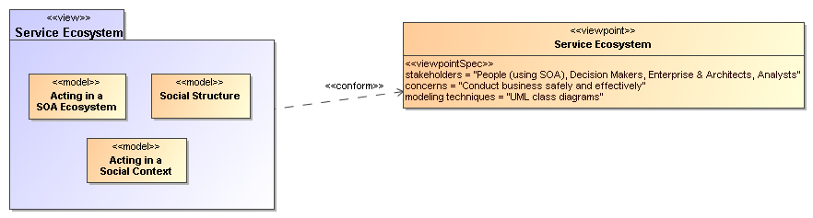
Figure 4 Model elements described in the Service Ecosystem view

Acting in a SOA Ecosystem Model
At the core of participants interacting in a SOA ecosystem is the concept of action – participants are acting against services in order to get their needs met. Service providers are acting in order to satisfy those needs and governance parties act in order to ensure the smooth operation of the systems.
Actions may also be across one or more ownership boundaries; in particular, participants in a SOA ecosystem may be performing actions involving systems that do not belong to them.
For example, if a consumer wishes to use a service to book an airline ticket for a journey, the consumer must interact with the airline reservation system in order to achieve the goal of a reservation. The consumer must be able to accomplish her goal using actions recognized by a reservation system that was designed to satisfy the policies and other assumptions about context made by the airline and those implementing the system.
When the consumer purchases a ticket, the action is to purchase the ticket but the means of doing so involves an interaction with the airline. However, both the interaction itself and the purchase are actions that must be understood at different levels – at the level of the IT systems through which messages are communicated and at the level of the reservation service through which the effects of the purchase are recorded.
There are many parallels between the way that human society is organized, and the way that humans can act using the power of others. There are also parallels in satisfying business needs and satisfying the mechanistic needs of the systems and processes that enable the bringing together of needs and capabilities to satisfy our goals
In this section we establish the key principles of action as an abstract concept. We elaborate on action in the context of acting in a social context as joint action. And we also establish the connections necessary between the different levels of understanding of action that allow participants to interact as a means of getting things done.

Actors, Delegates and Participants
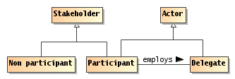
Figure 5 Actors, Participants and Delegates
Actor
An actor is an entity, human, non-human or organization of entities, that is capable of action.
The concept of actor encompasses many kinds of entities, human and corporate participants, even semi-autonomous computational agents. Two important kinds of actor are participants and delegates.
Stakeholder
A stakeholder in the SOA ecosystem is an individual entity, human or non-human, or organization of entities that has an interest in the state of the ecosystem.
Participant
A participant is a stakeholder that is an actor in a SOA ecosystem.
A participant is a stakeholder whose interests lie in the successful use of and fulfillment of services. However, human participants always require representation in an electronic system – they require mechanisms to facilitate their interactions: they require delegates.
Note that we admit non-human agents that have no identifiable representative as an extreme case: the normal situation is where participants are either human or organizations.
Non-Participant Stakeholder
A non-participant stakeholder is any stakeholder who is not an actor in the ecosystem.
Stakeholders do not necessarily participate in service interactions. For example, a government may have an interest in the outcomes of commercial services deployed in a SOA ecosystem for the purposes of collecting tax from one or more of the participants. A government may also be interested in regulatory compliance as it affects service interactions.
There are two main classes of such non-participatory stakeholders: third parties who are affected by someone's use or provisioning of a service, and regulatory agencies who wish to control the outcome of service interactions in some way (such as by taxation). An example of an affected third party may be someone using the service infrastructure whose activities are impeded because an errant participant is consuming excessive bandwidth in another interaction.
Delegate
A delegate is an actor that is acting on behalf of a participant.
In order for people to be able to offer, consume and otherwise participate in SOA service interactions, they require the use of an entity capable of directly interacting with electronic communications – we use the term delegate to identify that entity. Common examples are software applications that make use of services, hardware devices that embody a particular mission, and enterprise systems that offer services.
We do not attempt to characterize delegates in terms of their internal architecture, computational requirements or platforms here.
There are many kinds of entities that may function in a SOA ecosystem. For example, there may be software agents that permit people to offer and interact with services; there may be delegates that represent the interests of other stakeholders – such as security agents charged with managing the security of the ecosystem.
In the different models in this architecture we use the actor concept when it is not important whether the entity involved is a delegate, participant or some other entity. If the entity is acting on behalf of another, then we use the delegate concept. If the entity is a stakeholder in the ecosystem then we use participant.

Action and Joint Action
Entities act in order to achieve their goals. In this model, we look at the most basic form of action – an action performed by a single actor. Figure 6 depicts a model of action showing the relationships between action, goals and effects of action.

Action and Actors
Within this initial model of action, we focus on the actions of individual entities. However, we should remark that for the most part within a SOA ecosystem, the actions we are most interested in are actions involving multiple participants – we address this further in Section 3.1.2.2.
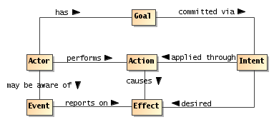
Figure 6 Actions, Real World Effect and Events
The most important concept in any model of actions and effects is that of action itself:
Action
An action is the application of intent to achieve an effect (within the SOA ecosystem).
This concept is simultaneously one of the fulcrums of the Service Oriented Architecture and a touch point for many other aspects of the architecture: such as policies, service descriptions, management, security and so on.
The aspect of action that distinguishes it from mere force or accident is that someone or something intended the action to occur.
Goal
A goal is a measurable state of the ecosystem that an actor is seeking to establish.
Goals are conditions that people, and more generally actors, are seeking to satisfy. A key aspect of goals is measurability: it should be possible to know if a goal has been satisfied.
Intent
Intent is the commitment of an actor to achieve a goal.
An actor’s intent in performing an action is to further one or more of the actor’s goals.
In some situations it may be difficult to determine an actor’s actual intent. This is particularly true for social actions such as those performed within a SOA-based system.
However, in most cases, entities in a SOA ecosystem make an assumption of implied intent. I.e., if an actor performs an action, it is assumed that the actor also intended to perform the action – it was not an accident, or the action of another actor.
Much of the infrastructure of interaction is there to eliminate the potential for accidental or malicious actions.
Effect
An effect is a measurable change in the state of the ecosystem.
Note the normal intent of applying an action is to cause an effect that reflects the actor’s goals. However, there is often the possibility that the actual effects will include unintended consequences that fall outside of, and may run counter to, the intent of the actor.
Changes in the ecosystem may be reported by means of events:
Event
An event is the report of an effect of which at least one participant has an interest in being aware.
In effect (sic), an event is a corollary to action: in a public arena, actions result in changes to the state of ecosystem (primarily changes to the states of individual participants); these changes may be manifested as events of which participants in the arena have an awareness.
Note that, while performing an action may be an event that other participants have an interest in, an event that reports an action is not the same as the action itself.

Joint Actions
Joint actions are the foundation for understanding interaction between participants in a SOA ecosystem. In this Reference Architecture, we see joint actions at two levels: as communication and as participants using and offering services.
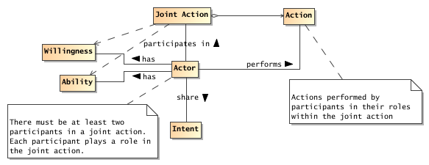
Figure 7 Joint Action
Joint Action
A joint action is a coordinated set of actions involving the efforts of two or more actors to achieve an effect.
In order for multiple actors to participate in a joint action, they must each act according to their role within the joint action. For example, a common example of a joint action is for one actor to speak to another. A communication between actors cannot take place unless there is both a speaker and a listener – although it is not necessarily required that they both be active simultaneously. The two actors involved have different roles – one is a speaker and the other is a listener.
By definition, joint actions are actions that cannot be performed by single participants. Sometimes this is because no single participant has the ability to perform the action on his own; or, in the case of the speaker and listener, the ‘joint-ness’ of joint actions is inherent.
In any social context joint actions abound: people talking to each other, people buying and selling, people arranging their lives. In addition, joint action is at the heart of interactions within the context of a SOA ecosystem.
There is another sense in which joint actions abound: even within a single incident of interaction there are typically several overlapping joint actions.
For example, when one person says to another: "it is stuffy in here" there is an immediate sense in which there is a joint action – a joint communicative action (see below). The intended effect being that the listener believes that the speaker intends him to understand that the speaker believes that the atmosphere is uncomfortable. (The listener may also believe that the atmosphere is uncomfortable as a result of the communication.)
However, in the right context, there may be another joint action: the apparent declaration may in fact be a command. The intent being that the speaker wishes the listener to understand that the door should be opened, the effect being that of actually opening the door.
There may be a further layer to this scenario: the speaker might be aware that there is someone who is waiting to be let in. The command to open the door is actually a command to admit the visitor to the room.
Fundamentally all three of these senses of joint action are superimposed on top of each other. However, there is a strong sense in which the different joint actions may be quite interchangeable. For example, instead of declaring that the "room is stuffy", the speaker might have simply said "open the door". Or the speaker might have said "please let John in". In each case the effect would have been the same – modulo the sensitivities of the speaker and listener – the door being open and the visitor admitted to the room.
The relationship between the communicative joint action: the utterance of the declaration and the command joint action is a `uses' relationship. The speaking joint action is used to convey the command joint action; which in turn is used to convey the visitor admittance action.
In many situations the best predicate that describes the relationship between these different joint actions is the 'counts as' predicate. The utterance action counts as the command to open the door. The command to open the door counts as the request to admit the visitor.
It can be extremely useful to identify and separate the different overlapping senses of joint action. It allows us to separately describe and process the communicative actions from the command joint actions. This, in turn, reflects the fact that each layer has its own logic and ontology.
For example, at the utterance level, the issues are to do with the successful understanding of the content of the communication – did the listener hear and understand the words, did the speaker intend to say them, and so on.
At the level of the command to open the door, the issues center on whether there is a predisposition on the part of the listener to obey commands given to him by the speaker.
In the context of a SOA ecosystem we can separately capture the logic and mechanics of what is involved in electronic communication – the sending of messages, the security of the communication and so on; from the logic and mechanics of command -- does the listener believe that the speaker has the appropriate authority to issue the command.
As with human communication, electronic interactions are similarly interchangeable: the commitment to purchase a book requires some form of communication between buyer and seller; but the purchase action itself is unchanged by the use of email or an HTTP post of an XML document.
In summary, the concept of joint action allows us to honor the fact that both parties in an interaction are required for there to be an actual effect; it allows us to separate out the different levels of the interaction into appropriate semantic layers; and it allows us to recombine those layers in potentially different ways whilst still achieving the intended real world effects of action in a SOA ecosystem.

Communication as Joint Action
Because there is inherently some separation between actors in a SOA ecosystem, they are effectively driven to use communication techniques to ‘get their business done’. When an actor sends a message to another actor there are actually two (at least) senses in which the actor can be said to be acting: by communicating with other actors; and the purpose of the communication is also action.
The primary mechanism whereby actors interact with each other is through the exchange of messages, where the messages may cross ownership boundaries. Communication and the interpretation of communicated content is the foundation of all interaction within the SOA ecosystem.
However content is actually communicated, communicating is also a form of action. We define the communicative action as the action of message exchange:
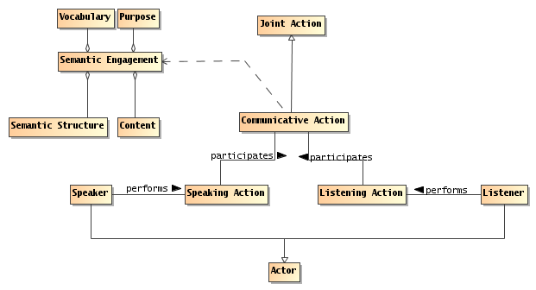
Figure 8 Communication as Joint Action
Communicative Action
A communicative action is a joint action in which an actor communicates with one or more other actors.
A communicative action has a speaker and a listener; each of whom must perform their part for the communicative action to occur.
The concept of communicative action is important in the explanation of how we can use the exchange of messages to realize interaction between service participants. The Reference Model defines interaction as the activity that is involved in making use of a capability offered. A communicative action is the joint action involved in the exchange of messages.
Speaking Action
A speaking action is the action required of an actor in order to communicate a desired content.
Listening Action
A listening action is the action required of an actor in order to acquire and comprehend communicated content.
Notice that an actor listening to a message not only acquires the message but is also able to understand it. The implications of this are discussed further below.
Speaker & Listener
A speaker is an actor who performs the speaking action; A listener is an actor who performs the listening action.
Speaking and listening are roles that (normally) different actors play in a given communicative action.
Typically, a communicative action involves one participant speaking and the other listening simultaneously; although there are many potential important variations, such as broadcast, writing and so on.
A given speaking action may have any number of listeners. Indeed, in some situations, it may not be possible for the speaker to be aware of the listener in a communicative action; however, this does not change the fundamentals of communication: without both a speaker and a listener there is no communication.
Content
Content is the information passed from the speaker to the listener in a communicative action.
Even though communication is effected through action, it is not actually effective if the listener cannot understand the content of the communication. We can characterize the necessary modes of understanding in terms of a shared vocabulary and a shared understanding of the communicated intent.
The meaning of a communication is typically conveyed as a combination of the syntax of the content, its semantics and its illocutionary force.
Typically, the syntax takes the form of highly regular tree structure, with a well-defined method for interpreting the structure. For example, an invoice will often follow pre-established standards for communicating invoices.
Semantics
The semantics of a communicative action is the meaning of the content being communicated.
The semantics of a fragment of content can be characterized in terms of the vocabulary of terms referenced in the content and the relationships between those terms that are represented by the syntactic form of the content.
Vocabulary
A vocabulary is a set of terms together with an interpretation that is shared by actors involved in a communicative action.
In order for there to be any communication, there must be sufficient shared understanding of the elements of interaction and of terms used in communication. A shared vocabulary may range from a simple understanding of particular strings as commands to a sophisticated collection of terms that are formalized in shared ontologies.
Note that, while it is often easier to visualize the semantics of communication in terms that reflect human experience, it is not required for interactions between service consumers and providers to particularly look like human speech. Machine-machine communication is typically highly stylized in form, it may have particular forms and it may involve particular terms not found in everyday human interaction.
Illocutionary Force
The illocutionary force of a communicative act is the proximate purpose of the communication.
For example, a communicative action may be a request, or it may inform the listener of some fact.
Of course, the ultimate purpose for a communication may not be closely related to the proximate purpose. For example, a bank service may inform a customer that their account balance is too low; the ultimate purpose being to persuade the customer to augment the account.
Taken together, the syntax, semantics, vocabulary, and the illocutionary force of communicated content is the basis of all interaction in the SOA ecosystem.

Using Communication for Service Action
Like communicative actions, service actions, or actions involving a service, are inherently joint actions – there can be no service action without both the service and the actor originating the action. However, because there is a gap between the participant performing a service action and the service being acted upon, there must be a bridge across that gap; bridging this gap relies on the count as relationship.
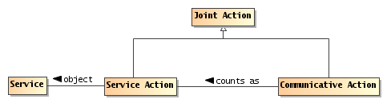
Figure 9 Communicative actions as Service Actions
Service Action
A service action is an element of the action model of the service.
Service actions are inherently joint actions; they require both the entity performing the action and the service itself to participate in the action.
Counts as
Counts as is a relationship between two logical systems in which an action, event or concept in one system can be understood as another action, event or concept in another system.
The two systems involved in SOA-based systems are the system of communication on the one hand and the system of services on the other.
When we state that a communicative action counts as a service action, we are relating a system of communication to a system of action against services. Since a participant cannot (normally) act directly on a service it must use some means of mediating the action. However, from the perspective of all the participants involved, when a participant uses a communicative action appropriately, the participants are expected to understand the communication as though a service action were actually performed.
When a customer ‘tells’ an airline service that it ‘confirms’ the purchase of the ticket it is simultaneously a communication and a service action – two ways of understanding the same event, both actions, one layered on top of the other, but with independent semantics.

Communicating for Action
Actors participating in a SOA ecosystem are often attempting to get other actors to do something – the service action alluded to above. For example, a customer trying to buy a book has to convince the book selling service to deliver the book. Conversely the book selling service has to convince the customer to pay for it.
When an actor agrees to a course of action as a result of its interactions with other actors it is adopting an objective.
Objective
An objective is a real world effect that an actor wishes to achieve.
Objectives refer to Real World Effects that actors may actively consider achieving.
In general, there is a subsumption relationship between actors’ goals and their objectives: an objective can be considered to be consistent with one of more goals. Generally, a goal is a long term state of the world that may be, in practice, difficult to measure. On the other hand, an objective is a directly measurable and preferably predictable outcome of a particular action or set of actions.
Objective Adoption
An actor may adopt an objective as a result of interacting with another actor.
A consequence of an actor adopting an objective on behalf of another actor is that the actor becomes accountable to the latter for the successful satisfaction of the objective.
Accountability
An actor is accountable to another actor when the former consents to achieve an identified objective.
An objective adopted by one actor as a result of an interaction need not be consistent with the objectives of the originating actor. In many situations, the adopted objective is not all the same and may even be contrary to the desires of the original actor.
It is possible to characterize an actor’s accountability in terms of obligation policies that are in force in relation to that actor.

Social Structure Model
The actions undertaken by participants, whether mediated by services or in some other way, are performed in a context that defines the meaning of the actions themselves. That context is fundamentally a social context – a context that includes other participants. We can formalize that context as a social structure: the embodiment of a particular social context.
The social structure model is important to defining and understanding the implications of crossing ownership boundaries; it is the foundation for an understanding of security in SOA and also provides the context for determining how SOA-based systems can be effectively managed and governed.
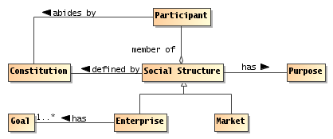
Figure 10 Social Structure
Social Structure
A social structure embodies some of the cultural aspects that characterize the relationships and actions among a group of participants.
A social structure may have any number of participants, and a given participant can be a member of multiple social structures. Thus, there is frequent interaction among social structures, sometimes resulting in disagreements when the goals of the social structures do not align.
In the Reference Architecture, we are concerned primarily with social structures that reflect the anticipated participants in SOA-based systems; these are often embodied in legal and quasi-legal frameworks; i.e., they have some rules that are commonly understood. For example, an enterprise is a common kind of social structure, as is an online chat room. At the other extreme, the legal frameworks of entire countries and regions also count as social structures.
It is not necessarily the case that the social structures involved in a service interaction are explicitly identified. For example, when a customer buys a book over the Internet, the social structure that defines the validity of the transaction is often the legal framework of the region associated with the book vendor. This legal jurisdiction qualification is typically buried in the fine print of the service description.
Purpose
A measurable condition ascribed to a thing or action relating it to a goal.
By their nature, purposes are external to the purposed entities, whereas goals are internal to the entity.
A social structure has a purpose – the reason for which it exists. All social structures have a purpose, some social structures also have goals.
Constitution
A constitution is an agreement shared by a group of participants that defines a social structure.
Every social structure defines the rules by which participants interact with each other within the structure. Whether or not it is explicitly written, the constitution is that agreement that identifies the social structure itself.
A social structure’s rules are abided to by the participants. In some cases, this is based on an explicit agreement, in other cases participants behave as though they agree to the constitution without a formal agreement. In other cases, participants abide by the rules with some degree of reluctance – this is an issue raised later on when we discuss governance in SOA-based systems.
The SOA ecosystem is marked by two primary forms of social structure – the market social structure which is primarily oriented to the interrelationship between participants within the ecosystem and the enterprise which represents a kind of composite participant – an entity that has sufficient internal cohesiveness that allows us to consider it as a potential stakeholder in its own right.
Enterprise
An enterprise is an organization with identifiable officers and with internally established goals that reflect the purpose of the organization.
The enterprise is marked out as being associated with internal goals in a way that a strict market type of social structure is not. Figure 11 shows a simplified model of enterprises as they relate to social structures.
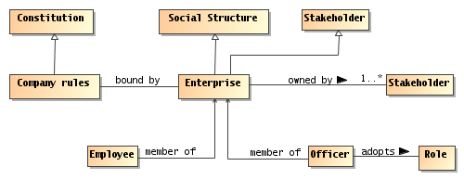
Figure 11 Enterprise as a Social Structure
Market
A market social structure is the locus of interaction between participants who are peers of one another.
If an enterprise is often the focus of the differing roles and responsibilities of members, a market or meeting place is more concerned with the exchange of goods and services for mutual benefit.
It is entirely possible for a given interaction between participants to take place within a social structure that is an enterprise as well as being a market place. However, interactions within a market place are inherently across ownership boundaries.

Roles in Social Structures
One of the primary benefits of formalizing the relationships between people in terms of groups, corporations, legal entities and so on, is that it allows greater efficiencies in the operation of society. However, corporations, governments and even society, are abstractions: a government is not a person that can perform actions – only people or automated processes following the instructions of people can actually do things.
For example, a fishing club is an abstraction that is important to its members. A club, however, is an abstraction that has no physical ability to act in the world. On the other hand, a person who is appropriately empowered by the fishing club can act. For example, when that person writes a check and mails it to the telephone company, that action counts as though the fishing club has paid its bills.
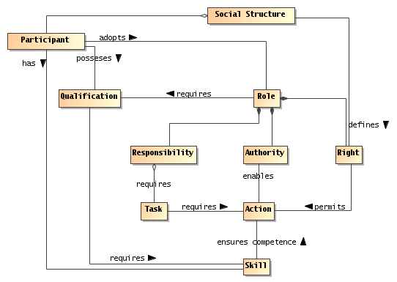
Figure 12 Roles, Rights and Responsibilities
Participants’ actions within a social structure are often defined by the roles that they adopt.
Role
A role is an identified relationship between a participant and a social structure that defines the rights, responsibilities, qualifications, and authorities of that participant within the context of the social structure.
For many scenarios, the roles of participants are easily identified: for example, a buyer uses the service offered by the seller to achieve a purchase. However, in particular in situations involving delegation, the role of a participant may be considerably more complex.
A participant can be identified with one or more roles. Someone in authority in the social structure may have formally designated the participant as assuming the role with associated rights and responsibilities. Qualification and skill describe the expectations of the social structure in who should fill the role, but formal certifications of those qualifications and skills may or may not be required of the designated participant.
Conversely, someone who exhibits qualification and skill may by consensus assume the role without any formal designation. Someone with some degree of qualification and skill may become identified with a role because they perform the associated tasks.
Note that, while many roles are clearly identified, with appropriate names and definitions of the responsibilities, it is also entirely possible to separately bestow rights, responsibilities and so on; usually in a temporary fashion. For example, when a CEO delegates the responsibility of ensuring that the company accounts are correct to the CTO, this does not imply that the CTO is adopting the full role of CFO.
In order for a person to act on behalf of some other person or on behalf of some legal entity, it is required that they have the power to do so and the authority to do so.
Right
A right is a predetermined permission that permits an actor to perform some action or adopt a stance in relation to the social structure and other actors.
For example, in most circumstances, sellers have a right to refuse service to potential customers; but may only do so based on certain criteria.
Authority
Authority is the right to act as agent on behalf of an organization or another person.
Usually, authority is constrained in terms of the kinds of actions that are authorized, and in terms of the necessary skills and qualifications of the persons invoking the authority.
An entity may authorize or be assigned another entity to act as its agent. Often the actions that are so authorized are restricted in some sense. In the case of human organizations, the only way that they can act is via an agent.
Rights, authorities, responsibilities and roles form the foundation for the security architecture of the Reference Architecture. Rights and responsibilities have similar structure to permissive and obligation policies; except that the focus is from the perspective of the constrained participant rather than the constrained actions.
Responsibility
A responsibility is an obligation on a role player to perform some action or to adopt a stance in relation to other role players.
Skill
A skill is a competence or capability to achieve some real world effect.
Skills are typically associated with roles in terms of requirements: a given role description may require that the role player has a certain skill.
Qualification
A qualification is a public determination by an issuing authority that an actor has achieved some state.
The issuing authority may require some successful actions on the part of the actor (such as demonstrating some skills). The qualification may have constraints attached to it; for example, the certification may be time limited.
There is a distinction between a skill – which is capability that a participant may have to act – and a publicly accepted right to act. For example, someone may have the skills to fly an airplane but not have a pilot's license. Conversely, someone may have a pilot license, but because of some temporary cause be incapable of flying a plane (they may be ill for example).
Qualifications are often used as constraints on roles: any entity adopting a role within an organization (or other social structure) must have certain qualifications.

Shared State and Social Facts
Many of the actions performed by people and most of the important aspects of a person's state are inherently social in nature. The social context of an action is what gives it much of its meaning. We call actions in society social actions and, those facts that are understood in a society, social facts. It is often the case that social actions give rise to social facts.
Compared to facts about the natural world, social facts are inherently abstract: they only have meaning in the context of a social structure.
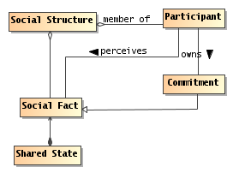
Figure 13 Shared State and Social Facts
Social Fact
A social fact is an element of the state of a social structure that is defined by that social structure.
Social structures provide a context in which social facts are given their meaning. For example, the existence of a valid purchase order with a particular customer has a meaning that is defined primarily by the company itself, together with the society that the company is part of.
Social facts typically require some kind of ritual to establish the validity of the fact itself. For example, the existence of an agreed contract typically requires both parties to sign papers and to exchange those papers. If the signatures are not performed correctly, or if the parties are not properly empowered to perform the ritual, then it is as though nothing happened.
In the case of agreements reached by electronic means, this involves the exchange of electronic messages; often with special tokens being exchanged in place of a hand-written signature.
State
State is the condition that an entity is in at a particular time.
State is characterized by a set of facts that is true of the entity – in effect we are concerned only with aspects of an entity that are potentially measurable.
Private State
Private state is the set of facts that is known and understood by a participant.
Shared State
The set of facts that are knowable by participants as a result of their communicative actions.
Note that shared state does not imply the state is known to all participants. It simply refers to the elements of state that may be known.
Note that any participant has only a partial view of the world. Furthermore, the participant will have internal private state that is not accessible to other participants directly. However, elements of the shared state are in principle accessible to participants even if a given participant does not have access to all elements at any given time.
Public Semantics
The public semantics of a communicative action is the set of facts that any observer of the action would be sanctioned to infer by virtue of the observer’s situation in a social structure.
Of course, the most obvious observer of a communication is the intended recipient of the communication. However, the key is that the public semantics of a communication would enable any observer to make the same inferences.
For example, a standard purchase order denotes a commitment to buy some goods or services. Any observer of the purchase order would be entitled to interpret it as a purchase order (whether or not the purchase order was targeted at the observer).
Public semantics is often couched in terms of the shared state of the various members of the social structure – a purchase order is interpreted relative to the social structure within which it is made.
Commitment
A commitment is a social fact about the future: in the future some fact will be true and a participant has the current responsibility of ensuring that that fact will indeed be true.
A commitment to deliver some good or service is a classic example of a fact about the future.
Other important classes of social facts include the policies adopted by an organization, any agreements that it is holding for participants, and the assignment of participants to roles within the organization.
Facts have the property of being verifiable (technically, a social fact can be verified to determine if it is satisfied in the social context). If, as a result of interacting with a service, a buyer incurs the obligation of paying for some good or service, this obligation (and the discharge of it) is measurable (perhaps by further interactions with the same or other services).

Proposition
When a participant wishes to share knowledge of a social fact or commitment, it may take the form of one or more Propositions.
Proposition
A proposition is an expression, normally in a language that has a well-defined written form, that expresses some property of the world from the perspective of a stakeholder.
In principle, the truth of a proposition must be verifiable – using a decision procedure – by examining the world and checking that the proposition and the world are consistent with each other.
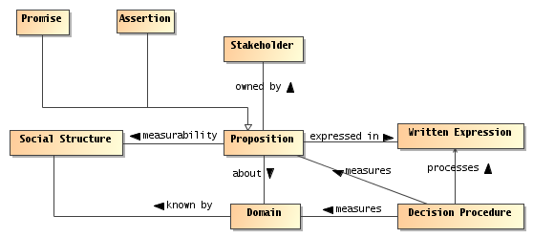
Figure 14 Propositions
Decision Procedure
A decision procedure is a process for determining whether an expression is true, or is satisfied, in the world.
Decision procedures are algorithms, programs that can measure the world against a formula, expression or description and answer the question whether the world corresponds to the description. If the truth of a proposition is indeterminable, then a decision procedure does not exist, and the logic is undecidable.
Domain
A domain is a ‘world’ that is used as the basis for the truth of a proposition.
When we say ‘world’, we are not restricted to the physical world. The criterion is an ability to discover facts about it. In our case governmental, commercial and social structures that form the backdrop for SOA-based systems are important examples of modeled worlds.
Written Expression
The written expression of a proposition is a formula written in a systematic system of marks that denotes the proposition.
Note that not all `systems of marks’ have a decision procedure. However, for the uses to which we put the concept of proposition: policies, service descriptions, and so on, we require that the language used to write policy and other propositions have a decision procedure.
Propositions, as used in reference to needs, policies and contracts can be further analyzed in terms of facts that are about the world as it is, will be, or should be. The latter are particularly of concern in policies and contracts and other propositions concerning the relationships between people.
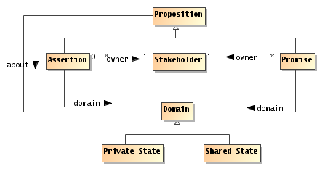
Figure 15 Assertions and Promises
Assertion
An assertion is a proposition that is held to be true by a stakeholder. It is essentially a claim about the state of the world.
Promise
A promise is a proposition regarding the future state of the world by a stakeholder. In particular, it represents a commitment by the stakeholder to ensure the truth of the proposition.
For example, an airline may report its record in on-time departures for its various flights. This is a claim made by the airline which is, in principle, verifiable. The same airline may promise that some percentage of its flights depart within 5 minutes of their scheduled departure. The truth of this promise depends on the effectiveness of the airline in meeting its commitments.
Another way of contrasting assertions and promises is to see what happens when the propositions fail: a stakeholder that makes a false assertion about the world might be classified as a liar; a stakeholder that makes a false promise is said to break its promises.

Acting in a Social Context Model
In the context of SOA, actions are primarily social in nature — one participant is asking another to do something that is directly related to the organization(s) that they are part of — and goal oriented — the purpose of interacting with a service is to satisfy a need by attempting to ensure that a remote entity applies its capabilities to the need.
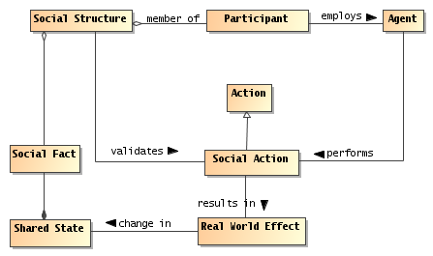
Figure 16 Acting within Social Structures
Social Action
Social actions are actions that are performed in order to achieve some result within a social structure.
A social action is an action that is defined primarily by the effect it has on the relationship between participants and state of a social structure by establishing one or more new social facts.
Social actions are always contextualized by a social structure: the organization gives meaning to the action, and often defines the requirements for an action to be recognized as having an effect within the organization.

Service Providers and Consumers
Section 3.1.1 defines the distinction between participants and nonparticipants. In a SOA social structure, several types of participants play prominent roles.
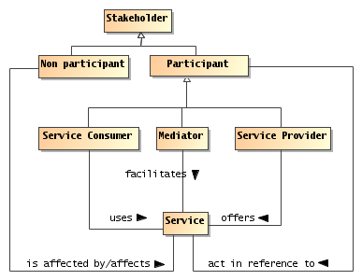
Figure 17 Service Participants
Service Provider
A service provider is a participant that offers a service that enables some capability to be used by other participants.
Note that several kinds of stakeholders may be involved in provisioning a service. These include but are not limited to the provider of the capability, an enabler that exposes it as a service, a mediator that translates and/or manages the relationship between service consumers and the service, a host that offers support for the service, a government that permits the service and/or collects taxes based on service interactions.
Service Consumer
A service consumer is a participant that interacts with a service in order to realize the real world effect produced by a capability to address a consumer need.
It is a common understanding that service consumers typically initiate service interactions. Again, this is not necessarily true in all situations (for example, in publish-and-subscribe scenarios, a service consumer may initiate an initial subscription, but thereafter, the interactions are initiated by publishers). As with service providers, several stakeholders may be involved in a service interaction supporting the consumer.
Service providers and service consumers do not represent truly symmetric roles: each participant has different objectives and often has different capabilities. However, the objectives and the conditions under which those objectives align are critical for a successful interaction to proceed.
Service Mediator
A service mediator is a participant that facilitates the offering or use of services in some way.
There are many kinds of mediator, for example a registry is a kind of mediator that permits providers and consumers to find each other. Another example might be a filter service that enhances another service by encrypting and decrypting messages. Yet another example of a mediator is a proxy broker that actively stands for one or other party in an interaction.

Needs and Capabilities
The Reference Model defines SOA in terms of a bringing together of needs and capabilities – the primary motivation for actors to engage with each other. A provider has a capability of generating a set of real world effects and making that capability available contributes to the satisfaction of some set of provider needs. The consumer has a need for those real world effects and has the capability of providing monetary or other return (for example, acknowledgement of effort) to the provider.
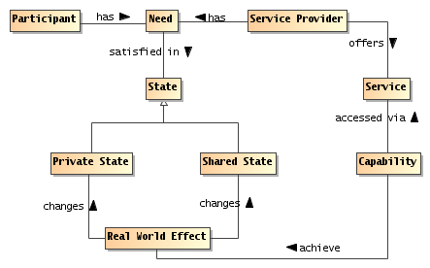
Figure 18 Needs and Capabilities
Need
A need is a measurable requirement that a service participant is actively seeking to satisfy.
A need may or may not be publicly measurable; the needs that this Reference Architecture finds in scope are those that are publicly measurable. However, the satisfaction of a participant’s need can only be determined by that participant.
The extent to which a need is captured in a formal way is likely to be very different in each situation.
Capability
A capability is an ability to achieve a real world effect.
The model in Section 3.1.3 shows that there is often some indirection between needs and having them satisfied. Both needs and the effects of using capabilities are expressed in terms of state: a need is expressed as a condition on the desired state and the Real World Effect of using capabilities is a change in the state of the world.
By making a capability available for use, the owners aim to address their needs as well as the needs of other participants who use the service. The extent to which a capability is exposed via a service (or via multiple services) is controlled by the owner of the capability but may also be limited by the service provider. As noted in the Reference Model, a given service is not required to provide access to all aspects of an underlying capability.

Resources
In the SOA-RM and this Reference Architecture, we discuss service, underlying capabilities, and numerous other entities that are part of the SOA ecosystem. We categorize these as Resources, and define Resource as follows:
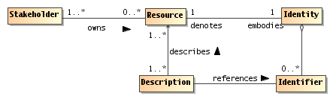
Figure 19 Resources
Resource
A resource is any entity of some perceived value that has identity.
A resource may have more than one identifier, but any well-formed identifier should unambiguously resolve to the intended resource.
An important class of resource is the class of capabilities that underlie services. Other examples of resources are services themselves, descriptions of entities (a kind of meta-resource), IT infrastructure elements used to deliver services, contracts and policies, and so on.
Identity
Identity is the collection of individual characteristics by which an entity, human or nonhuman, is recognized or known.
The ability to unambiguously identify a resource in a SOA interaction is critical to determine such things as authorizations, to understand what functions are being performed and what the results mean, and to ensure repeatability or characterize differences with future SOA interactions.
Identifier
An identifier is any block of data – such as a string – that unambiguously connects a resource with a particular identity.
Identifiers typically require a context in order to establish the connection between the identifier and the resource. A given resource may have multiple identifiers, with different utility for different contexts.
In a SOA eco-system, it is good practice to use globally unique identifiers; for example globally unique IRIs. An identifier must uniquely disambiguate the indicated resource from other resources but more than one identifier may uniquely resolve to the same resource.
Description
A description is a structure that may be interpreted as containing assertions about a resource.
This model of resource is a simplification and an elaboration of the concept that underlies the Web Architecture [WA]. Being more abstract, we do not require that the identity of a resource be in any particular form (although in practice, many resource identifiers are URIs), nor do we require resources to have representations. However, we do require resources to have owners.

Ownership
A fundamental aspect of a resource is that it is owned by a stakeholder. Ownership is also important in understanding the various kinds of obligations participants may enter into. Fundamentally, we view ownership as a relationship between a stakeholder and a resource, where the owner has certain rights over the resource.
Ownership
Ownership is a set of rights and responsibilities that a stakeholder has in relation to a resource; including the right to transfer that ownership to another entity.
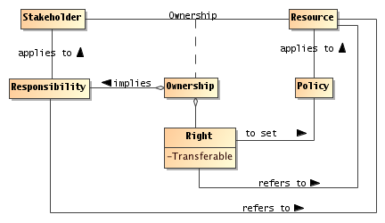
Figure 20 Resource Ownership
To own a resource implies taking responsibility for creating, maintaining, and if it is to be available to others, provisioning the resource. More than one stakeholder may own different rights, such as one stakeholder having the right to deploy a capability as a service, another owning the rights to the profits that result from using the capability, and yet another owning the rights to use the service.
One who owns a resource may delegate rights and responsibilities to others, but typically retains some responsibility to see that the delegated responsibilities are met. There may also be joint ownership of a resource, where the responsibility is shared.
A crucial property that distinguishes ownership from a more limited right to use is the right to transfer ownership to another person or organization. When a resource is being used without being owned, there is an implied requirement that at the end of a period of time the rights and responsibilities relating to the resource will be returned to the original owner of the resource.
Ownership is defined in relation to the social structure relative to which rights and responsibilities are exercised. In particular, there may be constraints on how ownership may be transferred. For example, a government may not permit a corporation to transfer assets to a subsidiary in a different jurisdiction.
Ownership Boundary
An ownership boundary is the social structure within which the rights and responsibilities associated with a particular ownership may be recognized.
Individual participants are within an ownership boundary in relation to a specific owned resource if they are members of the social structure that owns the resource.

Trust, Risk and Willingness
For interactions to be possible within the SOA ecosystem, each actor must have a sufficient degree of trust in other actors to form a basis for willingness to engage in the interactions.
Trust
Trust is a private assessment or internal perception that some entity will perform actions that will lead to an identifiable set of real world effects.
The reference to real world effects implies the existence of measurements or other observations of shared state that represent the real world effect.
Willingness
Willingness is the internal commitment of an actor to carry out its part of an interaction.
As discussed in the Reference Model, willingness on the part of actors to interact is not the same as a willingness to perform requested actions. A service provider that rejects all attempts to cause it to perform some action may still be fully willing and engaged in interacting with the consumer.
Trusting Actor
A Trusting Actor is an actor who establishes and maintains willingness to proceed with an interaction based on its trust of other actors.
Typically, it is not important to know the specific actions undertaken by any given actor because these may be private. Additionally, it is not important to share or even to know the goals of the individual actors as long as the Trusting Actor believes that individual actions by others will be sufficient to result in expected real world effects. For example, the Trusting Actor may have a desired real world effect of an important message being delivered and is willing to pay for this business service; those delivering the message have no interest in the importance of the message but want to do what is necessary to ensure payment. Successful completion of the interaction will result in both (and possibly other) real world effects to be realized.
Trusted Actor
A Trusted Actor is an actor with which a Trusting Actor has sufficient trust for that Trusting Actor to be willing to proceed with an interaction.
The relationship of Willingness to the Trusting and Trusted Actors is shown in Figure 21.
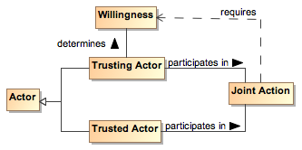
Figure 21 Trusting Actor and Willingness
Risk
Risk is a private assessment or internal perception that certain undesirable real world effects may come into being.
The Actor perceiving risk may take actions to mitigate the risk. For example, the actor may assess a high degree of risk to clicking on an email link where the actor believes the email to be spam, and the actor forgoes any possible benefit by not clicking on the link. Alternately, the actor may see a risk in having a hard drive fail and mitigate the effect of losing files by backing up those files considered important.

Assessing Trust and Risk
The assessments of trust and risk are based on evidence available to the Trusting Actor.
Evidence
Evidence is the accumulation of real world effects by which a Trusting Actor can assess trust and risk.
The evidence may be physical artifacts or a set of information from which the Trusting Actor can assess the degree of trust. The evidence may include a history of previous interaction between the Trusting and Trusted Actors or previous interactions of the Trusted Actor with other actors for which the real world effects of their interactions are public. Such an accumulation of real world effects forms the basis of the Trusted Actor’s reputation.
Reputation
Reputation is the social assessment of an actor with respect to an expectation of behavior or skill, where the assessment is made on the basis of evidence.
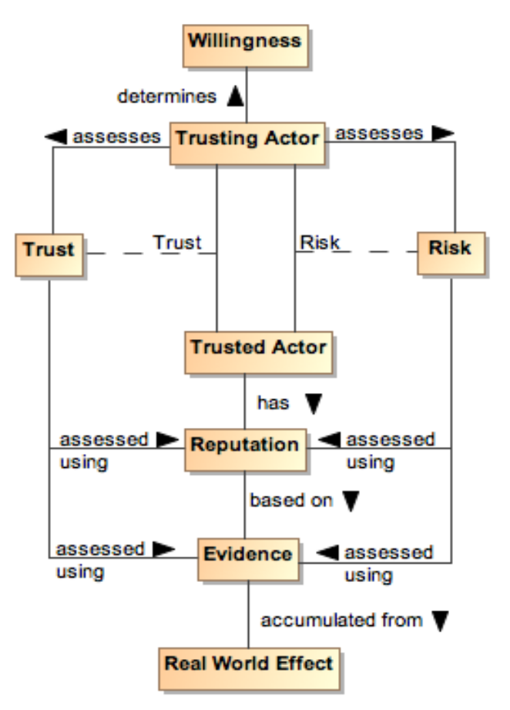
Figure 22 Assessing Trust and Risk
Trust is based on the confidence the Trusting Actor has in the accuracy and sufficiency of the gathered evidence and the degree to which any assessment is appropriate for the situation for which trust is being assessed. Trust is not binary, i.e. an Actor is not completely trusted or untrusted, because there is typically some degree of uncertainty in the accuracy or completeness of the evidence or the assessment. Similarly, there is uncertainty in the amount and consequences of potential risk.
The balance between perceived trust and perceived risk results in a willingness or unwillingness to proceed. If there is little or no perceived risk, then the degree of trust may not be relevant in assessing possible actions. For example, most people consider there to be an acceptable level of risk to privacy when using search engines, and submit queries without any sense of trust being considered.
As perceived risk increases, the issue of trust becomes more of a consideration. There are recognized risks in providing or accepting credit cards as payment, and standard procedures have been put in place to increase trust or, at a minimum, bringing trust and risk into balance by mitigating risk. For interactions with a high degree of risk, the Trusting Actor requires stronger or additional evidence when evaluating the balance between risk and trust when deciding whether to participate in an interaction.

Trust and SOA
In traditional systems, the balance between trust and risk was achieved by severely restricting the interactions and those that could participate: the more trust and the higher the perceived risk, the more tightly coupled we made the corresponding system.
Realizing many of the perceived benefits of SOA will require a fuller understanding of what trust and risk mean in the relevant business processes and what is an appropriate balance to be achieved. Actors need to assess trust and risk and act on those assessments while remaining part of the ecosystem and not just in a walled garden.

Transactions and Exchanges
An important class of joint action is the business transaction, or contract exchange. Many interactions between participants in the SOA ecosystem are based around business transactions.
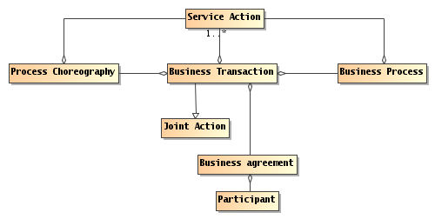
Figure 23 Business Transaction
Business Transaction
A business transaction is a joint action engaged in by two or more participants in which the ownership of one of more resources is exchanged.
A classic business transaction is buying some good or service, but there is a huge variety of kinds of possible business transactions.
Key to the concept of business transaction is the contract or agreement to exchange. The form of the contract can vary from a simple handshake to an elaborately drawn contract with lawyers giving advice from all sides.
A completed transaction establishes a set of social facts relating to the exchange; typically to the changes of ownerships of the resources being exchanged.
Business Agreement
A business agreement is an agreement entered into by two or more partners that constrains their future behaviors and permitted states.
A business agreement is typically associated with business transactions: the transaction is guided by the agreement and an agreement can be the result of a transaction.
Business transactions often have a well defined life-cycle: a negotiation phase in which the terms of the transaction are discussed, an agreement action which establishes the commitment to the transaction, an action phase in which the agreed-upon items are exchanged (they may need to be manufactured before they can be exchanged), and a termination phase in which there may be long-term commitments by both parties but no particular actions required (e.g., if the exchanged goods are found to be defective, then there is likely a commitment to repair or replace them).
From an architectural perspective, the business transaction often represents the top-most mode of interpretation of service interactions. When participants interact in a service, they exchange information and perform actions that have an effect in the world. These exchanges can be interpreted as realizing part of, and in support of, business transactions.
Business Process
A business process is a description of the tasks, participants' roles and information needed to fulfill a business objective.
Business processes are often used to describe the actions and interactions that form business transactions. This is most clear when the business process defines an activity involving parties external to the organization; however, even within an enterprise, a business process typically involves multiple participants and stakeholders.
In the context of transactions mediated and supported by electronic means, business processes are often required to be defined well enough to permit automation. The forms of such definitions are often referred to as choreographies:
Process Choreography
A process choreography is a description of the possible interactions that may take place between two or more participants to fulfill an objective.
A choreography is, in effect, a description of what the forms of permitted joint actions are when trying to achieve a particular result. Joint actions are by nature formed out of the individual actions of the participants; a choreography can be used to describe those interlocking actions that make up the joint action itself.

Realizing Service Oriented Architectures View

Make everything as simple as possible but no simpler.
Albert Einstein
The Realizing Service Oriented Architectures View focuses on the infrastructure elements that are needed in order to support the discovery and interaction with services. The key questions asked are "What are services, what support is needed and how are they realized?"
The models in this view include the Service Description Model, the Service Visibility Model, the Interacting with Services Model, and the Policies and Contracts Model.
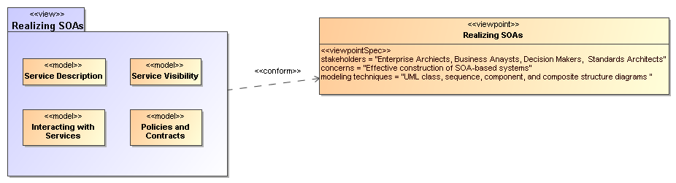
Figure 24 Model Elements Described in the Realizing a Service Oriented Architecture View
The Service Description Model informs the participants of what services exist and the conditions under which these can be used. Some of those conditions follow from policies and agreements on policy that flow from the Policies and Contracts Model. The information in the service description as augmented by details of policy provides the basis for visibility as defined in the SOA Reference Model and captured in the Service Visibility Model. Finally, the process by which services as described are used under the defined conditions and agreements is described in the Interacting with Services Model.

Service Description Model
A service description is an artifact, usually document-based, that defines or references the information needed to use, deploy, manage and otherwise control a service. This includes not only the information and behavior models associated with a service to define the service interface but also includes information needed to decide whether the service is appropriate for the current needs of the service consumer. Thus, the service description will also include information such as service reachability, service functionality, and the policies and contracts associated with a service.
A service description artifact may be a single document or it may be an interlinked set of documents. For the purposes of this model, differences in representation are to be ignored, but the implications of a “web of documents” is discussed later in this section.
There are several points to note regarding the following discussion of service description:
- The Reference Model states that one of the hallmarks of SOA is the large amount of associated description. The model presented below focuses on the description of services but it is equally important to consider the descriptions of the consumer, other participants, and needed resources other than services.
- Descriptions are inherently incomplete but may be determined as sufficient when it is possible for the participants to access and use the described services based only on the descriptions provided. This means that, at one end of the spectrum, a description along the lines of “That service on that machine” may be sufficient for the intended audience. On the other extreme, a service description with a machine-process-able description of the semantics of its operations and real world effects may be required for services accessed via automated service discovery and planning systems.
- Descriptions come with context, i.e. a given description comprises information needed to adequately support the context. For example, a list of items can define a version of a service, but for many contexts an indicated version number is sufficient without the detailed list. The current model focuses on the description needed by a service consumer to understand what the service does, under what conditions will the service do it, how well does the service do it, and what steps are needed by the consumer to initiate and complete a service interaction. Such information also enables the service provider to clearly specify what is being provided and the intended conditions of use.
- Descriptions will change over time as, for example, the ingredients and nutrition information for food labeling continues to evolve. A requirement for transparency of transactions may require additional description for those associated contexts.
- Description always proceeds from a basis of what is considered "common knowledge". This may be social conventions that are commonly expected or possibly codified in law. It is impossible to describe everything and it can be expected that a mechanism as far reaching as SOA will also connect entities where there is inconsistent "common" knowledge.
- Descriptions will become the collection point of information related to a service or any other resource, but it will not necessarily be the originating point or the motivation for generating this information. In particular, given a SOA service as the access to an underlying capability, the service may point to some of the capability’s previously generated description, e.g. a service providing access to a data store may reference update records that indicate the freshness of the data.
- Descriptions of the provider and consumer are the essential building blocks for establishing the execution context of an interaction.
These points emphasize that there is no one “right” description for all contexts and for all time. Several descriptions for the same subject may exist at the same time, and this emphasizes the importance of the description referencing source material maintained by that material’s owner rather than having multiple copies that become out of synch and inconsistent.
It may also prove useful for a description assembled for one context to cross-reference description assembled for another context as a way of referencing ancillary information without overburdening any single description. Rather than a single artifact, description can be thought of as a web of documents that enhance the total available description.
This Reference Architecture uses the term service description for consistency with the concept defined in the Reference Model. Some SOA literature treats the idea of a “service contract” as equivalent to service description. In this Reference Architecture, the term service description is preferred. Replacing service description with service contract implies just one side of the interaction is governing and misses the point that a single set of policies identified by a service description may lead to numerous contracts, i.e. service level agreements, leveraging the same description.

The Model for Service Description
Figure 25 shows Service Description as a subclass of the general Description class, where Description is a subclass of the Resource class as defined in Section 3.3.3. In addition, each Resource is assumed to have a description. The following section discusses the relationships among elements of general description and the subsequent sections focus on service description itself. Note, other descriptions, such as those of participants, are important to SOA but are not individually elaborated in this document.

Elements Common to General Description
The general Description class is composed of a number of elements that are expected to be common among all specialized descriptions supporting a service oriented architecture. A registry often contains a subset of the description instance, where the chosen subset is identified as that which facilitates mediated discovery. Additional information contained in a more complete description may be needed to initiate and continue interaction.
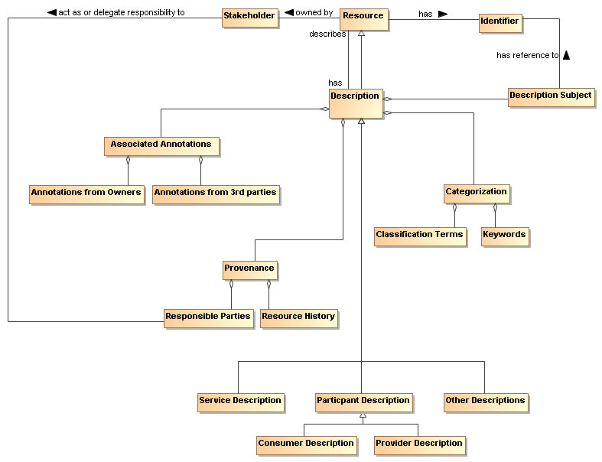
Figure 25 General Description

Description Subject
The subject of a description is a Resource. The value assigned to the Description Subject class may be of any form that provides understanding of what constitutes the Resource, but it is often in human-readable text. The Description Subject MUST also reference the Identifier of the resource it describes so it can unambiguously identify the subject of each description instance.
As a Resource, Description also has an identifier with a unique value for each description instance. The description instance provides vital information needed to both establish visibility of the resource and to support its use in the execution context for the associated interaction. The identifier of the description instance allows the description itself to be referenced for discussion, access, or reuse of its content.

Provenance
While the Resource Identifier provides the means to know which subject and subject description are being considered, Provenance as related to the Description class provides information that reflects on the quality or usability of the subject. Provenance specifically identifies the entity (human, defined role, organization, ...) that assumes responsibility for the resource being described and tracks historic information that establishes a context for understanding what the resource provides and how it has changed over time. Responsibilities may be directly assumed by the Stakeholder who owns a Resource or the Owner may designate Responsible Parties for the various aspects of maintaining the resource and provisioning it for use by others. There may be more than one entity identified under Responsible Parties; for example, one entity may be responsible for code maintenance while another is responsible for provisioning of the executable code. The historical aspects may also have multiple entries, such as when and how data was collected and when and how it was subsequently processed, and as with other elements of description, may provide links to other assets maintained by the Resource owner.

Keywords and Classification Terms
A traditional element of description has been to associate the resource being described with predefined keywords or classification taxonomies that derive from referenceable formal definitions and vocabularies. This Reference Architecture does not prescribe which vocabularies or taxonomies may be referenced, nor does it limit the number of keywords or classifications that may be associated with the resource. It does, however, state that a normative definition SHOULD be referenced, whether that be a representation in a formal ontology language, a pointer to an online dictionary, or any other accessible source. See Section 4.1.1.2 for further discussion on associating semantics with assigned values.

Associated Annotations
The general description instance may also reference associated documentation that is in addition to that considered necessary in this model. For example, the owner of a service may have documentation on best practices for using the service. Alternately, a third party may certify a service based on their own criteria and certification process; this may be vital information to other prospective consumers if they were willing to accept the certification in lieu of having to perform another certification themselves. Note, while the examples of Associated Documentation presented here are related to services, the concept applies equally to description of other entities.

Assigning Values to Description Instances
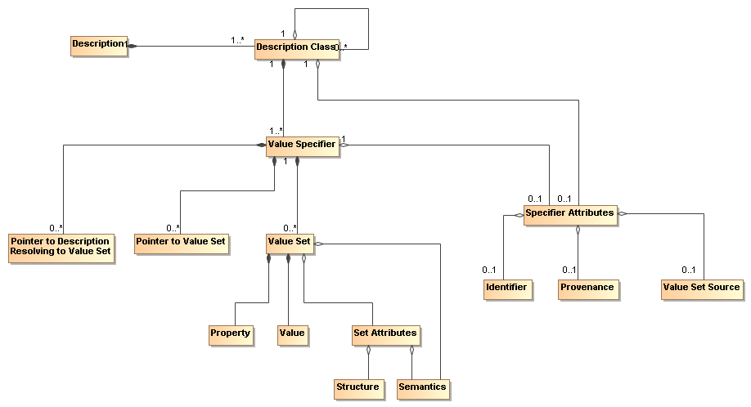
Figure 26 Representation of a Description
Figure 25 shows the template for a general description but individual description instances depend on the ability to associate meaningful values with the identified elements. Figure 26 shows a model for a collection of information that provides for value assignment and traceability for both the value meaning and the source of a value. The model is not meant to replace existing or future schema or other structures that have or will be defined for specific implementations, but it is meant as guidance for the information such structures need to capture to generate sufficient description. It is expected that tools will be developed to assist the user in populating description and auto-filling many of these fields, and in that context, this model provides guidance to the tool developers.
In Figure 26 each class has an associated value specifier or is made up of components that will eventually resolve to a value specifier. For example, Description has several components, one of which is Categorization, which would have an associated a value specifier.
A value specifier consists of
- a collection of value sets with associated property-value pairs, pointers to such value sets, or pointers to descriptions that eventually resolve to value sets that describe the component; and
- attributes that qualify the value specifier and the value sets it contains.
The qualifying attributes for the value specifier include
- an optional identifier that would allow the value set to be defined, accessed, and reused elsewhere;
- provenance information that identifies the party (individual, role, or organization) that has responsibility for assigning the value sets to any description component;
- an optional source of the value set, if appropriate and meaningful, e.g. if a particular data source is mandated.
If the value specifier is contained within a higher-level component, (such as Service Description containing Service Functionality), the component may inherit values from the attributes from its container.
Note, provenance as a qualifying attribute of a value specifier is different from provenance as part of an instance of Description. Provenance for a service identifies those who own and are responsible for the service, as described in Section 3.3.4. Provenance for a value specifier identifies who is responsible for choosing and assigning values to the value sets that comprise the value specifier. It is assumed that granularity at the value specifier level is sufficient and provenance is not required for each value set.
The value set also has attributes that define its structure and semantics.
- The semantics of the value set property should be associated with a semantic context conveying the meaning of the property within the execution context, where the semantic context could vary from a free text definition to a formal ontology.
- For numeric values, the structure would provide the numeric format of the value and the “semantics” would be conveyed by a dimensional unit with an identifier to an authoritative source defining the dimensional unit and preferred mechanisms for its conversion to other dimensional units of like type.
- For nonnumeric values, the structure would provide the data structure for the value representation and the semantics would be an associated semantic model.
- For pointers, architectural guidelines would define the preferred addressing scheme.
The value specifier may indicate a default semantic model for its component value sets and the individual value sets may provide an override.
The property-value pair construct is introduced for the value set to emphasize the need to identify unambiguously both what is being specified and what is a consistent associated value. The further qualifying of Structure and Semantics in the Set Attributes allows for flexibility in defining the form of the associated values.

Model Elements Specific to Service Description
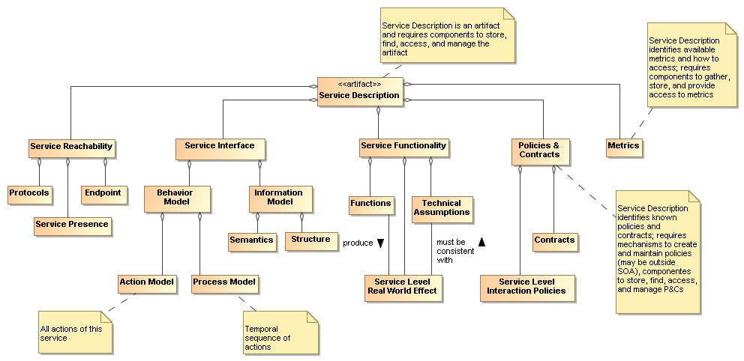
Figure 27 Service Description
The major elements for the Service Description subclass follow directly from the areas discussed in the Reference Model. Here, we discuss the detail shown in Figure 27 and the purpose served by each element of service description.
Note, the intent in the subsections that follow is to describe how a particular element, such as the service interface, is reflected in the service description, not to elaborate on the details of that element. Other sections of the Reference Model and this Reference Architecture describe the “physics” of each element whereas the service description subsections will only touch on the meta aspects.

Service Interface
As noted in the Reference Model, the service interface is the means for interacting with a service. For this Reference Architecture and as shown in Section 4.3 the service interface will support an exchange of messages, where
- the message conforms to a referenceable message exchange pattern (MEP),
- the message payload conforms to the structure and semantics of the indicated information model,
- the messages are used to denote events or actions against the service, where the actions are specified in the action model and any required sequencing of actions is specified in the process model.
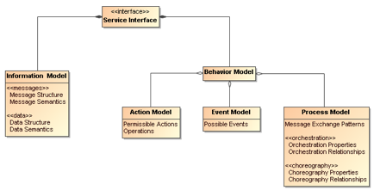
Figure 28 Service Interface
Note we distinguish the structure and semantics of the message from that of the underlying protocol that conveys the message. The message structure may include nested structures that are independently defined, such as an enclosing envelope structure and an enclosed data structure.
These aspects of messages are discussed in more detail in Section 4.3

Service Reachability
Service reachability, as modeled in Section 4.2.2.3 enables service participants to locate and interact with one another. To support service reachability, the service description should indicate the endpoints to which a service consumer can direct messages to invoke actions and the protocol to be used for message exchange using that endpoint.
As applied in general to an action, the endpoint is the conceptual location where one applies an action; with respect to service description, it is the actual address where a message is sent.
In addition, the service description should provide information on collected metrics for service presence; see Section 4.1.1.3.4 for the discussion of metrics as part of service description.

Service Functionality
While the service interface and service reachability are concerned with the mechanics of using a service, service functionality and performance metrics (discussed in Section 4.1.1.3.4) describe what can be expected when interacting with a service. Service Functionality, shown in Figure 27 as part of the overall Service Description model and extended in Figure 29, is an unambiguous expression of service function(s) and the real world effects of invoking the function. The Functions likely represent business activities in some domain that produce the desired Real World Effects.
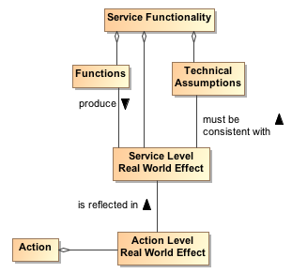
Figure 29 Service Functionality
The Service Functionality may also be constrained by Technical Assumptions that underlie the effects that can result. Technical assumptions are defined as domain specific restrictions and may express underlying physical limitations, such as flow speeds must be below sonic velocity or disk access that cannot be faster than the maximum for its host drive. Technical assumptions are likely related to the underlying capability accessed by the service. In any case, the Real World Effects must be consistent with the Technical Assumptions.
In Figure 27 and Figure 29, we specifically refer to Service Level and Action Level Real World Effects.
Service Level Real World Effect
A service level real world effect is a specific change in shared state or information returned as a result of interacting with a service.
Action Level Real World Effect
An action level real world effect is a specific change in shared state or information returned as a result of performing a specific action against a service.
Service description describes the service as a whole while the component aspects should contribute to that whole. Thus, while individual Actions may contribute to the real world effects to be realized from interaction with the service, there would be a serious disconnect for Actions to contribute real world effects that could not consistently be reflected in the Service Level Real World Effects and thus the Service Functionality. The relationship to Action Level Real World Effects and the implications on defining the scope of a service are discussed in Section 4.1.2.1.
Elements of Service Functionality may be expressed as natural language text, reference to an existing taxonomy of functions, or reference to a more formal knowledge capture providing richer description and context.

Policies and Contracts, Metrics, and Compliance Records
Policies prescribe the conditions and constraints for interacting with a service and impact the willingness to continue visibility with the other participants. Whereas technical assumptions are statements of “physical” fact, policies are subjective assertions made by the service provider (sometimes as passed on from higher authorities).
The service description provides a central location for identifying what policies have been asserted by the service provider. The specific representation of the policy, e.g. in some formal policy language, is likely done outside of the service description and the service description would reference the normative definition of the policy.
Policies may also be asserted by other service participants, as illustrated by the model shown in Figure 30. Policies that are generally applicable to any interaction with the service are likely to be asserted by the service provider and included in the Policies and Contracts section of the service description. Conversely, policies that are asserted by specific consumers or consumer communities would likely be identified as part of a description’s Annotations from 3rd parties (see Section 4.1.1.1.4) because these would be specific to those parties and not a general aspect of the service being described.
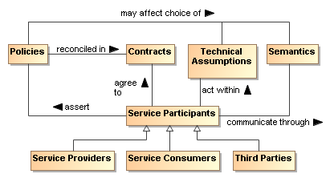
Figure 30 Model for Policies and Contracts as related to Service Participants
In Figure 27 and Figure 31, we specifically refer to Service Level Interaction Policies. In a similar manner to that discussed for Service Level vs. Action Level Real World Effects in Section 4.1.1.3.3, individual Actions may have associated policies stating conditions for performing the action, but these must be reflected in and be consistent with the policies made visible at the service level and thus the description of the service as a whole. The relationship to Action Level Policies and the implications on defining the scope of a service are discussed in Section 4.1.2.1.

Figure 31 Action-Level and Service-Level Policies
As noted in Figure 30, the policies asserted may affect the allowable Technical Assumptions that can be embodied in services or their underlying capabilities and may affect the semantics that can be used. For example of the former, there may be a policy that specifies the surge capacity to be accommodated by a server, and a service that designs for a smaller capacity would not be appropriate to use. For the latter, a policy may require that only services using a community-sponsored vocabulary can be used.
Contracts are agreements among the service participants. The contract may reconcile inconsistent policies asserted by the participants or may specify details of the interaction. Service level agreements (SLAs) are one commonly used category of contracts.
References to contracts under which the service can be used may also be included in the service description. As with policies, the specific representation of the contract, e.g. in some formal contract language, is likely done outside of the service description and the service description would reference the normative definition of the contract. Policies and contracts are discussed further in Section 4.4.
The definition and later enforcement of policies and contracts are predicated on the existence of metrics; the relationships among the relevant concepts are shown in the model in Figure 32. Performance Metrics identify quantities that characterize the speed and quality of realizing the real world effects produced via the SOA service; in addition, policies and contracts may depend on nonperformance metrics, such as whether a license is in place to use the service. Some of these metrics reflect the underlying capability, e.g. a SOA service cannot respond in two seconds if the underlying capability is expected to take five seconds to do its processing; some metrics reflect the implementation of the SOA service, e.g. what level of caching is present to minimize data access requests across the network.
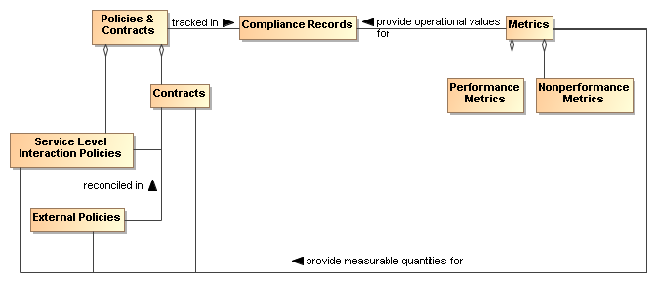
Figure 32 Policies and Contracts, Metrics, and Compliance Records
As with many quantities, the metrics associated with a service are not themselves defined by this Service Description because it is not known a priori which metrics are being collected or otherwise checked by the services, the SOA infrastructure, or other resources that participate in the SOA interactions. However, the service description SHOULD provide a placeholder (possibly through a link to an externally compiled list) for identifying which metrics are available and how these can be accessed.
The use of metrics to evaluate compliance is discussed in Section 4.4.2. The results of compliance evaluation SHOULD be maintained in compliance records and the means to access the compliance records SHOULD be included in the Policies and Contracts portion of the service description. For example, the description may be in the form of static information (e.g. over the first year of operation, this service had a 91% availability), a link to a dynamically generated metric (e.g. over the past 30 days, the service has had a 93.3% availability), or access to a dynamic means to check the service for current availability (e.g. a ping). The relationship between service presence and the presence of the individual actions that can be invoked is discussed under Reachability in Section 4.2.2.3.
Note, even when policies relate the perspective of a single participant, policy compliance can be measured and policies may be enforceable without contractual agreement with other participants. This should be reflected in the policy, contract, and compliance record information maintained in the service description.

Use Of Service Description

Service Description in support of Service Interaction
If we assume we have awareness, i.e. access to relevant descriptions, the service participants must still establish willingness and presence to ensure full visibility (See Section 4.2) and to interact with the service. Service description provides necessary information for many aspects of preparing for and carrying through with interaction. Recall the fundamental definition of service is a mechanism to access an underlying capability; the service description describes this mechanism and its use. It lays the groundwork for what can occur, whereas service interaction defines the specifics through which occurrences are realized.
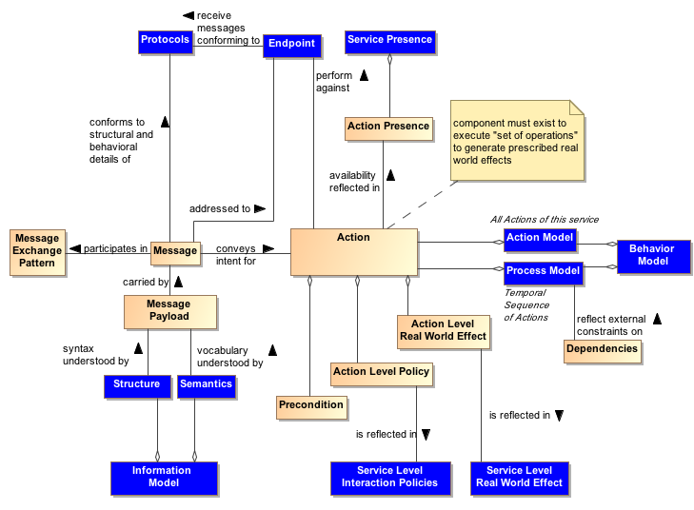
Figure 33 Relationship Between Action and Service Description Components
Figure 33 combines the models in the subsections of Section 4.1.1 to concisely relate Action and the relevant components of Service Description. The purpose of Figure 33 is to demonstrate that the components of service description go beyond arbitrary documentation and form the critical set of information needed to define the what and how of Action. In Figure 33, the leaf nodes from Figure 27 are shown in blue.
Action is invoked via a Message where the structure and behavioral details of the message conform to an identified Protocol and is directed to the address of the identified endpoint, and the message payload conforms to the service Information Model.
The availability of an action is reflected in the Action Presence and each Action Presence contributes to the overall Service Presence; this is discussed further in Section 4.2.2.3. Each action has its own endpoint and also its own protocols associated with the endpoint and to what extent, e.g. current or average availability, there is presence for the action through that endpoint. The endpoint and service presence are also part of the service description.
An action may have preconditions where a Precondition is something that needs to be in place before an action can occur, e.g. confirmation of a precursor action. Whether preconditions are satisfied is evaluated when someone tries to perform the action and not before. Presence for an action means someone can initiate it and is independent of whether the preconditions are satisfied. However, the successful completion of the action may depend on whether its preconditions were satisfied.
Analogous to the relationship between actions and preconditions, the Process Model may imply Dependencies for succeeding steps in a process, e.g. that a previous step has successfully completed, or may be isolated to a given step. An example of the latter would be a dependency that the host server has scheduled maintenance and access attempts at these times would fail. Dependencies related to the process model do not affect the presence of a service although these may affect whether the business function successfully completes.
The conditions under which an action can be invoked may depend on policies associated with the action. The Action Level Policies MUST be reflected in the Service Level Interaction Policies because such policies may be critical to determining whether the conditions for use of the service are consistent with the policies asserted by the service consumer. The service level interaction policies are included in the service description.
Similarly, the result of invoking an action is one or more real world effects, and the Action Level Real World Effects MUST be reflected in the Service Level Real World Effect included in the service description. The unambiguous expression of action level policies and real world effects as service counterparts is necessary to adequately understand what constitutes the service interaction.
An adequate service description MUST provide a consumer with information needed to determine if the service policies and the (business) functions and service-level real world effects are of interest and there is nothing in the technical assumptions that preclude use of the service.
Note at this level, the business functions are not concerned with the action or process models. These models are detailed separately.
The service description is not intended to be isolated documentation but rather an integral part of service use. Changes in service description SHOULD immediately be made known to consumers and potential consumers.

Description and Invoking Actions Against a Service
At this point, let us assume the descriptions were sufficient to establish willingness; see Section 4.2.2.2. Figure 33 indicates the service endpoint establishes where to actually carry out the interaction. This is where we start considering the action and process models.
The action model identifies the multiple actions a user can perform against a service and the user would perform these in the context of the process model as specified or referenced under the Service Interface portion of Service Description. For a given business function, there is a corresponding process model, where any process model may involve multiple actions. From the above discussion of model elements of description we may conclude (1) actions have reachability information, including endpoint and presence, (2) presence of service is some aggregation of presence of its actions, (3) action preconditions and service dependencies do not affect presence although these may affect successful completion.
Having established visibility, the interaction can proceed. Given a business function, the consumer knows what will be accomplished (the service functionality), the conditions under which interaction will proceed (service policies and contracts), and the process that must be followed (the process model). The remaining question is how does the description information for structure and semantics enable interaction.
We have established the importance of the process model in identifying relevant actions and their sequence. Interaction proceeds through messages and thus it is the syntax and semantics of the messages with which we are here concerned. A common approach is to define the structure and semantics that can appear as part of a message; then assemble the pieces into messages; and, associate messages with actions. Actions make use of structure and semantics as defined in the information model to describe its legal messages.
The process model identifies actions to be performed against a service and the sequence for performing the actions. For a given action, the Reachability portion of description indicates the protocol bindings that are available, the endpoint corresponding to a binding, and whether there is presence at that endpoint. The interaction with actions is through messages that conform to the structure and semantics defined in the information model and the message sequence conforming to the action’s identified MEP. The result is some portion of the real world effect that will need to be assessed and/or processed (e.g. if an error exists, that part that covers the error processing would be invoked).

The Question of Multiple Business Functions
Action level effects and policies MUST be reflected at the service level for service description to support visibility.
It is assumed that a SOA service represents an identifiable business function to which policies can be applied and from which desired business effects can be obtained. While contemporary discussions of SOA services and supporting standards do not constrain what actions or combinations of actions can or should be defined for a service, this Reference Architecture considers the implications of service description in defining the range of actions appropriate for an individual SOA service.
Consider the situation if a given SOA service is the container for multiple independent (but loosely related) business functions. These are not multiple effects from a single function but multiple functions with potentially different sets of effects for each function. A service can have multiple actions a user may perform against it, and this does not change with multiple business functions. As an individual business function corresponds to a process model, so multiple business functions imply multiple process models. The same action may be used in multiple process models but the aggregated service presence would be specific to each business function because the components being aggregated will likely be different between process models. In summary, for a service with multiple business functions, each function has (1) its own process model and dependencies, (2) its own aggregated presence, and (3) possibly its own list of policies and real world effects.
A common variation on this theme is for a single service to have multiple endpoints for different levels of quality of service (QoS). Different QoS imply separate statements of policy, separate endpoints, possibly separate dependencies, and so on. One could say the QoS variation does not require this because there can be a single QoS policy that encompasses the variations. and all other aspects of the service would be the same except for the endpoint used for each QoS. However, the different aspects of policy at the service level would need to be mapped to endpoints, and this introduces an undesirable level of coupling across the elements of description. In addition, it is obvious that description at the service level can become very complicated if the number of combinations is allowed to grow.
One could imagine a service description that is basically a container for action descriptions, where each action description is self contained; however, this would lead to duplication of description components across actions. If common description components are factored, this either is limited to components common across all actions or requires complicated tagging to capture the components that often but do not universally apply.
If a provider cannot describe a service as a whole but must describe every action, this leads to the situation where it may be extremely difficult to construct a clear and concise service description that can effectively support discovery and use without tedious logic to process the description and assemble the available permutations. In effect, if adequate description of an action begins to look like description of a service, it may be best to have it as a separate service.
Recall, more than one service can access the same underlying capability, and this is appropriate if a different real world effect is to be exposed. Along these lines, one can argue that different QoS are different services because getting a response in one minute rather than one hour is more than a QoS difference; it is a fundamental difference in the business function being provided.
As a best practice, a criteria for whether a service is appropriately scoped may be the ease or difficulty in creating an unambiguous service description. A consequence of having tightly-scoped services is there will be a greater reliance on combining services, i.e. more fundamental business functions, to create more advanced business functions. This is consistent with the principles of service oriented architecture and is the basic position of the Reference Architecture, although not an absolute requirement. Combining services increases the reliance on understanding and implementing the concepts of orchestration, choreography, and other approaches yet to be developed; these are discussed in more detail in section 4.4 Interacting with Services.

Service Description, Execution Context, and Service Interaction
The service description MUST provide sufficient information to support service visibility, including the willingness of service participants to interact. However, the corresponding descriptions for providers and consumers may both contain policies, technical assumptions, constraints on semantics, and other technical and procedural conditions that must be aligned to define the terms of willingness. The agreements which encapsulate the necessary alignment form the basis upon which interactions may proceed – in the Reference Model, this collection of agreements and the necessary environmental support establish the execution context.
To illustrate the concept of the execution context, consider a Web-based system for timecard entry. For an employee onsite at an employer facility, the execution context requires a computer connected to the local network and the employee must enter their network ID and password. Relevant policies include that the employee must maintain the most recent anti-virus software and virus definitions for any computer connected to the network.
For the same employee connecting from offsite, the execution context specifies the need for a computer with installed VPN software and a security token to negotiate the VPN connection. The execution context also includes proxy settings as needed to connect to the offsite network. The employee must still comply with the requirements for onsite computers and access, but the offsite execution context includes additional items before the employee can access the same underlying capability and realize the same real world effects, i.e. the timecard entries.
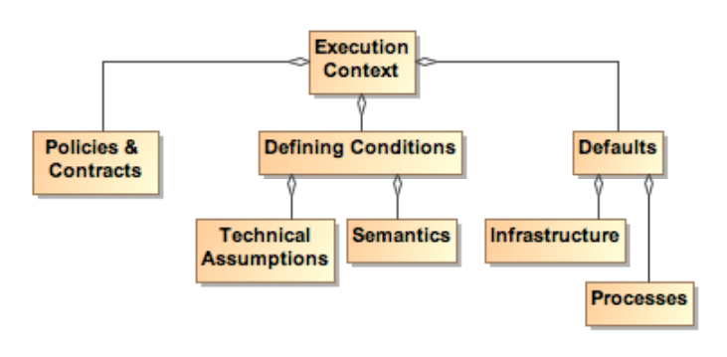
Figure 34 Execution Context
Figure 34 shows a few broad categories found in execution context. These are not meant to be comprehensive. Other items may need to be included to collect a sufficient description of the interaction conditions. Any other items not explicitly noted in the model but needed to set the environment SHOULD be included in the execution context.
While the execution context captures the conditions under which interaction can occur, it does not capture the specific service invocations that do occur in a specific interaction. A service interaction as modeled in Figure 33 introduces the concept of an Interaction Description which is composed of both the Execution Context and an Interaction Log. The execution context specifies the set of conditions under which the interaction occurs and the interaction log captures the sequence of service interactions that occur within the execution context. This sequence should follow the Process Model but can include details beyond those specified there. For example, the Process Model may specify an action that results in identifying a data source, and the identified source is used in a subsequent action. The Interaction Log would record the specific data source used.
The execution context can be thought of as the container in which the interaction occurs and the interaction log captures what happens inside the container. This combination is needed to support auditability and repeatability of the interactions.
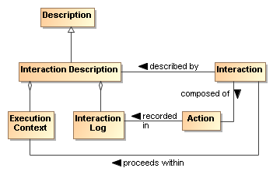
Figure 35 Interaction Description
SOA allows flexibility to accomplish repeatability or reusability. One benefit of this is that a service can be updated without disrupting the user experience of the service. So, Google can improve their ranking algorithm without notifying the user about the details of the update.
However, it may also be vital for the consumer to be able to recreate past results or to generate consistent results in the future, and information such as what conditions, which services, and which versions of those services are used is indispensible in retracing one’s path. The interaction log is a critical part of the resulting real world effects because it defines how the effects were generated and possibly the meaning of observed effects. This increases in importance as dynamic composability becomes more feasible. In essence, a result has limited value if one does not know how it was generated.
The interaction log SHOULD be a detailed trace for a specific interaction, and its reuse is limited to duplicating that interaction. An execution context can act as a template for identical or similar interactions. Any given execution context MAY define the conditions of future interactions.
Such uses of execution context imply (1) a standardized format for capturing execution context and (2) a subclass of general description could be defined to support visibility of saved execution contexts. The specifics of the relevant formats and descriptions are beyond the scope of this Reference Architecture.
A service description is unlikely to track interaction descriptions or the constituent execution contexts or interaction logs that include mention of the service. However, as appropriate, linking to specific instances of either of these could be done through associated annotations.

Relationship to Other Description Models
While the representation shown in Figure 26 is derived from considerations related to service description, it is acknowledged that other metadata standards are relevant and should, as possible, be incorporated into this work. Two standards of particular relevance are the Dublin Core Metadata Initiative (DCMI) and ISO 11179, especially Part 5.
When the service description (or even the general description class) is considered as the DCMI “resource”, Figure 26 aligns nicely with the DCMI resource model. While some differences exist, these are mostly in areas where DCMI goes into detail that is considered beyond the scope of the current Reference Architecture. For example, DCMI defines classes of “shared semantics” whereas this Reference Architecture considers that an identification of relevant semantic models is sufficient. Likewise, the DCMI “description model” goes into the details of possible syntax encodings whereas for the Reference Architecture it is sufficient to identify the relevant formats.
With respect to ISO 11179 Part 5, the metadata fields defined in that reference may be used without prejudice as the properties in Figure 26. Additionally, other defined metadata sets may be used by the service provider if the other sets are considered more appropriate, i.e. it is fundamental to this Reference Architecture to identify the need and the means to make vocabulary declarations explicit but it is beyond the scope to specify which vocabularies are to be used. In addition, the identification of domain of the properties and range of the values has not been included in the current Reference Architecture discussion, but the text of ISO 11179 Part 5 can be used consistently with the model prescribed in this document.
Description as defined in the context of this Reference Architecture considers a wide range of applicability and support of the principles of service oriented architecture. Other metadata models can be used in concert with the model presented here because most of these focus on a finer level of detail that is outside the present scope, and so provide a level of implementation guidance that can be applied as appropriate.

Architectural Implications
The description of service description indicates numerous architectural implications on the SOA ecosystem:
- Description will change over time and its contents will reflect changing needs and context. This requires the existence of:
  - mechanisms to support the storage, referencing, and access to normative definitions of one or more versioning schemes that may be applied to identify different aggregations of descriptive information, where the different schemes may be versions of a versioning scheme itself;
  - configuration management mechanisms to capture the contents of the each aggregation and apply a unique identifier in a manner consistent with an identified versioning scheme;
  - one or more mechanisms to support the storage, referencing, and access to conversion relationships between versioning schemes, and the mechanisms to carry out such conversions.
- Description makes use of defined semantics, where the semantics may be used for categorization or providing other property and value information for description classes. This requires the existence of:
  - semantic models that provide normative descriptions of the utilized terms, where the models may range from a simple dictionary of terms to an ontology showing complex relationships and capable of supporting enhanced reasoning;
  - mechanisms to support the storage, referencing, and access to these semantic models;
  - configuration management mechanisms to capture the normative description of each semantic model and to apply a unique identifier in a manner consistent with an identified versioning scheme;
  - one or more mechanisms to support the storage, referencing, and access to conversion relationships between semantic models, and the mechanisms to carry out such conversions.
- Descriptions include reference to policies defining conditions of use and optionally contracts representing agreement on policies and other conditions. This requires the existence of (as also enumerated under governance):
  - descriptions to enable the policy modules to be visible, where the description includes a unique identifier for the policy and a sufficient, and preferably a machine processible, representation of the meaning of terms used to describe the policy, its functions, and its effects;
  - one or more discovery mechanisms that enable searching for policies that best meet the search criteria specified by the service participant; where the discovery mechanism will have access to the individual policy descriptions, possibly through some repository mechanism;
  - accessible storage of policies and policy descriptions, so service participants can access, examine, and use the policies as defined.
- Descriptions include references to metrics which describe the operational characteristics of the subjects being described. This requires the existence of (as partially enumerated under governance):
  - the infrastructure monitoring and reporting information on SOA resources;
  - possible interface requirements to make accessible metrics information generated or most easily accessed by the service itself;
  - mechanisms to catalog and enable discovery of which metrics are available for a described resources and information on how these metrics can be accessed;
  - mechanisms to catalog and enable discovery of compliance records associated with policies and contracts that are based on these metrics.
- Descriptions of the interactions are important for enabling auditability and repeatability, thereby establishing a context for results and support for understanding observed change in performance or results. This requires the existence of:
  - one or more mechanisms to capture, describe, store, discover, and retrieve interaction logs, execution contexts, and the combined interaction descriptions;
  - one or more mechanisms for attaching to any results the means to identify and retrieve the interaction description under which the results were generated.
- Descriptions may capture very focused information subsets or can be an aggregate of numerous component descriptions. Service description is an example of a likely aggregate for which manual maintenance of all aspects would not be feasible. This requires the existence of:
  - tools to facilitate identifying description elements that are to be aggregated to assemble the composite description;
  - tools to facilitate identifying the sources of information to associate with the description elements;
  - tools to collect the identified description elements and their associated sources into a standard, referenceable format that can support general access and understanding;
  - tools to automatically update the composite description as the component sources change, and to consistently apply versioning schemes to identify the new description contents and the type and significance of change that occurred.
- Descriptions provide up-to-date information on what a resource is, the conditions for interacting with the resource, and the results of such interactions. As such, the description is the source of vital information in establishing willingness to interact with a resource, reachability to make interaction possible, and compliance with relevant conditions of use. This requires the existence of:
  - one or more discovery mechanisms that enable searching for described resources that best meet the criteria specified by a service participant, where the discovery mechanism will have access to individual descriptions, possibly through some repository mechanism;
  - tools to appropriately track users of the descriptions and notify them when a new version of the description is available.

Service Visibility Model
One of the key requirements for participants interacting with each other in the context of a SOA is achieving visibility: before services can interoperate, the participants have to be visible to each other using whatever means are appropriate. The Reference Model analyzes visibility in terms of awareness, willingness, and reachability. In this section, we explore how visibility may be achieved.

Visibility to Business
The relationship of visibility to the SOA ecosystem encompasses both human social structures and automated IT mechanisms. Figure 36 depicts a business setting that is a basis for visibility as related to the Social Structure Model in the Service Ecosystem View (see Section 3.2). Service consumers and service providers may have direct awareness or mediated awareness where mediated awareness is achieved through some third party. A consumer’s willingness to use a service is reflected by the consumer’s presumption of satisfying goals and needs based on the description of the service. Service providers offer capabilities that have real world effects that result in a change in state of the consumer. Reachability of the service by the consumer leads to interactions that change the state of the consumer. The consumer can measure the change of state to determine if the claims made by description and the real world effects of consuming the service meet the consumer’s needs.

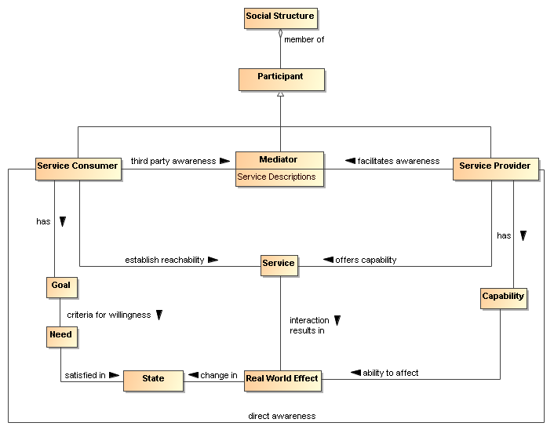
Figure 36 Visibility to Business
Visibility and interoperability in a SOA ecosystem requires more than location and interface information. A meta-model for this broader view of visibility is depicted in Section 4.1. In addition to providing improved awareness of service capabilities through description of information such as reachability, behavior models, information models, functionality, and metrics, the service description may contain policies valuable for determination of willingness to interact.
A mediator of service descriptions may provide event notifications to both consumers and providers about information relating to service descriptions. One example of this capability is a publish/subscribe model where the mediator allows consumers to subscribe to service description version changes made by the provider. Likewise, the mediator may provide notifications to the provider of consumers that have subscribed to service description updates.
Another important business capability in a SOA environment is the ability to narrow visibility to trusted members within a social structure. Mediators for awareness may provide policy based access to service descriptions allowing for the dynamic formation of awareness between trusted members.

Visibility
Attaining visibility is described in terms of steps that lead to visibility. While there can be many contexts for visibility within a single social structure, the same general steps can be applied to each of the contexts to accomplish visibility.
Attaining SOA visibility requires
- service description creation and maintenance,
- processes and mechanisms for achieving awareness of and accessing descriptions,
- processes and mechanisms for establishing willingness of participants,
- processes and mechanisms to determine reachability.
Visibility may occur in stages, i.e. a participant can become aware enough to look or ask for further description, and with this description, the participant can decide on willingness, possibly requiring additional description. For example, if a potential consumer has a need for a tree cutting (business) service, the consumer can use a web search engine to find web sites of providers. The web search engine (a mediator) gives the consumer links to relevant web pages and the consumer can access those descriptions. For those prospective providers that satisfy the consumer's criteria, the consumer's willingness to interact increases. The consumer likely contacts several tree services to get detailed cost information (or arrange for an estimate) and may ask for references (further description). Likely, the consumer will establish full visibility and proceed with the interaction with a tree service who mutually establishes visibility.

Awareness
A service participant is aware of another participant if it has access to a description of that participant with sufficient completeness to establish the other requirements of visibility.
Awareness is inherently a function of a participant; awareness can be established without any action on the part of the target participant other than the target providing appropriate descriptions. Awareness is often discussed in terms of consumer awareness of providers but the concepts are equally valid for provider awareness of consumers.
Awareness can be decomposed into the creation of descriptions, making them available, and discovering the descriptions. Discovery can be initiated or it can be by notification. Initiated discovery for business may require formalization of the required capabilities and resources to achieve business goals.
Achieving awareness in a SOA can range from word of mouth to formal service descriptions in a standards-based registry-repository. Some other examples of achieving awareness in a SOA are the use of a web page containing description information, email notifications of descriptions, and document based descriptions.
A mediator as discussed for awareness is a third party participant that provides awareness to one or more consumers of one or more services. Direct awareness is awareness between a consumer and provider without the use of a third party.
Direct awareness may be the result of having previously established an execution context, or direct awareness may include determining the presence of services and then querying the service directly for description. As an example, a priori visibility of some sensor device may provide the means for interaction or a query for standardized sensor device metadata may be broadcast to multiple locations. If acknowledged, the service interface for the device may directly provide description to a consumer so the consumer can determine willingness to interact.
The same medium for awareness may be direct in one context and may be mediated in another context. For example, a service provider may maintain a web site with links to the provider’s descriptions of services giving the consumers direct awareness to the provider’s services. Alternatively, a community may maintain a mediated web site with links to various provider descriptions of services for any number of consumers. More than one mediator may be involved, as different mediators may specialize in different mediation functions.
Descriptions may be formal or informal. Section 4.1, provides a comprehensive model for service description that can be applied to formal registry/repositories used to mediate visibility. Using consistent description taxonomies and standards based mediated awareness helps provide more effective awareness.

Mediated Awareness
Mediated awareness promotes loose coupling by keeping the consumers and services from explicitly referring to each other and the descriptions. Mediation lets interaction vary independently. Rather than all potential service consumers being informed on a continual basis about all services, there is a known or agreed upon facility or location that houses the service description.
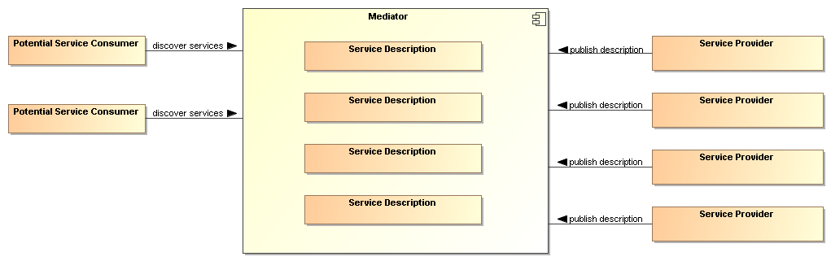
Figure 37 Mediated Service Awareness
In Figure 37, the potential service consumers perform queries or are notified in order to locate those services that satisfy their needs. As an example, the telephone book is a mediated registry where individuals perform manual searches to locate services (i.e. the yellow pages). The telephone book is also a mediated registry for solicitors to find and notify potential customers (i.e. the white pages).
In mediated service awareness for large and dynamic numbers of service consumers and service providers, the benefits typically far outweigh the management issues associated with it. Some of the benefits of mediated service awareness are
- Potential service consumers have a known location for searching thereby eliminating needless and random searches
- Typically a consortium of interested parties (or a sufficiently large corporation) signs up to host the mediation facility
- Standardized tools and methods can be developed and promulgated to promote interoperability and ease of use.
However, mediated awareness can have some risks associated with it:
- A single point of failure. If the central mediation service fails then a potentially large number of service providers and consumers will be adversely affected.
- A single point of control. If the central mediation service is owned by, or controlled by, someone other than the service consumers and/or providers then the latter may be put at a competitive disadvantage based on policies of the discovery provider.
A common mechanism for mediated awareness is a registry-repository. The registry stores links or pointers to service description artifacts. The repository in this example is the storage location for the service description artifacts. Service descriptions can be pushed (publish/subscribe for example) or pulled from the register-repository mediator.
The registry is like a card catalog at the library and a repository is like the shelves for the books. Standardized metadata describing repository content can be stored as registry objects in a registry and any type of content can be stored as repository items in a repository. The registry may be constructed such that description items stored within the mediation facility repository will have intrinsic links in the registry while description items stored outside the mediation facility will have extrinsic links in the registry.
When independent but like SOA IT mechanisms interoperate with one another, the IT mechanisms may be referred to as federated.

Awareness in Complex Social Structures
Awareness applies to one or more communities within one or more social structures where a community consists of at least one description provider and one description consumer. These communities may be part of the same social structure or be part of different ones.
In Figure 38, awareness can be within a single community, multiple communities, or all communities in the social structure. The social structure can encourage or restrict awareness through its policies, and these policies can affect participant willingness. The information about policies should be incorporated in the relevant descriptions. The social structure also governs the conditions for establishing contracts, the results of which will be reflected in the execution context if interaction is to proceed.
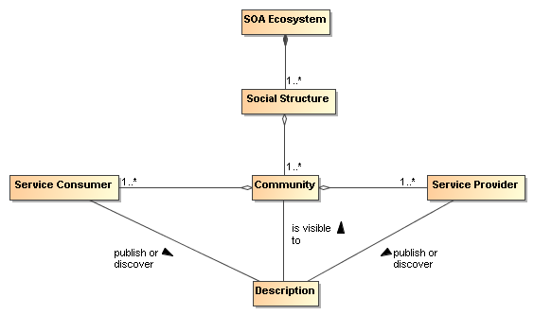
Figure 38 Awareness In a SOA Ecosystem
IT policy/contract mechanisms can be used by visibility mechanisms to provide awareness between communities. The IT mechanisms for awareness may incorporate trust mechanisms to assure awareness between trusted communities. For example, government organizations will often want to limit awareness of an organization’s services to specific communities of interest.
Another common business model for awareness is maximizing awareness to communities within the social structure, the traditional market place business model. A centralized mediator often arises as a provider for this global visibility, a gatekeeper of visibility so to speak. For example, Google is a centralized mediator for accessing information on the web. As another example, television networks have centralized entities providing a level of awareness to communities that otherwise could not be achieved without going through the television network.
However, mediators have motivations, and they may be selective in which information they choose to make available to potential consumers. For example, in a secure environment, the mediator may enforce security policies and make information selectively available depending on the security clearance of the consumers.

Willingness
Having achieved awareness, participants use descriptions to help determine their willingness to interact with another participant. Both awareness and willingness are determined prior to consumer/provider interaction.

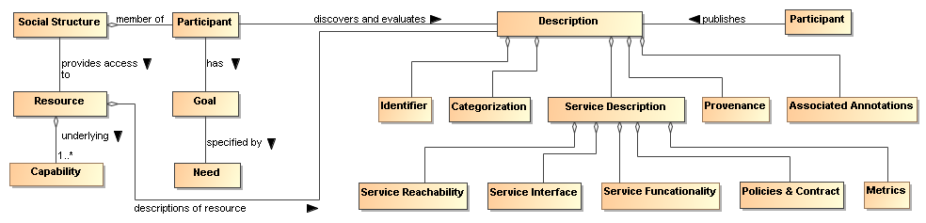
Figure 39 Business, Description and Willingness
Figure 39 relates elements of the Service Ecosystem View, and elements from the Service Description Model to willingness. By having a willingness to interact within a particular social structure, the social structure provides the participant access to capabilities based on conditions the social structure finds appropriate for its context. The participant can use these capabilities to satisfy goals and objectives as specified by the participant’s needs.
In Figure 39, information used to determine willingness is defined by Description. Information referenced by Description may come from many sources. For example, a mediator for descriptions may provide 3rd party annotations for reputation. Another source for reputation may be a participant’s own history of interactions with another participant.
A participant will inspect functionality for potential satisfaction of needs. Identity is associated with any participant, however, identity may or may not be verified. If available, participant reputation may be a deciding factor for willingness to interact. Policies and contracts referenced by the description may be particularly important to determine the agreements and commitments required for business interactions. Provenance may be used for verification of authenticity of a resource.
Mechanisms that aid in determining willingness will likely make use of the artifacts referenced by descriptions of services. Mechanisms for establishing willingness could be as simple as rendering service description information for human consumption to automated evaluation of functionality, policies, and contracts by a rules engine. The rules engine for determining willingness could operate as a policy decision procedure as defined in Section 4.4.

Reachability
Reachability involves knowing the endpoint, protocol, and presence of a service. At a minimum, reachability requires information about the location of the service and the protocol describing the means of communication.
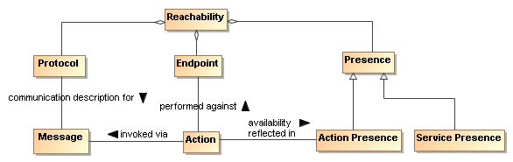
Figure 40 Service Reachability

Endpoint
An endpoint is a reference-able entity, processor or resource against which an action can be performed.
Protocol
A protocol is a structured means by which service interaction is regulated.

Presence
Presence is the measurement of reachability of a service at a particular point in time.
A protocol defines a structured method of communication with a service. Presence is determined by interaction through a communication protocol. Presence may not be known in many cases until the act of interaction begins. To overcome this problem, IT mechanisms may make use of presence protocols to provide the current up/down status of a service.
Service reachability enables service participants to locate and interact with one another. Each action may have its own endpoint and also its own protocols associated with the endpoint and whether there is presence for the action through that endpoint. Presence of a service is an aggregation of the presence of the service’s actions, and the service level may aggregate to some degraded or restricted presence if some action presence is not confirmed. For example, if error processing actions are not available, the service can still provide required functionality if no error processing is needed. This implies reachability relates to each action as well as applying to the service/business as a whole.

Architectural Implications
Visibility in a SOA ecosystem has the following architectural implications on mechanisms providing support for awareness, willingness, and reachability:
- Mechanisms providing support for awareness will likely have the following minimum capabilities:
  - creation of Description, preferably conforming to a standard Description format and structure;
  - publishing of Description directly to a consumer or through a third party mediator;
  - discovery of Description, preferably conforming to a standard for Description discovery;
  - notification of Description updates or notification of the addition of new and relevant Descriptions;
  - classification of Description elements according to standardized classification schemes.
- In a SOA ecosystem with complex social structures, awareness may be provided for specific communities of interest. The architectural mechanisms for providing awareness to communities of interest will require support for:
  - policies that allow dynamic formation of communities of interest;
  - trust that awareness can be provided for and only for specific communities of interest, the bases of which is typically built on keying and encryption technology.
- The architectural mechanisms for determining willingness to interact will require support for:
  - verification of identity and credentials of the provider and/or consumer;
  - access to and understanding of description;
  - inspection of functionality and capabilities;
  - inspection of policies and/or contracts.
- The architectural mechanisms for establishing reachability will require support for:
  - the location or address of an endpoint;
  - verification and use of a service interface by means of a communication protocol;
  - determination of presence with an endpoint which may only be determined at the point of interaction but may be further aided by the use of a presence protocol for which the endpoints actively participate.

Interacting with Services Model
Interaction is the activity involved in using a service to access capability in order to achieve a particular desired real world effect, where real world effect is the actual result of using a service. An interaction can be characterized by a sequence of actions. Consequently, interacting with a service, i.e. performing actions against the service—usually mediated by a series of message exchanges—involves actions performed by the service. Different modes of interaction are possible such as modifying the shared state of a resource. Note that a participant (or agent acting on behalf of the participant) can be the sender of a message, the receiver of a message, or both.

Interaction Dependencies
Recall from the Reference Model that service visibility is the capacity for those with needs and those with capabilities to be able to interact with each other, and that the service interface is the means by which the underlying capabilities of a service are accessed. Ideally, the details of the underlying service implementation are abstracted away by the service interface. [Service] interaction therefore has a direct dependency on the visibility of the service as well as its implementation-neutral interface (see Figure x). Service visibility is composed of awareness, willingness, and reachability and service interface is composed of the information and behavior models. Service visibility is modeled in Section 4.2 while service interface is modeled in Section x.
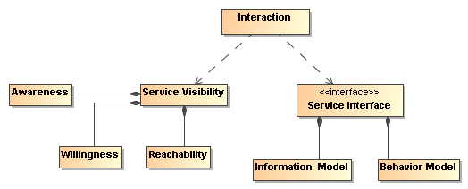
Figure 41 Interaction dependencies.

Actions and Events
For purposes of this Reference Architecture, the authors have committed to the use of message exchange between service participants to denote actions performed against and by the service, and to denote events that report on real world effects that are caused by the service actions. A visual model of the relationship between these concepts is shown in Figure 42.
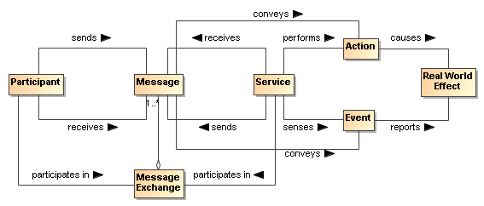
Figure 42 A ''message'' conveys either an action or an event.
A message conveys either an action or an event. In other words, both actions and events, realized by the SOA services, are denoted by the messages. The Reference Model states that the action model characterizes the “permissible set of actions that may be invoked against a service.” We extend that notion here to include events as part of the event model and that messages denote either actions or events.
In Section 3.3, we saw that participants interact with each other in order to perform actions. An action is not itself the same thing as the result of performing the action. When an action is performed against a service, the real world effect that results is reported in the form of events

Message Exchange
Message exchange is the means by which service participants (or their agents) interact with each other. There are two primary modes of interaction: joint actions that cause real world effects, and notification of events that report real world effects.
A message exchange is used to affect an action when the messages contain the appropriately formatted content that should be interpreted as joint action and the agents involved interpret the message appropriately.
A message exchange is also used to communicate event notifications. An event is a report of an occurrence that is of interest to some participant; in our case when some real world effect has occurred. Just as action messages will have formatting requirements, so will event notification messages. In this way, the Information Model of a service must specify the syntax (structure), and semantics (meaning) of the action messages and event notification messages as part of a service interface. It must also specify the syntax and semantics of any data that is carried as part of a payload of the action or event notification message. The Information Model is described in greater detail in the Service Description Model (see Section 4.1).
In addition to the Information Model that describes the syntax and semantics of the messages and data payloads, exception conditions and error handling in the event of faults (e.g., network outages, improper message formats, etc.) must be specified or referenced as part of the Service Description.
When a message is interpreted as an action, the correct interpretation typically requires the receiver to perform a set of operations. These operations represent the sequence of actions (often private) a service must perform in order to validly participate in a given joint action.
Similarly, the correct consequence of realizing a real world effect may be to initiate the reporting of that real world effect via an event notification.
Message Exchange
The means by which joint actions and event notifications are coordinated by service participants (or agents).
Operations
The sequence of actions a service must perform in order to validly participate in a given joint action.

Message Exchange Patterns (MEPs)
As stated earlier, this Reference Architecture commits to the use of message exchange to denote actions against the services, and to denote events that report on real world effects that arise from those actions.
Based on these assumptions, the basic temporal aspect of service interaction can be characterized by two fundamental message exchange patterns (MEPs):
- Request/response to represent how actions cause a real world effect
- Event notification to represent how events report a real world effect
This is by no means a complete list of all possible MEPs used for inter- or intra-enterprise messaging but it does represent those that are most commonly used in exchange of information and reporting changes in state both within organizations and across organizational boundaries, a hallmark of a SOA.
Recall from the OASIS Reference Model that the Process Model characterizes “the temporal relationships between and temporal properties of actions and events associated with interacting with the service.” Thus, MEPs are a key element of the Process Model. The meta-level aspects of the Process Model (just as with the Action Model) are provided as part of the Service Description Model (see Section 4.1).
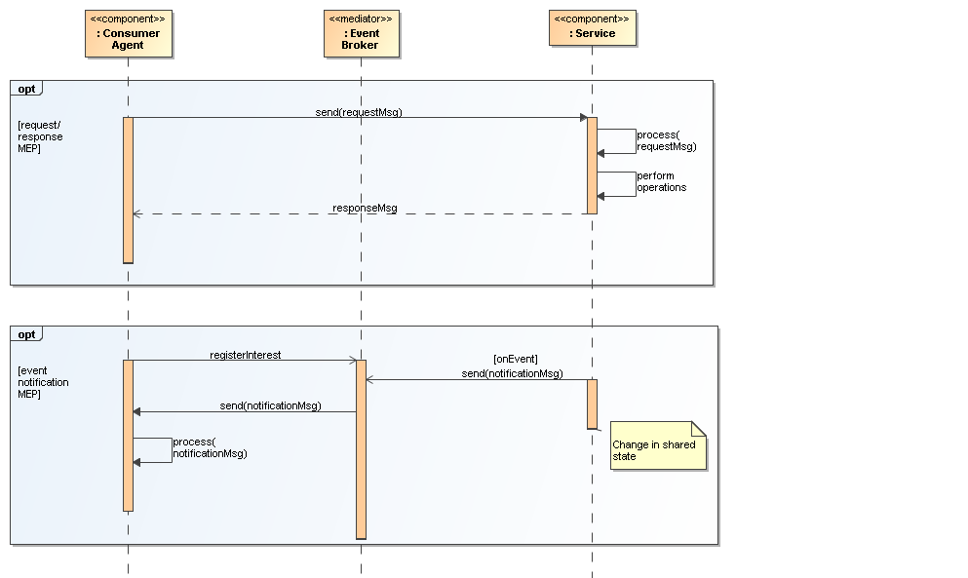
Figure 43 Fundamental SOA message exchange patterns (MEPs)
In the UML sequence diagram shown in Figure 43 it is assumed that the service participants (consumer and provider) have delegated message handling to hardware or software agents acting on their behalf. In the case of the service consumer, this is represented by the Consumer Agent component. In the case of the service provider, the agent is represented by the Service component. The message interchange model illustrated represents a logical view of the MEPs and not a physical view. In other words, specific hosts, network protocols, and underlying messaging system are not shown as these tend to be implementation specific. Although such implementation-specific elements are considered outside the scope of this Reference Architecture, they are important considerations in modeling the SOA execution context. Recall from the Reference Model that the execution context of a service interaction is “the set of infrastructure elements, process entities, policy assertions and agreements that are identified as part of an instantiated service interaction, and thus forms a path between those with needs and those with capabilities.”

Request/Response MEP
In a request/response MEP, the Consumer Agent component sends a request message to the Service component. The Service component then processes the request message. Based on the content of the message, the Service component performs the service operations. Following the completion of these operations, a response message is returned to the Consumer Agent component. The response could be that a step in a process is complete, the initiation of a follow-on operation, or the return of requested information.
Although the sequence diagram shows a synchronous interaction (because the sender of the request message, i.e., Consumer Agent, is blocked from continued processing until a response is returned from the Service) other variations of request/response are valid, including asynchronous (non-blocking) interaction through use of queues, channels, or other messaging techniques.
What is important to convey here is that the request/response MEP represents action, which causes a real world effect, irrespective of the underlying messaging techniques and messaging infrastructure used to implement the request/response MEP.

Event Notification MEP
An event is realized by means of an event notification message exchange that reports a real world effect; specifically, a change in shared state between service participants. The basic event notification MEP takes the form of a one-way message sent by a notifier agent (in this case, the Service component) and received by agents with an interest in the event (here, the Consumer Agent component).
Often the sending agent may not be fully aware of all the agents that will receive the notification; particularly in so-called publish/subscribe (“pub/sub”) situations. In event notification message exchanges, it is rare to have a tightly-coupled link between the sending and the receiving agent(s) for a number of practical reasons. One of the most common is the potential for network outages or communication interrupts that can result in loss of notification of events. Therefore, a third-party agent or service is often used to decouple the sending and receiving agents .
Although this is typically an implementation issue, because this type of third-party decoupling is so common in event-driven systems, we felt that for this Reference Architecture, it was warranted for use in modeling this type of message exchange. This third-party intermediary is shown in Figure 43 as an Event Broker mediator. As with the request/response MEP, no distinction is made between synchronous versus asynchronous communication, although asynchronous message exchange is illustrated in Figure 43 .

Composition of Services
Composition of services is the act of aggregating or “composing” a single service from one or more other services. Before we provide an architectural model of service composition, it is important that we distinguish two fundamentally different types of services, atomic services and composite services.
Atomic Service
A service visible to a service consumer (or agent) via a single interface and described via a single service description that does not use or interact with other services.
Composite Service
A service visible to a service consumer (or agent) via a single interface and described via a single service description that is the aggregation or composition of one or more other services. These other services can be atomic services, other composite services, or a combination of both.
From the consumer’s point of view, the distinction is, of course, mostly irrelevant. The consumer still interacts with a composite service via a single interface and utilizes the meta-level information about the composite service provided by a single Service Description. Nevertheless, there are important dependencies that need to be considered in services that utilize other services such as propagation of policy constraints, security profiles, etc.
A simple model of service composition is illustrated in Figure 44.
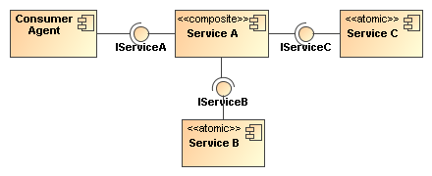
Figure 44 Simple model of service composition ("public” composition).
Here, Service A is a composite service that has an exposed interface IServiceA that is available to the Consumer Agent component and relies on two other service components in its implementation. The Consumer Agent does not know that atomic Services B and C are used by Service A, or whether they are used in serial or parallel, or if their operations succeed or fail. The Consumer Agent only cares about the success or failure of Service A. The exposed interfaces of Services B and C (IService B and IServiceC) are not necessarily hidden from the Consumer Agent; only the fact that these services are used as part of the composition of Service A. In this example, there is no practical reason the Consumer Agent could not interact with Service B or Service C in some other interaction scenario.
It is possible for a service composition to be opaque from one perspective and transparent from another. For example, a service may appear to be a single service from the Consumer Agent’s perspective, but is transparently composed of one or more services from a service management perspective. A Service Management Service needs to be able to have visibility into the composition in order to properly manage the dependencies between the services used in constructing the composite service—including managing the service’s lifecycle. The subject of services as management entities is described and modeled in the Owning Service Oriented Architectures View of this Reference Architecture and will not be further elaborated here. The point to be made here is that there can be different levels of opaqueness or transparency when it comes to visibility of service composition.
Services can be composed in a variety of ways including direct service-to-service interaction by using programming techniques, or they can be aggregated by means of a scripting approach that leverages a service composition scripting language. Such scripting approaches are further elaborated in the following sub-sections on service-oriented business processes and collaborations.

Service-Oriented Business Processes
The concepts of business processes and collaborations in the context of transactions and exchanges across organizational boundaries are described and modeled as part of the Service Ecosystem View of this Reference Architecture (see Section 3). Here, we focus on the belief that the principle of composition of services can be applied to business processes and collaborations. Of course, business processes and collaborations traditionally represent complex, multi-step business functions that may involve multiple participants, including internal users, external customers, and trading partners. Therefore, such complexities cannot simply be ignored when transforming traditional business processes and collaborations to their service-oriented variants.
Business processes are comprised of a set of coherent activities that, when performed in a logical sequence over a period of time and with appropriate rules applied, result in a certain business outcome. Service orientation as applied to business processes (i.e., “service-oriented business processes”) means that the aggregation or composition of all of the abstracted activities, flows, and rules that govern a business process can themselves be abstracted as a service [BLOOMBERG/SCHMELZER].
When business processes are abstracted in this manner and accessed through SOA services, all of the concepts used to describe and model composition of services that were articulated in Section 4.3.4 apply. There are some important differences from a composite service that represents an abstraction of a business process from a composite service that represents a single-step business interaction. As stated earlier, business processes have temporal properties and can range from short-lived processes that execute on the order of minutes or hours to long-lived processes that can execute for weeks, months, or even years. Further, these processes may involve many participants. These are important considerations for the consumer of a service-oriented business process and these temporal properties must be articulated as part of the meta-level aspects of the service-oriented business process in its Service Description, along with the meta-level aspects of any sub-processes that may be of use or need to be visible to the Service Consumer.
In addition, a workflow activity represents a unit of work that some entity acting in a described role (i.e., role player) is asked to perform. Activities can be broken down into steps with each step representing a task for the role player to perform. Based on our earlier assertion that messages denote joint action between service participants, we model these tasks as actions, i.e., message exchanges, which model activities as a collection of action-specific message exchanges. The role player performing a task or sub-task of a particular activity in an overall process flow may actually be a human entity and not a software or hardware agent.
A technique that is used to compose service-oriented business processes that are hierarchical (top-down) and self-contained in nature is known as orchestration.
Orchestration
A technique used to compose hierarchical and self-contained service-oriented business processes that are executed and coordinated by a single agent acting in a “conductor” role.
An orchestration is typically implemented using a scripting approach to compose service-oriented business processes. This typically involves use of a standards-based orchestration scripting language. In terms of automation, an orchestration can be mechanized using a business process orchestration engine, which is a hardware or software component (agent) responsible for acting in the role of central conductor/coordinator responsible for executing the flows that comprise the orchestration.
A simple generic example of such an orchestration is illustrated in Figure 45.
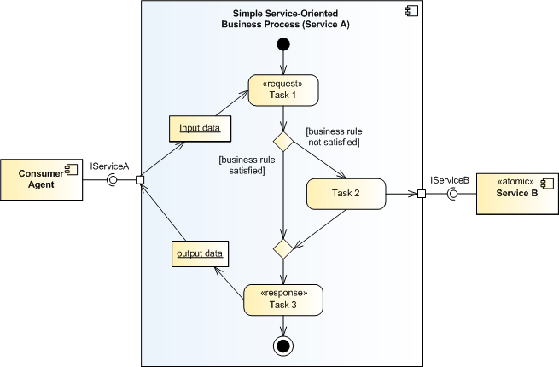
Figure 45 Abstract example of orchestration of service-oriented business process.
Here, we use a UML activity diagram to model the simple service-oriented business process as it allows us to capture the major elements of business processes such as the set of related tasks to be performed, linking between tasks in a logical flow, data that is passed between tasks, and any relevant business rules that govern the transitions between tasks. A task is a unit of work that an individual, system, or organization performs and can be accomplished in one or more steps or subtasks. While subtasks can be readily modeled, they are not illustrated in the orchestration model In Figure 45..
This particular example is based on a request/response MEP and captures how one particular task (Task 2) actually utilizes an externally-provided service, Service B. The entire service-oriented business process is exposed as Service A that is accessible via its externally visible interface, IServiceA.
Although not explicitly shown in the orchestration model above, it is assumed that there exists a software or hardware component, i.e., orchestration engine that executes the process flow. Recall that a central concept to orchestration is that process flow is coordinated and executed by a single conductor agent; hence the name “orchestration.”

Service-Oriented Business Collaborations
Business collaborations typically represent the interaction involved in executing business transactions, where a business transaction is defined in the Service Ecosystem View as “a joint action engaged in by two or more participants in which resources are exchanged” (see Section 3.3.5).
It is important to note that business collaborations represent “peer”-style interactions; in other words, peers in a business collaboration act as equals. This means that unlike the orchestration of business processes, there is no single or central entity that coordinates or “conducts” a business collaboration. These peer styles of interactions typically occur between trading partners that span organizational boundaries.
Business collaborations can also be service-enabled. For purposes of this Reference Architecture, we refer to these as “service-oriented business collaborations.” Service-oriented business collaborations do not necessarily imply exposing the entire peer-style business collaboration as a service itself but rather the collaboration uses service-based interchanges.
The technique that is used to compose service-oriented business collaborations in which multiple parties collaborate in a peer-style as part of some larger business transaction by exchanging messages with trading partners and external organizations (e.g., suppliers) is known as choreography [NEWCOMER/LOMOW].
Choreography
A technique used to characterize and to compose service-oriented business collaborations based on ordered message exchanges between peer entities in order to achieve a common business goal.
Choreography differs from orchestration primarily in that each party in a business collaboration describes its part in the service interaction in terms of public message exchanges that occur between the multiple parties as standard atomic or composite services, rather than as specific service-oriented business processes that a single conductor/coordinator (e.g., orchestration engine) executes. Note that choreography as we have defined it here should not be confused with the term process choreography, which is defined in the Service Ecosystem View as “the description of the possible interactions that may take place between two or more participants to fulfill an objective.” This is an example of domain-specific nomenclature that often leads to confusion and why we are making note of it here.
As is the case of an orchestration, a choreography is typically implemented by using a scripting approach to composing service-oriented business collaborations. This typically involves use of a standards-based choreography scripting language.
A simple generic example of a choreography is illustrated in Figure 46
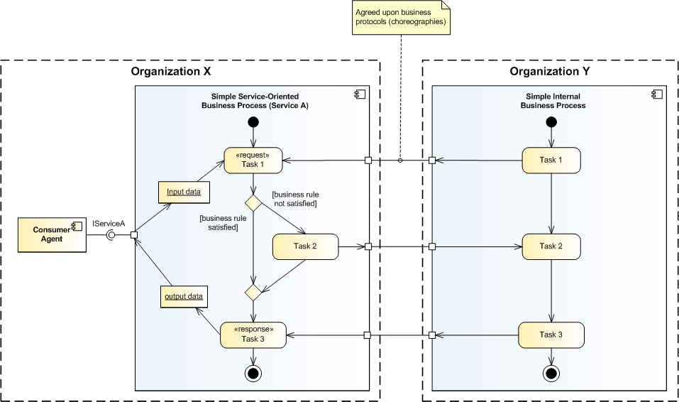
Figure 46 Abstract example of choreography of service-oriented business collaboration.
This example, which is a variant of the orchestration example illustrated earlier in Figure 45 adds trust boundaries between two organizations; namely, Organization X and Organization Y. It is assumed that these two organizations are peer entities that have an interest in a business collaboration, for example, Organization X and Organization Y could be trading partners. Organization X retains the service-oriented business process Service A, which is exposed to internal consumers via its provided service interface, IServiceA. Organization Y also has a business process that is involved in the business collaboration; however, for this example, it is an internal business process that is not exposed to potential consumers either within or outside its organizational boundary.
The scripting language that is used for the choreography needs to define how and when to pass control from one trading partner to another, i.e., Organization X and Organization Y. Defining the business protocols used in the business collaboration involves precisely specifying the visible message exchange behavior of each of the parties involved in the protocol, without revealing internal implementation details [NEWCOMER/LOMOW].
If, a peer-style business collaboration in which visibility into and use of each participating organization’s internal service-oriented business processes was necessary as part of an end-to-end business transaction, then it would be desirable to select a choreography scripting language that would support interaction between different orchestration engines that spans organizational boundaries. WS-CDL is an example of such a language.

Architectural Implications of Interacting with Services
Interacting with Services has the following architectural implications on mechanisms that facilitate service interaction:
- A well-defined service Information Model that:
  - describes the syntax and semantics of the messages used to denote actions and events;
  - describes the syntax and semantics of the data payload(s) contained within messages;
  - documents exception conditions in the event of faults due to network outages, improper message/data formats, etc.;
  - is both human readable and machine processable;
  - is referenceable from the Service Description artifact.
- A well-defined service Behavior Model that:
  - characterizes the knowledge of the actions invokes against the service and events that report real world effects as a result of those actions;
  - characterizes the temporal relationships and temporal properties of actions and events associated in a service interaction;
  - describe activities involved in a workflow activity that represents a unit of work;
  - describes the role(s) that a role player performs in a service-oriented business process or service-oriented business collaboration;
  - is both human readable and machine processable;
  - is referenceable from the Service Description artifact.
- Service composition mechanisms to support orchestration of service-oriented business processes and choreography of service-oriented business collaborations such as:
  - Declarative and programmatic compositional languages;
  - Orchestration and/or choreography engines that support multi-step processes as part of a short-lived or long-lived business transaction;
  - Orchestration and/or choreography engines that support compensating transactions in the presences of exception and fault conditions.
- Infrastructure services that provides mechanisms to support service interaction, including but not limited to:
  - mediation services such as message and event brokers, providers, and/or buses that provide message translation/transformation, gateway capability, message persistence, reliable message delivery, and/or intelligent routing semantics;
  - binding services that support translation and transformation of multiple application-level protocols to standard network transport protocols;
  - auditing and logging services that provide a data store and mechanism to record information related to service interaction activity such as message traffic patterns, security violations, and service contract and policy violations
  - security services that abstract techniques such as public key cryptography, secure networks, virus protection, etc., which provide protection against common security threats in a SOA ecosystem;
  - monitoring services such as hardware and software mechanisms that both monitor the performance of systems that host services and network traffic during service interaction, and are capable of generating regular monitoring reports.
- A layered and tiered service component architecture that supports multiple message exchange patterns (MEPs) in order to:
  - promote the industry best practice of separation of concerns that facilitates flexibility in the presence of changing business requirements;
  - promote the industry best practice of separation of roles in a service development lifecycle such that subject matter experts and teams are structured along areas of expertise;
  - support numerous standard interaction patterns, peer-to-peer interaction patterns, enterprise integration patterns, and business-to-business integration patterns.

Policies and Contracts Model
As described in the Reference Model, a policy is an enforceable constraint or condition on the use, deployment, or description of an owned entity as defined by any participant. A contract is a constraint that has the agreement of the constrained participants.
This Reference Architecture reflects a common separation between mechanism and policy. In many situations it is often simpler to build mechanisms that address a more general problem than the one at hand, and then to use that general mechanism to solve the particular problem. In the case of a SOA ecosystem, the mechanisms focus on the ability to match participants’ needs with service capabilities. However, each particular combination of need and capability is very likely to be distinct; resulting in a large number of circumstances. Policies can be used as a framework for managing this combinatorial explosion.
Policies and contracts have wide applicability within this Reference Architecture. They are used to express security policies, service policies, relationships and constraints within the social structures that encapsulate service participants, management of services and many other instances. The enforcement of a policy or contract may be a part of the SOA-based computing environment or it may be handled outside of the SOA-based computing environment.

Policy and Contract Principles
In the realization of policies and contracts for a SOA, there are common policy principles that will be encountered in many of the standards and/or technology choices used for the realization. Some of these common principles are covered in this section.

Goals of Policies and Contracts
Policies SHOULD reflect the goals of governance or management processes, see Section 5.1 Governance of Service Oriented Architectures and section 5.3 Services as Managed Entities Model. The governance and management processes SHOULD use formal and standardized policy languages to enable the widest possible understanding and use of stated policies and contracts, and architecture components SHOULD be available to enable compliance.

Policy and Contract Specification
The language used to describe policies and contracts inevitably constrains the forms and types of policies and contracts expressible in the description. Formal policy language definitions are outside the scope of this specification. For formal policy languages, standard specifications such as XACML and WS-Policy may be referenced. Policy/Contract descriptions may be associated with a service through the Service Description as defined in Section 4.1 Service Description Model.
Regardless of the language used to describe policies and contracts, there are certain aspects to capture in any system for the representation of policies and contracts such as:
- how to describe atomic policy constraints
- how to nest policy constraints allowing for abstractions and refinements of a policy constraint
- how to reference policy constraints allowing for the reuse of a policy constraint
- how to define alternative policy constraints for the selection of compatible policy constraints between the consumer and provider
- policy versioning
- policy modules

Policy Constraints
Policies are often characterized in terms of permissions or about obligations. An overriding meta-constraint is that policy constraints (likewise contract constraints) MUST be enforceable – a constraint that is not enforceable is not a legitimate element of a system of policies and contracts in the SOA ecosystem.
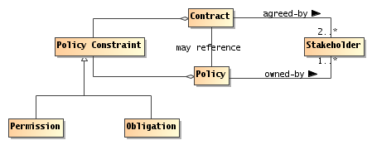
Figure 47 Policies and Contracts
Policy
A policy represents some constraint or condition on the use, deployment or description of a resource as defined by a participant or, more generally, a stakeholder.
Contract
A contract represents an agreement by two or more participants to constrain their behavior and state.
Policy Constraint
A policy constraint is a measurable proposition that characterizes the constraint that the policy is about.
Permission
A permission constraint governs the ability of a participant or other actor to perform an action or enter some specified state.
Permissions may apply to any action that any actor may be able to perform. Note that permissions are distinct from ability and from authority. Authority refers to the legitimate nature of an action, whereas permission refers to the right to perform the action.
Obligation
An obligation constraint governs the requirement that a participant or other actor should perform an action or maintain some specified state.
For example, once the service consumer and provider have entered into an agreement to provide and consume a service, both participants incur obligations: the consumer is obligated to pay for the service and the provider is obligated to provide the service.
Obligations to maintain state may range from a requirement to maintain a minimum balance on an account through a requirement that a service provider ‘remember’ that a particular service consumer is logged in.
A permission-style constraint is about the right to access some resource or perform some action; an obligation-style constraint is about the requirement to perform some action or maintain the state of a resource.
Obligations and Permissions have a positive form and a negative form. A positive permission refers to something that you may do, a negative permission refers to something you should not do.
These are combinable, in the sense that you may have a positive permission constraint (for example, you may use encryption in your messages), whereas a negative permission constraint indicates that there is something you may not do. Similarly, a positive obligation may be something like you must keep the balance of your account positive; whereas an example of a negative obligation may be that the bank will not cover a check for more than the balance in your account.
Permission-style constraints are often checkable a-priori: before the intended action or access is completed the current permission constraints may be applied to deny the access if necessary. However, obligation-style constraints can normally only be verified post-priori.
Policies and contracts can contain a mix of permissions and obligations. The degree with which these can be effectively combined depends on the specific policy management framework in use.
In a business context, contracts are legally binding agreements between two or more parties. A contract is formed when there is an offer that is duly made and the offer is accepted and there is evidence that indicates there was a tangible exchange of value between the two parties. While this Reference Architecture is inclusive of legally binding contracts for a SOA, contracts do not always have to be legally binding agreements.
A contract may include references to policies and other contracts while a policy may include references to contracts and other policies. For example, a contract may reference a set of policies and a policy may prioritize certain contracts over others.

Policy Composition
Multiple policies may be defined for one or more services in one or more ownership domains. The application of policies and contracts over distributed services requires the ability to compose one or more policies into an overarching policy. The composition of policies may be implemented as a hierarchy and/or it can be implemented as intersections and unions of sets.

Conflict Resolution
The analysis of policy rules may result in conflicts between the policy rules. There can be many causes for policy conflicts such as conflicting policy rules between ownership domains and policy language specifications that do not convert to first order predicate logic for IT policy mechanisms. This can cause policy decision results to be indeterminate. Policy administration mechanisms may provide conflict resolution capabilities prior to the storage/distribution of policies. At run time, conflicts may propagate to higher authorities inside or outside the SOA-based IT mechanisms.

Delegation of Policy
Policy authorization may be delegated to agents acting on behalf of a client to enable decentralized policy administration and/or policy enforcement. This allows policies to be administered and/or enforced in a hierarchical fashion. Policies may also be transferred to an agent or resource to effectively allow that agent or resource to separate from an ownership domain. The agent or resource may join another ownership domain or rejoin the same ownership domain at a later time.

Policy Metrics
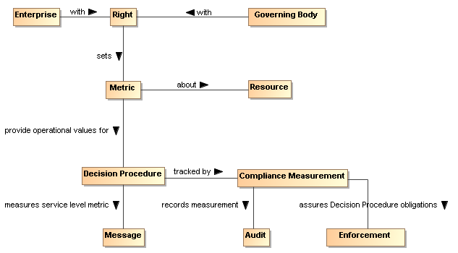
Figure 50 Policy Metrics

Metric
A metric is a policy constraint used to measure compliance.

Metrics are often expressed to measure service performance compliance and regulatory compliance. Service Level Agreements (SLAs) are one commonly used category of contractual compliance. The metrics that comprise a SLA often consist of (Service Level) constraints such as service warranties and remedies or business level constraints such as <business terms and conditions>.

Automating Support for Policies and Contracts
There are many functional `control points’ in a SOA ecosystem; for example, how messages are exchanged, what descriptions should be made available to which participant, what services should be offered and so on.
An effective technique for managing these control points is via policies; together with mechanisms for distributing and applying policies appropriately.
From the IT perspective, high level policies and contracts need to be translated into low level rules and measurable properties that programmatic elements can enforce. For low level rules and measurable properties, both contracts and policies are likely to be enforced by the same type of IT policy mechanisms.

IT Mechanisms Supporting Policies and Contracts
The mechanism for enforcing a permission-oriented constraint is typically prevention at the point of action. The mechanisms for enforcing obligation constraints are typically achieved by a combination of auditing and remedial action.
A common phenomenon of many machines and systems is that they are much broader in their potential than is actually needed for a particular circumstance. As a result, the behavior and performance of the system tend to be under-constrained by the implementation. Policy statements define the choices that a service provider and/or service consumer (or other stakeholder) makes; these choices are used to guide the actual behavior of the system to the desired behavior and performance.
While there are many possible approaches to the realization of policy/contracts for a SOA, one approach based on current policy standardization efforts is depicted in this section. The common policy architectural elements that are provided in this section are based on the minimal mechanisms required to provide policy guided delivery of services within an ownership domain and across ownership domains.

Architectural Implications
While policy and contract descriptions have much of the same architectural implications as described in Service Description, languages and mechanisms supporting policies and contracts also have the following architectural implications:
- Policy and Contract language specifications will typically provide support for the following capabilities:
  - expression of assertion and commitment policy constraints;
  - expression of positive and negative policy constraints;
  - expression of permission and obligation policy constraints;
  - nesting of policy constraints allowing for abstractions and refinements of a policy constraint;
  - definition of alternative policy constraints to allow for the selection of compatible policy constraints for a consumer and provider;
  - composition of policies to combine one or more policies.
- Policy and contract mechanisms in a SOA ecosystem will require the following capabilities:
  - decision procedures which must be able to measure and render decisions on constraints;
  - enforcement of decisions;
  - measurement and notification of obligation constraints;
  - auditability of decisions, enforcement, and obligation measurements;
  - administration of policy and contract language artifacts;
  - storage of policies and contracts;
  - distribution of policies/contracts;
  - conflict resolution or elevation of conflicts in policy rules;
  - delegation of policy authority to agents acting on behalf of a client;
  - decision procedures capable of incorporating roles and/or attributes for rendered decisions.

Owning Service Oriented Architectures View
Governments are instituted among Men,
deriving their just power from the consent of the governed
American Declaration of Independence

The Owning Service Oriented Architectures View focuses on the issues, requirements and responsibilities involved in owning a SOA-based system.
Owning a SOA-based system raises significantly different challenges to owning other complex systems -- such as Enterprise suites -- because there are strong limits on the control and authority of any one party when a system spans multiple ownership domains.
Even when a SOA-based system is deployed internally within an organization, there are multiple internal stakeholders involved and there may not be a simple hierarchy of control and management. Thus, an early consideration of how multiple boundaries affect SOA-based systems will provide a firm foundation for dealing with them in whatever form they are found rather than debating whether the boundaries should exist.
This view focuses on the Governance of SOA-based systems, on the security challenges involved in running a SOA-based system and the management challenges.
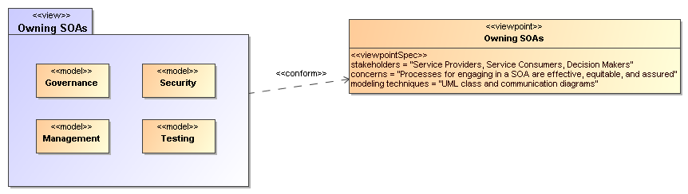
Figure 48 Model Elements Described in the Owning Service Oriented Architectures View
The following subsections present models of these functions.

Governance Model
The Reference Model defines Service Oriented Architecture as an architectural paradigm for organizing and utilizing distributed capabilities that may be under the control of different ownership domains [SOA-RM]. Consequently, it is important that organizations that plan to engage in service interactions adopt governance policies and procedures sufficient to ensure that there is standardization across both internal and external organizational boundaries to promote the effective creation and use of SOA-based services.

Understanding Governance

Terminology
Governance is about making decisions that are aligned with the overall organizational strategy and culture of the enterprise. [Gartner] It specifies the decision rights and accountability framework to encourage desirable behaviors [Weill/Ross-MIT Sloan School] towards realizing the strategy and defines incentives (positive or negative) towards that end. It is less about overt control and strict adherence to rules, and more about guidance and effective and equitable usage of resources to ensure sustainability of an organization’s strategic objectives. [TOGAF v8.1]
To accomplish this, governance requires organizational structure and processes and must identify who has authority to define and carry out its mandates. It must address the following questions: 1) what decisions must be made to ensure effective management and use?, 2) who should make these decisions?, and 3) how will these decisions be made and monitored? , and (4) how will these decisions be communicated? The intent is to achieve goals, add value, and reduce risk.
Within a single ownership domain such as an enterprise, generally there is a hierarchy of governance structures. Some of the more common enterprise governance structures include corporate governance, technology governance, IT governance, and architecture governance [TOGAF v8.1]. These governance structures can exist at multiple levels (global, regional, and local) within the overall enterprise.
It is often asserted that SOA governance is a specialization of IT governance as there is a natural hierarchy of these types of governance structures; however, the focus of SOA governance is less on decisions to ensure effective management and use of IT as it is to ensure effective management and use of SOA-based systems. Certainly, SOA governance must still answer the basic questions also associated with IT governance, i.e., who should make the decisions, and how these decisions will be made and monitored.

Relationship to Management
There is often confusion centered on the relationship between governance and management. As described earlier, governance is concerned with decision making. Management, on the other hand, is concerned with execution. Put another way, governance describes the world as leadership wants it to be; management executes activities that intends to make the leadership’s desired world a reality. Where governance determines who has the authority and responsibility for making decisions and the establishment of guidelines for how those decisions should be made, management is the actual process of making, implementing, and measuring the impact of those decisions [Loeb]. Consequently, governance and management work in concert to ensure a well-balanced and functioning organization as well as an ecosystem of inter-related organizations. In the sections that follow, we elaborate further on the relationship between governance and management in terms of setting and enforcing service policies, contracts, and standards as well as addressing issues surrounding regulatory compliance.

Why is SOA Governance Important?
One of the hallmarks of SOA that distinguishes it from other architectural paradigms for distributed computing is the ability to provide a uniform means to offer, discover, interact with and use capabilities (as well the ability to compose new capabilities from existing ones) all in an environment that transcends domains of ownership. Consequently, ownership, and issues surrounding it, such as obtaining acceptable terms and conditions (T&Cs) in a contract, is one of the primary topics for SOA governance. Generally, IT governance does not include T&Cs, for example, as a condition of use as its primary concern.
Just as other architectural paradigms, technologies, and approaches to IT are subject to change and evolution, so too is SOA. Setting policies that allow change management and evolution, establishing strategies for change, resolving disputes that arise, and ensuring that SOA-based systems continue to fulfill the goals of the business are all reasons why governance is important to SOA.

Governance Stakeholders and Concerns
As noted in Section 3.3.1 the participants in a service interaction include the service provider, the service consumer, and other interested or unintentional third parties. Depending on the circumstances, it may also include the owners of the underlying capabilities that the SOA services access. Governance must establish the policies and rules under which duties and responsibilities are defined and the expectations of participants are grounded. The expectations include transparency in aspects where transparency is mandated, trust in the impartial and consistent application of governance, and assurance of reliable and robust behavior throughout the SOA ecosystem.

A Generic Model for Governance
Governance
Governance is the prescribing of conditions and constraints consistent with satisfying common goals and the structures and processes needed to define and respond to actions taken towards realizing those goals.
The following is a generic model of governance represented by segmented models that begin with motivation and proceed through measuring compliance. It is not meant to be an all-encompassing treatise on governance but a focused subset that captures the aspects necessary to describe governance for SOA. It is also not meant to imply that practical application of governance is a single, isolated instance of these models; in fact, there are likely hierarchical chains of governance that apply and possibly parallel chains that govern different aspects or focus on different goals. This is discussed further in section 5.1.2.5. The defined models are simultaneously applicable to each of the overlapping instances.
A given enterprise may already have portions of these models in place. To a large extent, the models shown here are not specific to SOA; discussions on direct applicability begin in section 5.1.3.

Motivating Governance
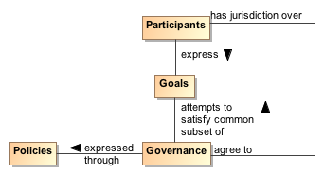
Figure 49 Motivating governance model
An organizational domain such as an enterprise is made up of Participants who may be individuals or groups of individuals forming smaller organizational units within the enterprise. The overall business strategy should be consistent with the Goals of the participants; otherwise, the business strategy would not provide value to the participants and governance towards those ends becomes difficult if not impossible. This is not to say that an instance of governance will simultaneously satisfy all the goals of all the participants; rather, the goals of any governance instance must sufficiently satisfy a useful subset of each participant's goals so as to provide value and ensure the cooperation of all the participants.
A policy is the formal characterization of the conditions and constraints that governance deems as necessary to realize the goals which it is attempting to satisfy. Policy may identify required conditions or actions or may prescribe limitations or other constraints on permitted conditions or actions. For example, a policy may prescribe that safeguards must be in place to prevent unauthorized access to sensitive material. It may also prohibit use of computers for activities unrelated to the specified work assignment. Policy is made operational through the promulgating and implementing of Rules and Regulations (as defined in section 5.1.2.3).
As noted in section 4.4.2, policy may be asserted by any participant or on behalf of the participant by its organization. Part of the purpose of governance is to arbitrate among diverse goals of participants and diverse policies articulated to realize those goals. The intent is to form a consistent whole that allows governance to minimize ambiguity about its purpose. While resolving all ambiguity would be an ideal, it is unlikely that all inconsistencies will be identified and resolved before governance becomes operational.
For governance to have effective jurisdiction over participants, there must be some degree of agreement by each participant that it will abide by the governance mandates. A minimal degree of agreement often presages participants who “slow-roll” if not actively reject complying with Policies that express the specifics of governance.

Setting Up Governance
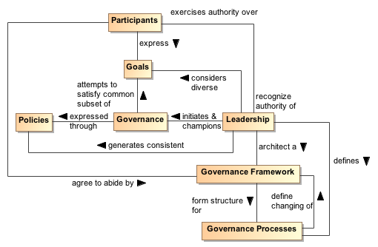
Figure 50 Setting up governance model
Leadership
Leadership is the entity who has the responsibility and authority to generate consistent policies through which the goals of governance can be expressed and to define and champion the structures and processes through which governance is realized.
Governance Framework
The Governance Framework is a set of organizational structures that enable governance to be consistently defined, clarified, and as needed, modified to respond to changes in its domain of concern.
Governance Processes
Governance Processes are the defined set of activities that are performed within the Governance Framework to enable the consistent definition, application, and as needed, modification of Rules that organize and regulate the activities of Participants for the fulfillment of expressed policies. (See section 5.1.2.3 for elaboration on the relationship of Governance Processes and Rules.)
As noted earlier, governance requires an appropriate organizational structure and identification of who has authority to make governance decisions. In Figure 50, the entity with governance authority is designated the Leadership. This is someone, possibly one or more of the Participants, that Participants recognize as having authority for a given purpose or over a given set of issues or concerns.
The Leadership is responsible for prescribing or delegating a working group to prescribe the Governance Framework that forms the structure for Governance Processes which define how governance is to be carried out. This does not itself define the specifics of how governance is to be applied, but it does provide an unambiguous set of procedures that should ensure consistent actions which Participants agree are fair and account for sufficient input on the subjects to which governance will be applied.
The Participants may be part of the working group that codifies the Governance Framework and Processes. When complete, the Participants must acknowledge and agree to abide by the products generated through application of this structure.
The Governance Framework and Processes are often documented in the charter of a body created or designated to oversee governance. This is discussed further in the next section. Note that the Governance Processes should also include those necessary to modify the Governance Framework itself.
An important function of Leadership is not only to initiate but also be the consistent champion of governance. Those responsible for carrying out governance mandates must have Leadership who makes it clear to Participants that expressed Policies are seen as a means to realizing established goals and that compliance with governance is required.

Carrying Out Governance
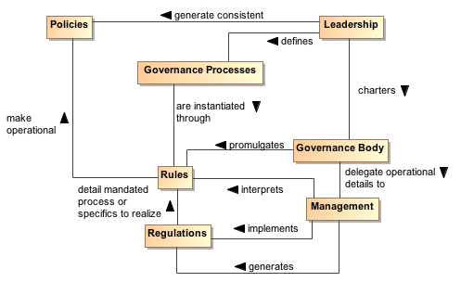
Figure 51 Carrying out governance model
Rule
A Rule is a prescribed guide for carrying out activities and processes leading to desired results, e.g. the operational realization of policies.
Regulation
A Regulation is a mandated process or the specific details that derive from the interpretation of Rules and lead to measureable quantities against which compliance can be measured.
To carry out governance, Leadership charters a Governance Body to promulgate the Rules needed to make the Policies operational. The Governance Body acts in line with Governance Processes for its rule-making process and other functions. Whereas Governance is the setting of Policies and defining the Rules that provide an operational context for Policies, the operational details of governance are likely delegated by the Governance Body to Management. Management generates Regulations that specify details for Rules and other procedures to implement both Rules and Regulations. For example, Leadership could set a Policy that all authorized parties should have access to data, the Governance Body would promulgate a Rule that PKI certificates are required to establish identity of authorized parties, and Management can specify a Regulation of who it deems to be a recognized PKI issuing body. In summary, Policy is a predicate to be satisfied and Rules prescribe the activities by which that satisfying occurs. A number of rules may be required to satisfy a given policy; the carrying out of a rule may contribute to several policies being realized.
Whereas the Governance Framework and Processes are fundamental for having Participants acknowledge and commit to compliance with governance, the Rules and Regulations provide operational constraints which may require resource commitments or other levies on the Participants. It is important for Participants to consider the framework and processes to be fair, unambiguous, and capable of being carried out in a consistent manner and to have an opportunity to formally accept or ratify this situation. Rules and Regulations, however, do not require individual acceptance by any given participant although some level of community comment is likely to be part of the Governance Processes. Having agreed to governance, the Participants are bound to comply or be subject to prescribed mechanisms for enforcement.

Ensuring Governance Compliance
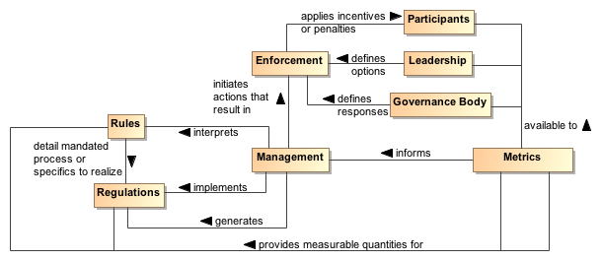
Figure 52 Ensuring governance compliance model
Setting Rules and Regulations does not ensure effective governance unless compliance can be measured and Rules and Regulations can be enforced. Metrics are those conditions and quantities that can be measured to characterize actions and results. Rules and Regulations MUST be based on collected Metrics or there will be no way for Management to assess compliance. The Metrics are available to the Participants, the Leadership, and the Governance Body so what is measured and the results of measurement are clear to everyone.
The Leadership in its relationship with Participants will have certain options that can be used for Enforcement. A common option may be to effect future funding. The Governance Body defines specific enforcement responses, such as what degree of compliance is necessary for full funding to be restored. It is up to Management to identify compliance shortfalls and to initiate the Enforcement process.
Note, enforcement does not strictly need to be negative consequences. Management can use Metrics to identify exemplars of compliance and Leadership can provide options for rewarding the Participants. It is likely the Governance Body that defines awards or other incentives.

Considerations for Multiple Governance Chains
As noted in section 5.1.2, instances of the governance model often occur as a tiered arrangement, with governance at some level delegating specific authority and responsibility to accomplish a focused portion of the original level’s mandate. For example, a corporation may encompass several lines of business and each line of business governs its own affairs in a manner that is consistent with and contributes to the goals of the parent organization. Within the line of business, an IT group may be given the mandate to provide and maintain IT resources, giving rise to IT governance.
In addition to tiered governance, there are likely to be multiple governance chains working in parallel. For example, a company making widgets likely has policies intended to ensure they make high quality widgets and make an impressive profit for their shareholders. On the other hand, Sarbanes-Oxley is a parallel governance chain in the United States that specifies how the management must handle its accounting and information that needs to be given to its shareholders. The parallel chains may just be additive or may be in conflict and require some harmonization.
Being distributed and representing different ownership domains, a SOA participant is likely under the jurisdiction of multiple governance domains simultaneously and may individually need to resolve consequent conflicts. The governance domains may specify precedence for governance conformance or it may fall to the discretion of the participant to decide on the course of actions they believe appropriate.

Governance Applied to SOA

Where SOA Governance is Different
SOA governance is often discussed in terms of IT governance, but rather than a parent-child relationship, Figure 53 shows the two as siblings of the general governance described in section 5.1.2. There are obvious dependencies and a need for coordination between the two, but the idea of aligning IT with business already demonstrates that resource providers and resource consumers must be working towards common goals if they are to be productive and efficient. While SOA governance will be shown to be active in the area of infrastructure, it is a specialized concern for having a dependable platform to support service interaction; a host of traditional IT issues is considered to be out of scope. A SOA governance plan for an enterprise will not resolve shortcomings with the enterprise IT governance.
Governance in the context of SOA is that organization of services: that promotes their visibility; that facilitates interaction among service participants; and that directs that the results of service interactions are those real world effects as described within the service description and constrained by policies and contracts as assembled in the execution context.
SOA governance must specifically account for control across different ownership domains, i.e. all the participants may not be under the jurisdiction of a single governance authority. However, for governance to be effective, the participants must agree to recognize the authority of the Governance Body and must operate within the Governance Framework and through the Governance Processes so defined.
SOA governance must account for interactions across ownership boundaries, which likely also implies across enterprise governance boundaries. For such situations, governance emphasizes the need for agreement that some Governance Framework and Governance Processes have jurisdiction, and the governance defined must satisfy the Goals of the Participants for cooperation to continue. A standards development organization such as OASIS is an example of voluntary agreement to governance over a limited domain to satisfy common goals.
The specifics discussed in the figures in the previous sections are equally applicable to governance across ownership boundaries as it is within a single boundary. There is a charter agreed to when Participants become members of the organization, and this charter sets up the structures and processes that will be followed. Leadership may be shared by the leadership of the overall organization and the leadership of individual groups themselves chartered per the Governance Processes. There are Rules/Regulations specific to individual efforts for which Participants agree to local goals, and Enforcement can be loss of voting rights or under extreme circumstances, expulsion from the group.
Thus, the major difference for SOA governance is an appreciation for the cooperative nature of the enterprise and its reliance on furthering common goals if productive participation is to continue.

What Must be Governed
An expected benefit of employing SOA principles is the ability to quickly bring resources to bear to deal with unexpected and evolving situations. This requires a great deal of confidence in the underlying capabilities that can be accessed and in the services that enable the access. It also requires considerable flexibility in the ways these resources can be employed. Thus, SOA governance requires establishing confidence and trust while instituting a solid framework that enables flexibility, indicating a combination of strict control over a limited set of foundational aspects but minimum constraints beyond those bounds.

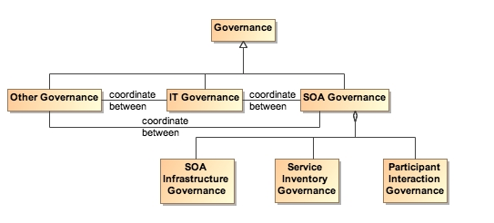
Figure 53 Relationship among types of governance
SOA governance applies to three aspects of service definition and use:
- SOA infrastructure – the “plumbing” that provides utility functions that enable and support the use of the service
- Service inventory – the requirements on a service to permit it to be accessed within the infrastructure
- Participant interaction – the consistent expectations with which all participants are expected to comply

Governance of SOA Infrastructure
The SOA infrastructure is likely composed of several families of SOA services that provide access to fundamental computing business services. These include, among many others, services such as messaging, security, storage, discovery, and mediation. The provisioning of an infrastructure on which these services may be accessed and the general realm of those contributing as utility functions of the infrastructure are a traditional IT governance concern. In contrast, the focus of SOA governance is how the existence and use of the services enables the SOA ecosystem.
By characterizing the environment as containing families of SOA services, the assumption is that there may be multiple approaches to providing the business services or variations in the actual business services provided. For example, discovery could be based on text search, on metadata search, on approximate matches when exact matches are not available, and numerous other variations. The underlying implementation of search algorithms are not the purview of SOA governance, but the access to the resulting service infrastructure enabling discovery must be stable, reliable, and extremely robust to all operating conditions. Such access enables other specialized SOA services to use the infrastructure in dependable and predictable ways, and is where governance is important.

Governance of the Service Inventory
Given an infrastructure in which other SOA services can operate, a key governance issue is which SOA services to allow in the ecosystem. The major concern SHOULD be a definition of well-behaved services, where the required behavior will likely inherit their characteristics from experiences with distributed computing but will also evolve with SOA experience. A major requirement for ensuring well-behaved services is collecting sufficient metrics to know how the service affects the SOA infrastructure and whether it complies with established infrastructure policies.
Another common concern of service approval is whether there will be duplication of function by multiple services. Some governance models talk to a tightly controlled environment where a primary concern is to avoid any service duplication. Other governance models talk to a market of services where the consumers have wide choices. For the latter, it is anticipated that the better services will emerge from market consensus and the availability of alternatives will drive innovation.
It is likely that some combination of control and openness will emerge, possibly with a different appropriate balance for different categories of use. For SOA governance, the issue is less which services are approved but rather ensuring that sufficient description is available to support informed decisions for appropriate use. Thus, SOA governance SHOULD concentrate on identifying the required attributes to adequately describe a service, the required target values of the attributes, and the standards for defining the meaning of the attributes and their target values. Governance may also specify the processes by which the attribute values are measured and the corresponding certification that some realized attribute set may imply.
For example, unlimited access for using a service may require a degree of life cycle maturity that has demonstrated sufficient testing over a certain size community. Alternately, the policy may specify that a service in an earlier phase of its life cycle may be made available to a smaller, more technically sophisticated group in order to collect the metrics that would eventually allow the service to advance its life cycle status.
This aspect of governance is tightly connected to description because, given a well-behaved set of services, it is the responsibility of the consumer (or policies promulgated by the consumer’s organization) to decide whether a service is sufficient for that consumer’s intended use. The goal is to avoid global governance specifying criteria that are too restrictive or too lax for the local needs of which global governance has little insight.
Such an approach to specifying governance allows independent domains to describe services in local terms while still having the services available for informed use across domains. In addition, changes to the attribute sets within a domain can be similarly described, thus supporting the use of newly described resources with the existing ones without having to update the description of all the legacy content.

Governance of Participant Interaction
Finally, given a reliable services infrastructure and a predictable set of services, the third aspect of governance is prescribing what is required during a service interaction.
Governance would specify adherence to service interface and service reachability parameters and would require that the result of an interaction MUST correspond to the real world effects as contained in the service description. Governance would ensure preconditions for service use are satisfied, in particular those related to security aspects such as user authentication, authorization, and non-repudiation. If conflicts arise, governance would specify resolution processes to ensure appropriate agreements, policies, and conditions are met.
It would also rely on sufficient monitoring by the SOA infrastructure to ensure services remain well-behaved during interactions, e.g. do not use excessive resources or exhibit other prohibited behavior. Governance would also require that policy agreements as documented in the execution context for the interaction are observed and that the results and any after effects are consistent with the agreed policies. It is likely that in this area the governance will focus on more contractual and legal aspects rather than the precursor descriptive aspects. SOA governance may prescribe the processes by which SOA-specific policies are allowed to change, but there are likely more business-specific policies that will be governed by processes outside SOA governance.

Overarching Governance Concerns
There are numerous governance related concerns whose effects span the three areas just discussed. One is the area of standards, how these are mandated, and how the mandates may change. The Web Services standards stack is an example of relevant standards where a significant number are still under development. In addition, while there are notional scenarios that guide what standards are being developed, the fact that many of these standards do not yet exist precludes operational testing of their adequacy or effectiveness as a necessary and sufficient set.
That said, standards are critical to creating a SOA ecosystem where SOA services can be introduced, used singularly, and combined with other services to deliver complex business functionality. As with other aspects of SOA governance, the Governance Body should identify the minimum set felt to be needed and rigorously enforce that that set be used where appropriate. The Governance Body must take care to expand and evolve the mandated standards in a predictable manner and with sufficient technical guidance that new services will be able to coexist as much as possible with the old, and changes to standards do not cause major disruptions.
Another area that may see increasing activity as SOA expands will be additional regulation by governments and associated legal institutions. New laws are likely that will deal with transactions which are service based, possibly including taxes on the transactions. Disclosures laws are likely to mandate certain elements of description so both the consumer and provider act in a predictable environment and are protected from ambiguity in intent or action. Such laws are likely to spawn rules and regulations that will influence the metrics collected for evaluation of compliance.

Considerations for SOA Governance
The Reference Architecture definition of a loosely coupled system is one in which the constraints on the interactions between components is minimal: sufficient to permit interoperation without additional constraints that may be an artifact of implementation technology. While governance experience for standalone systems provides useful guides, we must be careful not to apply constraints that would preclude the flexibility, agility, and adaptability we expect to realize from a SOA ecosystem.
One of the strengths of SOA is it can make effective use of diversity rather than requiring monolithic solutions. Heterogeneous organizations can interact without requiring each conforms to uniform tools, representation, and processes. However, with this diversity comes the need to adequately define those elements necessary for consistent interaction among systems and participants, such as which communication protocol, what level of security, which vocabulary for payload content of messages. The solution is not always to lock down these choices but to standardize alternatives and standardize the representations through which an unambiguous identification of the alternative chosen can be conveyed. For example, the URI standard specifies the URI string, including what protocol is being used, what is the target of the message, and how may parameters be attached. It does not limit the available protocols, the semantics of the target address, or the parameters that can be transferred. Thus, as with our definition of loose coupling, it provides absolute constraints but minimizes which constraints it imposes.
There is not a one-size-fits-all governance but a need to understand the types of things governance will be called on to do in the context of the goals of SOA. It is likely that some communities will initially desire and require very stringent governance policies and procedures while other will see need for very little. Over time, best practices will evolve, likely resulting in some consensus on a sensible minimum and, except in extreme cases where it is demonstrated to be necessary, a loosening of strict governance toward the best practice mean.
A question of how much governance may center on how much time governance activities require versus how quickly is the system being governed expected to respond to changing conditions. For large single systems that take years to develop, the governance process could move slowly without having a serious negative impact. For example, if something takes two years to develop and the steps involved in governance take two months to navigate, then the governance can go along in parallel and may not have a significant impact on system response to changes. Situations where it takes as long to navigate governance requirements as it does to develop a response are examples where governance may need to be reevaluated as to whether it facilitates or inhibits the desired results. Thus, the speed at which services are expected to appear and evolve needs to be considered when deciding the processes for control. The added weight of governance should be appropriate for overall goals of the application domain and the service environment.
Governance, as with other aspects of any SOA implementation, should start small and be conceptualized in a way that keeps it flexible, scalable, and realistic. A set of useful guidelines would include:
- Do not hardwire things that will inevitably change. For example, develop a system that uses the representation of policies rather than code the policies into the implementations.
- Avoid setting up processes that demo well for three services without considering how it will work for 300. Similarly, consider whether the display of status and activity for a small number of services will also be effective for an operator in a crisis situation looking at dozens of services, each with numerous, sometimes overlapping and sometimes differing activities.
- Maintain consistency and realism. A service solution responding to a natural disaster cannot be expected to complete a 6-week review cycle but be effective in a matter of hours.

Architectural Implications of SOA Governance
The description of SOA governance indicates numerous architectural requirements on the SOA ecosystem:
- Governance is expressed through policies and assumes multiple use of focused policy modules that can be employed across many common circumstances. This requires the existence of:
  - descriptions to enable the policy modules to be visible, where the description includes a unique identifier for the policy and a sufficient, and preferably a machine process-able, representation of the meaning of terms used to describe the policy, its functions, and its effects;
  - one or more discovery mechanisms that enable searching for policies that best meet the search criteria specified by the service participant; where the discovery mechanism will have access to the individual policy descriptions, possibly through some repository mechanism;
  - accessible storage of policies and policy descriptions, so service participants can access, examine, and use the policies as defined.
- Governance requires that the participants understand the intent of governance, the structures created to define and implement governance, and the processes to be followed to make governance operational. This requires the existence of:
  - an information collection site, such as a Web page or portal, where governance information is stored and from which the information is always available for access;
  - a mechanism to inform participants of significant governance events, such as changes in policies, rules, or regulations;
  - accessible storage of the specifics of Governance Processes;
  - SOA services to access automated implementations of the Governance Processes
- Governance policies are made operational through rules and regulations. This requires the existence of:
  - descriptions to enable the rules and regulations to be visible, where the description includes a unique identifier and a sufficient, and preferably a machine process-able, representation of the meaning of terms used to describe the rules and regulations;
  - one or more discovery mechanisms that enable searching for rules and regulations that may apply to situations corresponding to the search criteria specified by the service participant; where the discovery mechanism will have access to the individual descriptions of rules and regulations, possibly through some repository mechanism;
  - accessible storage of rules and regulations and their respective descriptions, so service participants can understand and prepare for compliance, as defined.
  - SOA services to access automated implementations of the Governance Processes.
- Governance implies management to define and enforce rules and regulations. Management is discussed more specifically in section Error: Reference source not found, but in a parallel to governance, management requires the existence of:
  - an information collection site, such as a Web page or portal, where management information is stored and from which the information is always available for access;
  - a mechanism to inform participants of significant management events, such as changes in rules or regulations;
  - accessible storage of the specifics of processes followed by management.
- Governance relies on metrics to define and measure compliance. This requires the existence of:
  - the infrastructure monitoring and reporting information on SOA resources;
  - possible interface requirements to make accessible metrics information generated or most easily accessed by the service itself.

Security Model
Security is one aspect of confidence – the confidence in the integrity, reliability, and confidentiality of the system. In particular, security focuses on those aspects of assurance that involve the accidental or malign intent of other people to damage or compromise trust in the system and on the availability of SOA-based systems to perform desired capability.
Security
Security concerns the set of mechanisms for ensuring and enhancing trust and confidence in the SOA ecosystem.
Providing for security for Service Oriented Architecture is somewhat different than for other contexts; although many of the same principles apply equally to SOA and to other systems. The fact that SOA embraces crossing ownership boundaries makes the issues involved with moving data more visible.
As well as securing the movement of data within and across ownership boundaries, security often revolves around resources: the need to guard certain resources against inappropriate access – whether reading, writing or otherwise manipulating those resources. The basic resource model that informs our discussion is outlined in Section 3.3.3.
Any comprehensive security solution must take into account the people that are using, maintaining and managing the SOA. Furthermore, the relationships between them must also be incorporated: any security assertions that may be associated with particular interactions originate in the people that are behind the interaction.
We analyze security in terms of the social structures that define the legitimate permissions, obligations and roles of people in relation to the system, and mechanisms that must be put into place to realize a secure system. The former are typically captured in a series of security policy statements; the latter in terms of security guards that ensure that policies are enforced.
How and when to apply these derived security policy mechanisms is directly associated with the assessment of the threat model and a security response model. The threat model identifies the kinds of threats that directly impact the message and/or application of constraints, and the response model is the proposed mitigation to those threats. Properly implemented, the result can be an acceptable level of risk to the safety and integrity of the system.

Secure Interaction Concepts
We can characterize secure interactions in terms of key security concepts [ISO/IEC 27002]: confidentiality, integrity, authentication, authorization, non-repudiation, and availability. The concepts for secure interactions are well defined in other standards and publications. The security concepts here are not defined but rather related to the SOA ecosystem perspective of this reference architecture foundation.

Confidentiality
Confidentiality concerns the protection of privacy of participants in their interactions. Confidentiality refers to the assurance that unauthorized entities are not able to read messages or parts of messages that are transmitted.
Note that confidentiality has degrees: in a completely confidential exchange, third parties would not even be aware that a confidential exchange has occurred. In a partially confidential exchange, the identities of the participants may be known but the content of the exchange obscured.

Integrity
Integrity concerns the protection of information that is exchanged – either from unauthorized writing or inadvertent corruption. Integrity refers to the assurance that information that has been exchanged has not been altered.
Integrity is different from confidentiality in that messages that are sent from one participant to another may be obscured to a third party, but the third party may still be able to introduce his own content into the exchange without the knowledge of the participants.
Figure 54 applies confidentiality and integrity to communicative action, see Section 3.1.3 for a description of communicative action.
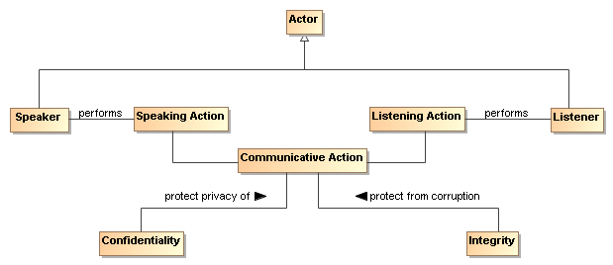
Figure 54 Confidentiality and Integrity
The communicative action is the joint action involved in the exchange of messages. Section 5.2.4 describes common computing techniques for providing confidentiality and integrity during message exchanges.

Authentication
Authentication concerns the identity of the participants in an exchange. Authentication refers to the means by which one participant can be assured of the identity of other participants.
Figure 55 applies authentication to the identity of participants.
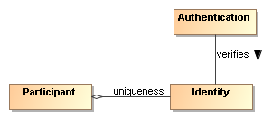
Figure 55 Authentication

Authorization
Authorization concerns the legitimacy of the interaction. Authorization refers to the means by which a stakeholder may be assured that the information and actions that are exchanged are either explicitly or implicitly approved.
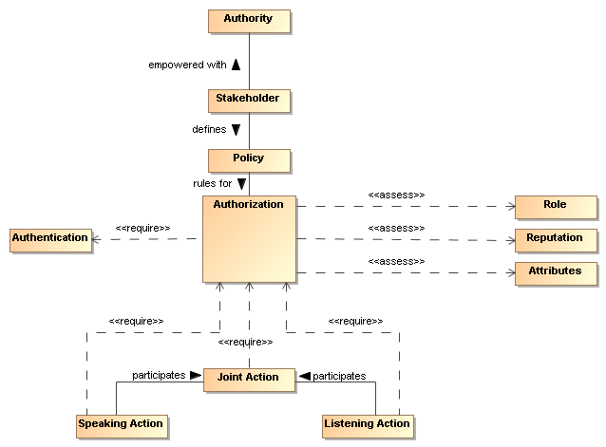
Figure 56 Authorization
The roles and attributes which provide a participant’s credentials are expanded to include reputation. Reputation often helps determine willingness to interact, for example, reviews of a service provider are likely to influence the decision to interact with the service provider. The roles, reputation, and attributes are represented as assertions measured by authorization decision points.
The role of policy for security is to permit stakeholders to express their choices. In Figure 56, a policy is a written constraint and the role, reputation, and attribute assertions are evaluated according to the constraints in the authorization policy. A combination of security mechanisms and their control via explicit policies can form the basis of an authorization solution.

Non-repudiation
Non-repudiation concerns the accountability of participants. To foster trust in the performance of a system used to conduct shared activities it is important that the participants are not able to later deny their actions: to repudiate them. Non-repudiation refers to the means by which a participant may not, at a later time, successfully deny having participated in the interaction or having performed the actions as reported by other participants.

Availability
Availability concerns the ability of systems to use and offer the services for which they were designed. One of the threats against availability is the so-called denial of service attack in which attackers attempt to prevent legitimate access to the system.
We differentiate here between general availability – which includes aspects such as systems reliability – and availability as a security concept where we need to respond to active threats to the system.

Where SOA Security is Different
The core security concepts are fundamental to all social interactions. The evolution of sharing information using a SOA requires the flexibility to dynamically secure computing interactions in a computing ecosystem where the owning social groups, roles, and authority are constantly changing as described in section 5.1.3.1.
SOA policy-based security can be more adaptive for a computing ecosystem than previous computing technologies allow for, and typically involves a greater degree of distributed mechanisms.
Standards for security, as is the case with all aspects of SOA, play a large role in flexible security on a global scale. SOA security may also involve greater auditing and reporting to adhere to regulatory compliance established by governance structures.

Security Threats
There are a number of ways in which an attacker may attempt to compromise the security of a system. The two primary sources of attack are third parties attempting to subvert interactions between legitimate participants and an entity that is participating but attempting to subvert its partner(s). The latter is particularly important in a SOA where there may be multiple ownership boundaries and trust boundaries.
The threat model lists some common threats that relate to the core security concepts listed in Section 5.2.1. Each technology choice in the realization of a SOA can potentially have many threats to consider.
Message alteration
If an attacker is able to modify the content (or even the order) of messages that are exchanged without the legitimate participants being aware of it then the attacker has successfully compromised the security of the system. In effect, the participants may unwittingly serve the needs of the attacker rather than their own.
An attacker may not need to completely replace a message with his own to achieve his objective: replacing the identity of the beneficiary of a transaction may be enough.
Message interception
If an attacker is able to intercept and understand messages exchanged between participants, then the attacker may be able to gain advantage. This is probably the most commonly understood security threat.
Man in the middle
In a man-in-the-middle attack, the legitimate participants believe that they are interacting with each other; but are in fact interacting with the attacker. The attacker attempts to convince each participant that he is their correspondent; whereas in fact he is not.
In a successful man-in-the-middle attack, legitimate participants will often not have a true understanding of the state of the other participants. The attacker can use this to subvert the intentions of the participants.
Spoofing
In a spoofing attack, the attacker convinces a participant that he is really someone else – someone that the participant would normally trust.
Denial of service attack
In a denial of service (DoS) attack, the attacker attempts to prevent legitimate users from making use of the service. A DoS attack is easy to mount and can cause considerable harm: by preventing legitimate interactions, or by slowing them down enough, the attacker may be able to simultaneously prevent legitimate access to a service and to attack the service by another means.
A variation of the DoS attack is the Distributed Denial of Service attack. In a DDoS attack the attacker uses multiple agents to the attack the target. In some circumstances this can be extremely difficult to counteract effectively.
One of the features of a DoS attack is that it does not require valid interactions to be effective: responding to invalid messages also takes resources and that may be sufficient to cripple the target.
Replay attack
In a replay attack, the attacker captures the message traffic during a legitimate interaction and then replays part of it to the target. The target is persuaded that a similar transaction to the previous one is being repeated and it will respond as though it were a legitimate interaction.
A replay attack may not require that the attacker understand any of the individual communications; the attacker may have different objectives (for example attempting to predict how the target would react to a particular request).
False repudiation
In false repudiation, a user completes a normal transaction and then later attempts to deny that the transaction occurred. For example, a customer may use a service to buy a book using a credit card; then, when the book is delivered, refuse to pay the credit card bill claiming that someone else must have ordered the book.

Security Responses
Security goals are never absolute: it is not possible to guarantee 100% confidentiality, non-repudiation, etc. However, a well designed and implemented security response model can ensure acceptable levels of security risk. For example, using a well-designed cipher to encrypt messages may make the cost of breaking communications so great and so lengthy that the information obtained is valueless.
Performing threat assessments, devising mitigation strategies, and determining acceptable levels of risk are the foundation for an effective process to mitigating threats in a cost-effective way. The choice in hardware and software to realize a SOA will be the basis for threat assessments and mitigation strategies. The stakeholders of a specific SOA implementation should determine acceptable levels of risk based on threat assessments and the cost of mitigating those threats.

Privacy Enforcement
The most efficient mechanism to assure confidentiality is the encryption of information. Encryption is particularly important when messages must cross trust boundaries; especially over the Internet. Note that encryption need not be limited to the content of messages: it is possible to obscure even the existence of messages themselves through encryption and ‘white noise’ generation in the communications channel.
The specifics of encryption are beyond the scope of this architecture. However, we are concerned about how the connection between privacy-related policies and their enforcement is made.
A policy enforcement point for enforcing privacy may take the form of an automatic function to encrypt messages as they leave a trust boundary; or perhaps simply ensuring that such messages are suitably encrypted.
Any policies relating to the level of encryption being used would then apply to these centralized messaging functions.

Integrity Protection
To protect against message tampering or inadvertent message alteration, and to allow the receiver of a message to authenticate the sender, messages may be accompanied by a digital signature. Digital signatures provide a means to detect if signed data has been altered. This protection can also extend to authentication and non-repudiation of a sender.
A common way a digital signature is generated is with the use of a private key that is associated with a public key and a digital certificate. The private key of some entity in the system is used to create a digital signature for some set of data. Other entities in the system can check the integrity of the signed data set via signature verification algorithms. Any changes to the data that was signed will cause signature verification to fail, which indicates that integrity of the data set has been compromised.
A party verifying a digital signature must have access to the public key that corresponds to the private key used to generate the signature. A digital certificate contains the public key of the owner, and is itself protected by a digital signature created using the private key of the issuing Certificate Authority (CA).

Message Replay Protection
To protect against replay attacks, messages may contain information that can be used to detect replayed messages. The simplest requirement to prevent replay attacks is that each message that is ever sent is unique. For example, a message may contain a message ID, a timestamp, and the intended destination.
By storing message IDs, and comparing each new message with the store, it becomes possible to verify whether a given message has been received before (and therefore should be discarded).
The timestamp may be included in the message to help check for message freshness. Messages that arrive after their message ID could have been cleared (after receiving the same message some time previously) may also have been replayed. A common means for representing timestamps is a useful part of an interoperable replay detection mechanism.
The destination information is used to determine if the message was misdirected or replayed. If the replayed message is sent to a different endpoint than the destination of the original message, the replay could go undetected if the message does not contain information about the intended destination.
In the case of messages that are replies to prior messages, it is also possible to include seed information in the prior messages that is randomly and uniquely generated for each message that is sent out. A replay attack can then be detected if the reply does not embed the random number that corresponds to the original message.

Auditing and Logging
False repudiation involves a participant denying that it authorized a previous interaction. An effective strategy for responding to such a denial is to maintain careful and complete logs of interactions which can be used for auditing purposes. The more detailed and comprehensive an audit trail is, the less likely it is that a false repudiation would be successful.
The countermeasures assume that the non-repudiation tactic (e.g. digital signatures) is not undermined itself. For example, if private key is stolen and used by an adversary, even extensive logging cannot assist in rejecting a false repudiation.
Unlike many of the security responses discussed here, it is likely that the scope for automation in rejecting a repudiation attempt is limited to careful logging.

Graduated engagement
The key to managing and responding to DoS attacks is to be careful in the use of resources when responding to interaction. Put simply, a system has a choice to respond to a communication or to ignore it. In order to avoid vulnerability to DoS attacks a service provider should be careful not to commit resources beyond those implied by the current state of interactions; this permits a graduation in commitment by the service provider that mirrors any commitment on the part of service consumers and attackers alike.

Architectural Implications of SOA Security
Providing SOA security in an ecosystem of governed services has the following implications on the policy support and the distributed nature of mechanisms used to assure SOA security:
- Security expressed through policies have the same architectural implications as described in Section 4.4.4 for policies and contracts architectural implications.
- Security policies require mechanisms to support security description administration, storage, and distribution.
- Service descriptions supporting security policies should:
  - have a meta-structure sufficiently rich to support security policies;
  - be able to reference one or more security policy artifacts;
  - have a framework for resolving conflicts between security policies.
- The mechanisms that make-up the execution context in secure SOA-based systems should:
  - provide protection of the confidentiality and integrity of message exchanges;
  - be distributed so as to provide centralized or decentralized policy-based identification, authentication, and authorization;
  - ensure service availability to consumers;
  - be able to scale to support security for a growing ecosystem of services;
  - be able to support security between different communication technologies;
- Common security services include:
  - services that abstract encryption techniques;
  - services for auditing and logging interactions and security violations;
  - services for identification;
  - services for authentication;
  - services for authorization;
  - services for intrusion detection and prevention;
  - services for availability including support for quality of service specifications and metrics.

Management Model
Management
Management is the control of the use, configuration, and availability of resources in accordance with the policies of the stakeholders involved.
There are three separate but linked domains of interest within the management of SOA-based systems. The first and most obvious is the management and support of the resources that are involved in any complex system – of which SOA-based systems are excellent examples. The second is the promulgation and enforcement of the policies and contracts agreed to by the stakeholders in SOA-based systems. The third domain is the management of the relationships of the participants in SOA-based systems – both to each other and to the services that they use and offer.
There are many artifacts in a large system that may need management. As soon as there is the possibility of more than one instance of a thing, the issue of managing those things becomes relevant. Historically, systems management capabilities have been organized by the following functional groups known as “FCAPS” functions (based on ITU-T Rec. M.3400 (02/2000), "TMN Management Functions"): Fault management, configuration management, account management, performance and security management.
In the context of SOA we see many possible resources that may require management: services, service descriptions, service capabilities, policies, contracts, roles, relationships, security, and infrastructure elements. In addition, given the ecosystem nature of SOA, it is also potentially necessary to manage the business relationships between participants in the SOA.
Managing systems that may be used across ownership boundaries raises issues that are not normally present when managing a system within a single ownership domain. For example, care is required managing a service when the owner of the service, the provider of the service, the host of the service and access mediators to the service may all belong to different stakeholders. In addition, it may be important to allow service consumers to communicate their requirements to the service provider so that they are satisfied in a timely manner.
A given service may be provided and consumed in more than one version. Version control of services is important both for service providers and service consumers (who may need to ensure certainty in the version of the service they are interacting with).
In fact, managing a service has quite a few similarities to using a service: suggesting that we can use the service oriented model to manage SOA-based systems as well as provide them. A management service would be distinguished from a non-management service more by the nature of the capabilities involved (i.e., capabilities that relate to managing services) than by any intrinsic difference.
In this model, we show how the SOA framework may apply to managing services as well as using and offering them. There are, of course, some special considerations that apply to service management which we bring out: namely that we will be managing the life-cycle of services, managing any service level attributes, managing dependencies between services and so on.
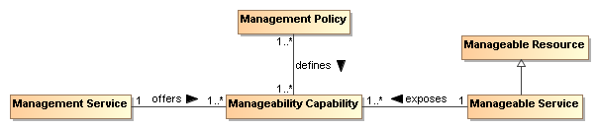
Figure 57 Managing resources in a SOA
The core concept in management is that of a manageability capability:
Manageability Capability
The manageability capability of a resource is the capability that allows it to be managed with respect to some property. Note that manageability capabilities are not necessarily part of the managed entities themselves.
Manageability capabilities are the core resources that management systems use to manage: each resource that may be managed in some way has a number of aspects that may be managed. For example, a service’s life-cycle may be manageable, as may its Quality of Service parameter; a policy may also be managed for life-cycle but Quality of Service would not normally apply.
Life-cycle manageability
A manageability capability associated with a resource that permits the life cycle of the resource to be managed. As noted above, the life-cycle manageability capability of a resource is unlikely to reside within the resource itself (you cannot tell a system that is not running to start itself).
The life-cycle management of a resource typically refers to how the resource is created, how it is destroyed and what dependencies there might exist that must be simultaneously managed.
Configuration manageability
A capability that permits the configuration of resources to be managed. Service configuration, in particular, may be complex in cases where there are dependencies between services and other resources.
Event monitoring manageability
Managing the reporting of events and faults is one of the key lower-level manageability capabilities.
Accounting manageability
A capability associated with resources that allows for the use of those resources to be measured and accounted for. This implies that not only can the use of resources be properly measured, but also that those using those resources also be properly identified.
Accounting for the use of resources by participants in the SOA supports the proper budgeting and allocation of funding by participants.
Quality of service manageability
A manageability capability associated with a resource that permits any quality of service associated with the resource to be managed. Classic examples of this include bandwidth requirements and offerings associated with a service.
Business performance manageability
A manageability capability that is associated with services that permits the service’s business performance to be monitored and managed. In particular, if there are business-level service level agreements that apply to a service, being able to monitor and manage those SLAs is an important role for management systems.
Building support for arbitrary business monitoring is likely to be challenging. However, given a measure for determining a service’s compliance to business service level agreements, management systems can monitor that performance in a way that is entirely similar to other management tasks.
Policy manageability
Where the policies associated with a resource may be complex and dynamic, so those policies themselves may require management. The ability to manage those policies (such as promulgating policies, retiring policies and ensuring that policy decision points and enforcement points are current) is a management function.
In the particular case of policies, there is a special relationship between management and policies. Just like other artifacts, policies require management in a SOA. However, much of management is about applying policies also: where governance is often about what the policies regarding artifacts and services should be, a key management role is to ensure that those policies are consistently applied.
Management service
A management service is a service that manages other services and resources.
Management Policy
A management policy is a policy whose topic is a management topic. Just as with other aspects of a SOA, the management of resources within the SOA may be governed by management policies, contracts (such as SLAs).
In a deployed system, it may well be that different aspects of the management of a given service are managed by different management services. For example, the life-cycle management of services often involves managing dependencies between services and resource requirements. Managing quality of service is often very specific to the service itself; for example, quality of service attributes for a video streaming service are quite different to those for a banking system.
There are additional concepts of management that often also apply to IT management:
Systems management
Systems management refers to enterprise-wide maintenance and administration of distributed computer systems.
Network management
Network management refers to the maintenance and administration of large-scale networks such as computer networks and telecommunication networks. Systems and network management execute a set of functions required for controlling, planning, deploying, coordinating, and monitoring the distributed computer systems and the resources of a network.
However, for the purposes of this Reference Architecture, while recognizing their importance, we do not focus on systems management or network management.
- the specific identifier is not prescribed by this Reference Architecture but the structure and semantics of the identifier must be indicated for the identifier value to be properly used. For example, part of identity may include version identification.
For this, the configuration management plan or similar document from which the version number is derived must be identified.

Management and Governance
The primary role of governance in the context of SOA is to allow the stakeholders in the SOA to be able to negotiate and set the key policies that govern the running of the system. Recall that in an ecosystems perspective, the goal is less to have complete fine-grained control but more to enable the individual participants to work together. Policies that are set at the governance of a SOA will tend to focus on the rules of engagement between participants – what kind of interacts are permissible, how to resolve disputes, and so on.
While governance may be primarily focused on setting policies, management is more focused on realization and enforcement of policies.

Management Contracts and Policies
As we noted above, management can often be viewed as the application of contracts and policies to ensure the smooth running of the SOA. Policies play an important part in managing systems both as artifacts that need to be managed and as the guiding constraints to determine how the SOA should be managed.

Policies
"Although provision of management capabilities enables a service to become manageable, the extent and degree of permissible management are defined in management policies that are associated with the services. Management policies are used to define the obligations for, and permissions to, managing the service." [WSA]
On the other hand, a policy without any means of enforcing it is vacuous. In the case of management policy, we rely on a management infrastructure to realize and enforce management policy.

Management Infrastructure
In order for a service or other resource to be manageable there must be a corresponding manageability capability that can effect that management. The particulars of this capability will vary somewhat depending on the nature of the capability. For example, a service life-cycle manageability capability requires the ability to start a service, to stop the service, and potentially to pause the service. Conversely, in order to manage document-like artifacts, such as service descriptions, the capability of storing the artifacts, controlling access to those artifacts, allowing updates of the artifacts to be deployed are all important capabilities for managing them.

Elements of a basic service management infrastructure should include the following characteristics:

- Integrate with existing security services
- Monitoring
- Heartbeat and Ping
- Alerting
- Pause/Restore/Restart Service Access
- Logging, Auditing, Non-Repudiation
- Runtime Version Management
- Complement other infrastructure services (discovery, messaging, mediation)

* Message Routing and Redirection
* Failover
* Load-balancing

* QoS, Management of Service Level Objects and Agreements
* Availability
* Response Time
* Throughput

- Fault and Exception Management

Service Life-cycle
Managing a service’s life cycle involves managing the establishment of the service, managing its steady-state performance, and managing its termination. The most obvious feature of this is that a service cannot manage its own life cycle (imagine asking a non-functioning service to start). Another important consideration is that services may have resource requirements that must be established at various points in the services’ life cycles. These dependencies may take the form of other services being established; possibly even services that are not exposed by the service’s own interface.

SOA Testing Model
Program testing can be used to show the presence of bugs,
but never to show their absence!
Edsger Dijkstra
Testing for SOA combines the typical challenges of software testing and certification with the additional needs of accommodating the distributed nature of the resources, the greater access of a more unbounded consumer population, and the desired flexibility to create new solutions from existing components over which the solution developer has little if any control. The purpose of testing is to demonstrate a required level of reliability, correctness, and effectiveness that enable prospective consumers to have adequate confidence in using a service. Adequacy is defined by the consumer based on the consumer's needs and context of use. As the Dijkstra quote points out, absolute correctness and completeness cannot be proven by testing; however, for SOA, it is critical for the prospective consumer to know what testing has been performed, how it has been performed, and what were the results.

Traditional Software Testing as Basis for SOA Testing
SOA services are largely software artifacts and can leverage the body of experience that has evolved around software testing. IEEE-829 specifies the basic set of software test documents while allowing flexibility for tailored use. As such, the document structure can also provide guidance to SOA testing.
IEEE-829 covers test specification and test reporting through use of the following document types:
• Test plan documenting the scope (what will be tested, both which entity and what features of the entity), the approach (how it will be tested), and the needed resources (who will do the testing, for how long), with details contained in the:
• Test design specification: features to be tested, test conditions (e.g. test cases, test procedures needed) and expected results (criteria for passing test); entrance and exit criteria
• Test case specification: test data used for input and expected output
• Test procedure specification: steps required to run the test, including any set-up preconditions
• Test item transmittal to identify the test items being transmitted for testing
• Test log to record what occurred during test, i.e. which tests run, who ran, what order, what happened
• Test incident report to capture any event that happened during test which requires further investigation
• Test summary as a management report summarizing test run and results, conclusions
In summary, IEEE-829 captures (1) what was tested, (2) how it was tested, e.g. the test procedure used, and (3) the results of the test.

Types of Testing
There are numerous aspects of testing that, in total, work to establish that an entity is (1) built as required per policies and related specifications prescribed by the entity's owner, and (2) delivers the functionality required by its intended users. This is often referred to as verification and validation.
Policies, as described in Section 4.4, that are related to testing may prescribe but are not limited to the business processes to be followed, the standards with which an implementation must comply, and the qualifications of and restrictions on the users. In addition to the functional requirements prescribing what an entity does, there may also be non-functional performance and/or quality metrics that state how well the entity does it. The relation of these policies to SOA testing is discussed further below.
The identification of policies is the purview of governance (section 5.1) and the assuring of compliance (including response to noncompliance) with policies is a matter for management (section Error: Reference source not found).

Range of Test Conditions
Test conditions and expected responses are detailed in the test case specification. The test conditions should be designed to cover the areas for which the entity's response must be documented and may include:
• nominal conditions
• boundaries and extremes of expected conditions
• breaking point where the entity has degraded below a certain level or has otherwise ceased effective functioning
• random conditions to investigate unidentified dependencies among combinations of conditions
• errors conditions to test error handling
The specification of how each of these conditions should be tested for SOA resources, including the infrastructure elements of the SOA ecosystem, is beyond the scope of this Reference Architecture but is an area that will evolve along with operational SOA experience.

Configuration Management of Test Artifacts
The test item transmittal provides an unambiguous identification of the entity being tested, thus REQUIRING that the configuration of the entity is appropriately tracked and documented. In addition, the test documents (such as those specified by IEEE-829) MUST also be under a documented and appropriately audited configuration management process, as should other resources used for testing. The description of each artifact would follow the general description model as discussed in section 4.1.1.1; in particular, it would include a version number for the artifact and reference to the documentation describing the versioning scheme from which the version number is derived.

[EDITOR'S NOTE: TO WHAT EXTENT SHOULD CM BE EXPLICITLY INCLUDED IN THE MANAGEMENT SECTION?]

Testing and the SOA Ecosystem
[EDITOR’S NOTE: THE EMPHASIS THOUGH MUCH OF THE RA IS THE LARGER ECOSYSTEM BUT WE NEED WORDS IN SECTION 3 TO ACKNOWLEDGE THE EXISTENCE OF THE ENTERPRISE AND THAT AN ENTERPRISE (AS COMMONLY INTERPRETED) IS LIKELY MORE CONSTRAINED AND MORE PRECISELY DESCRIBED FOR THE CONTEXT OF THE ENTERPRISE. THE ECOSYSTEM PERSPECTIVE, THOUGH, IS STILL APPLICABLE FOR THE FOLLOWING REASONS:

1. A GIVEN ENTERPRISE MAY COMPRISE NUMEROUS CONSTITUENT ENTERPRISES THAT RESEMBLE THE INDEPENDENT ENTITIES DESCRIBED FOR THE ECOSYSTEM. AN ENTERPRISE MAY ATTEMPT TO REDUCE VARIATIONS AMONG THE CONSTITUENTS BUT THE ECOSYSTEM VIEW ENABLES SOA TO BENEFIT THE ENTERPRISE WITHOUT REQUIRING THE ENTERPRISE ISSUES TO BE FULLY RESOLVED.
2. RESOURCES SPECIFICALLY MOTIVATED BY THE CONTEXT OF THE ENTERPRISE CAN BE MORE READILY USED IN A DIFFERENT CONTEXT IF ECOSYSTEM CONSIDERATIONS ARE INCLUDED AT AN EARLY STAGE. THE CHANGE IN A CONTEXT MAY BE A FUNDAMENTAL CHANGE IN THE ENTERPRISE OR THE NEWLY DISCOVERED APPLICABILITY OF ENTERPRISE RESOURCES TO USE OUTSIDE THE ENTERPRISE.

IN THIS REFERENCE ARCHITECTURE, REFERENCE TO THE SOA ECOSYSTEM APPLIES BUT WITH POSSIBLY LESS GENERALITY TO AN ENTERPRISE USE OF SOA.]
Testing of SOA artifacts for use in the SOA ecosystem differs from traditional software testing for several reasons. First, a highly touted benefit of SOA is to enable unanticipated consumers to make use of services for unanticipated purposes. Examples of this could include the consumer using a service for a result that was not considered the primary one by the provider, or the service may be used in combination with other services in a scenario that is different from the one considered when designing for the initial target consumer community. It is unlikely that a new consumer will push the services back to anything resembling the initial test phase to test the new use, and thus additional paradigms for testing are necessary. Some testing may depend on the availability of test resources made available as a service outside the initial test community, while some testing is likely to be done as part of limited use in the operational setting. The potential responsibilities related to such "consumer testing" is discussed further below.
Secondly, in addition to consumers who interact with a service to realize the described real world effects, the developer community is also intended to be a consumer. In the SOA vision of reuse, the developer will compose new solutions using existing services, where the existing services provides access to some desired real world effects that are needed by the new solution. The new solution is a consumer of the existing services, enabling repeated interactions with the existing services playing the role of reusable components. Note, those components are used at the locations where they individually reside and are not typically duplicated for the new solution. The new solution may itself be offered as a SOA service, and a consumer of the service composition representing the new solution may be totally unaware of the component services being used. (See section 4.3.4 for further discussion on service compositions.)
Another difference from traditional testing is that the distributed, unbounded nature of the SOA ecosystem makes it unlikely to have an isolated test environment that duplicates the operational environment. A traditional testing approach often makes use of a test system that is identical to the eventual operational system but isolated for testing. After testing is successfully completed, the tested entity would be migrated to the operational environment, or the test environment may be delivered as part of the system to become operational. This is not feasible for the SOA ecosystem as a whole.
SOA services must be testable in the environment and under the conditions that can be encountered in the operational SOA ecosystem. As the ecosystem is in a state of constant change, so some level of testing is continuous through the lifetime of the service, leveraging utility services used by the ecosystem infrastructure to monitor its own health and respond to situations that could lead to degraded performance. This implies the test resources must incorporate aspects of the SOA paradigm, and a category of services may be created to specifically support and enable effective monitoring and continuous testing for resources participating in the SOA ecosystem.
While SOA within an enterprise may represent a more constrained and predictable operational environment, the composability and unanticipated use aspects are highly touted within the enterprise. The expanded perspective on testing may not be as demanding within an enterprise but fuller consideration of the ecosystem enables the enterprise to be more responsive should conditions change.

Elements of SOA Testing
IEEE-829 identifies fundamental aspects of testing, and many of these should carry over to SOA testing: in particular, the identification of what is to be tested, how it is to be tested, and by whom the testing is to be done. While IEEE-829 identifies a suggested document tree, the availability of these documents in the SOA ecosystem is an additional matter of concern that will be discussed below.

What is to be Tested
The focus of this discussion is the SOA service. It is recognized that the infrastructure components of any SOA environment are likely to also be SOA services and, as such, will fall under the same testing guidance. Other resources that contribute to a SOA environment may not be SOA services, but will be expected to satisfy the intent if not the letter of guidance presented here. Specific differences for such resources are as yet largely undefined and further elaboration is beyond the scope of this Reference Architecture.
The following discussion often focuses on a singular SOA service but it is implicit that any service may be a composite of other services. As such, testing the functionality of a composite service may effectively be testing an end-to-end business process that is being provided by the composite service. If new versions are available for the component services, appropriate end-to-end testing of the composite may be required in order to verify that the composite functionality is still adequately provided. The level of required testing of an updated composite will depend on policies of those providing the service, policies of those using the service, and mission criticality of those depending on the service results.
The SOA service to be tested MUST be unambiguously identified as specified by its applicable configuration management scheme. Specifying such a scheme is beyond the scope of this Reference Architecture other than to say the scheme should be documented and itself under configuration management.

Origin of Test Requirements
In the Service Description model (Figure 21), the aspects of a service that need to be described are:
• the service functionality and technical assumptions that underlie the functionality;
• the policies that describe conditions of use;
• the service interface that defines information exchange with the service;
• service reachability that identifies how and where message exchange is to occur; and
• metrics access for any participant to have information on how a service is performing.
Service testing must provide adequate assurance that each of these aspects is operational as defined.
The information in the service description comes from different sources. The functionality is defined through whatever process identifies needs and the community for which these needs will be addressed. The process may be ad hoc as serves the prospective service owner or strictly governed, but defining the functionality is an essential first step in development. It is also an early and ongoing focus of testing to ensure the service accurately reflects the described functionality and the described functionality accurately addresses the consumer needs.
Policies define the conditions of development and conditions of use for a service and are typically specified as part of the governance process. Policies constraining service development, such as coding standards and best practices, require appropriate testing and auditing during development to ensure compliance. While the governance process will identify development policies, these are likely to originate from the technical community responsible for development activities. Policies that define conditions of use often define business practices that service owners and providers or those responsible for the SOA infrastructure want followed. These policies are initially tested during service development and are continuously monitored during the operational lifetime of the service.
The testing of the service interface and service reachability are often related but essentially reflect different motivations and needs. The service interface is specified as a joint product of the service owners and providers who define service functionality, the prospective consumer community, the service developer, and the governance process. The semantics of the information model must align with the semantics of those who consume the service in order for there to be meaningful exchange of information. The structure of the information is influenced by the consumer semantics and the requirements and constraints of the representation as interpreted by the service developer. The service process model that defines actions which can be performed against a service and any temporal dependencies derive from the defined functionality and may be influenced by the development process. Any of these constraints may be identified and expressed as policy through the governance process.
Service reachability conditions are the purview of the service provider who identifies the service endpoint and the protocols recognized at the endpoint. These may be constrained by governance decisions on how endpoint addresses may be allocated and what protocols should be used.
While the considerations for defining the service interface derive from several sources, testing of the service interface is more straightforward and isolated in the testing process. At any point where the interface is modified or exposes a new resource, the message exchange should be monitored both to ensure the message reaches its intended destination and it is parsed correctly once received. Once an interface has been shown to function properly, it is unlikely it will fail later unless something fundamental to the service changes.
The service interface is also tested when the service endpoint changes. Testing of the endpoint ensures message exchange can occur at the time of testing and the initial testing shows the interface is being processed properly at the new endpoint. Functioning of a service endpoint at one time does not guarantee it is functioning at another time, e.g. the server with the endpoint address may be down, making testing of service reachability a continual monitoring function through the life of the service’s use of the endpoint. Also, while testing of the service endpoint is a necessary and most commonly noted part of the test regiment, it is not in itself sufficient to ensure the other aspects of testing discussed in this section.
Finally, governance is impossible without the collection of metrics against which service behavior can be assessed. Metrics are also a key indicator for consumers to decide if a service is adequate for their needs. For instance, the average response time or the recent availability can be determining factors even if there are no rules or regulations promulgated through the governance process against which these metrics are assessed. The available metrics are a combination of those expected by the consumer community and those mandated through the governance process. The total set of metrics will evolve over time with SOA experience. Testing of the services that gather and provide access to the metrics will follow testing as described in this section, but for an individual service, testing will ensure that the metrics access indicated in the service description is accurate.
The individual test requirements highlight aspects of the service that testing must consider but testing must establish more than isolated behavior. The emphasis is the holistic results of interacting with the service in the SOA environment. Recall that the execution context is the set of agreements between a consumer and a provider that define the conditions under which service interaction occurs. The agreements are expected to be predominantly the acceptance of the standard conditions as enumerated by the service provider, but it may include the identification of alternate conditions that will govern the interaction.
For example, the provider may prefer a policy where it can sell the contact information of its consumers but will honor the request of a consumer to keep such information private. The identification of the alternate privacy policy is part of the execution context, and it is the application of and compliance with this policy that operational monitoring will attempt to measure. The collection of metrics showing this condition is indeed met when chosen is considered part of the ongoing testing of the service.
Other variations in the execution context also require monitoring to ensure that different combinations of conditions perform together as desired. For example, if a new privacy policy takes additional resources to apply, this may affect quality of service and propagate other effects. These could not be tested during the original testing if the alternate policy did not exist at that time.

Testing Against Non-Functional Requirements
Testing against non-functional requirements constitutes testing of business usability of the service. In a marketplace of services, non-functional characteristics may be the primary differentiator between services that produce essentially the same real world effects.
As noted in the previous section, non-functional characteristics are often associated with policies or other terms of use and may be collected in service level contracts offered by the service providers. Non-functional requirements may also reflect the network and hardware infrastructure that support communication with the service, and changes may impact quality of service. The service consumer and even the service provider may not be aware of all such infrastructure changes but the changes may manifest in shared states that impact the usability of the service.
In general, a change in the non-functional requirements results in a change to the execution context, but as with any collection of information that constitutes a description, the execution context is unable to explicitly capture all non-functional requirements that may apply. A change in non-functional requirements, whether explicitly part of the execution context or an implicit contributor, may require retesting of the service even if its functionality and the implementation of the functionality has not changed. Depending on the circumstances, retesting may require a formal recertifying of end-to-end behavior or more likely will be part of the continuous monitoring that applies throughout the service lifetime.

Testing Content and the Interests of Consumers
As noted in section 5.4.1.1, testing may involve verification of conformance with respect to policies and technical specifications and validation with respect to sufficiency of functionality to meet some prescribed use. It may also include demonstration of performance and quality aspects. For some of these items, such as demonstrating the business processes followed in developing the service or the use of standards in implementing the service, the testing or relevant auditing is done internal to the service development process and follows traditional software testing and quality assurance. If it is believed of value to potential consumers, information about such testing could be included in the service description. However, it is not required that all test or compliance artifacts be available to consumers, as many of the details tested may be part of the opacity of the service implementation.
Some aspects of the service being tested will reflect directly on the real world effects realized through interaction with the service. In these cases, it is more likely that testing results will be directly relevant to potential consumers. For example, if the service was designed to correspond to certain elements of a business process or that a certain workflow is followed, testing should verify that the real world effects reflect that the business process or workflow were satisfactorily captured.
The testing may also need to demonstrate that specified conditions of use are satisfied. For example, policies may be asserted that require certain qualifications of or impose restrictions on the consumers who may interact with the service. The service testing must demonstrate that the service independently enforces the policies or it provides the required information exchanges with the SOA ecosystem so other resources can ensure the specified conditions.
The completeness of the testing, both in terms of the features tested and the range of parameters for which response is tested, depends on the context of expected use: the more critical the use, the more complete the testing. There are always limits on the resources available for testing, if nothing else than the service must be available for use in a finite amount of time.
This again emphasizes the need for adequate documentation to be available. If the original testing is very thorough, it may be adequate for less demanding uses in the future. If the original testing was more constrained, then well-documented test results establish the foundation on which further testing can be defined and executed.

How Testing is to be Done
Testing should follow well-defined methodologies and, if possible, should reuse test artifacts that have proven generally useful for past testing. For example, IEEE-829 notes that test cases are separated from test designs to allow for use in more than one design and to allow for reuse in other situations. In the SOA ecosystem, description of such artifacts, as with description of a service, enables awareness of the item and describes how the artifact may be accessed or used.
As with traditional testing, the specific test procedures and test case inputs are important so the tests are unambiguously defined and entities can be retested in the future. Automated testing and regression testing may be more important in the SOA ecosystem in order to re-verify a service is still acceptable when incorporated in a new use. For example, if a new use requires the services to deal with input parameters outside the range of initial testing, the tests could be rerun with the new parameters. If the testing resources are available to consumers within the SOA ecosystem, the testing as designed by test professionals could be consumed through a service accessed by consumers, and their results could augment those already in place. This is discussed further in the next section.

Who Performs the Testing
As with any software, the first line of testing is unit testing done by software developers. It is likely that initial testing will be done by those developing the software but may also be done independently by other developers. For SOA development, unit testing is likely confined to a development sandbox isolated from the SOA ecosystem.
SOA testing will differ from traditional software testing in that testing beyond the development sandbox must incorporate aspects of the SOA ecosystem, and those doing the testing must be familiar with both the characteristics and responses of the ecosystem and the tools, especially those available as services, to facilitate and standardize testing. Test professionals will know what level of assurance must be established as the exposure of the service to the ecosystem and ecosystem to the service increases towards operational status. These test professionals may be internal resources to an organization or may evolve as a separate discipline provided through external contracting.
As noted above, it is unlikely that a complete duplicate of the SOA ecosystem will be available for isolated testing, and thus use of ecosystem resources will manifest as a transition process rather than a step change from a test environment to an operational one. This is especially true for new composite services that incorporate existing operational services to achieve the new functionality. The test professionals will need to understand the available resources and the ramifications of this transition.
As with current software development, a stage beyond work by test professionals will make use of a select group of typical users, commonly referred to as beta testers, to report on service response during typical intended use. This establishes fitness by the consumers, providing final validation of previously verified processes, requirements, and final implementation.
In traditional software development, beta testing is the end of testing for a given version of the software. However, although the initial test phase can establish an appropriate level of confidence consistent with the designed use for the initial target consumer community, the operational service will exist in an evolving ecosystem, and later conditions of use may differ from those thought to be sufficient during the initial testing. Thus, operational monitoring becomes an extension of testing through the service lifetime. This continuous testing will attempt to ensure that a service does not consume an inordinate amount of ecosystem resources or display other behavior that degrades the ecosystem, but it will not undercover functional errors that may surface over time.
As with any software, it is the responsibility of the consumers to consider the reasonableness of solutions in order to spot errors in either the software or the way the software is being used. This is especially important for consumers with unanticipated uses that may go beyond the original test conditions. It is unlikely the consumers will initiate a new round of formal testing unless the new use requires a significantly higher level of confidence in the service. Rather the consumer becomes a new extension to the testing regiment. Obvious testing would include a sanity check of results during the new use. However, if the details of legacy testing are associated with the service through the service description and if testing resources are available through automated testing services, then the new consumers can rerun and extend previous testing to include the extended test conditions. If the test results are acceptable, these can be added to the documentation of previous results and become the extended basis for future decisions by prospective consumers on the appropriateness of the service. If the results are not acceptable or in some way questionable, the responsible party for the service or testing professionals can be brought in to decide if remedial action is necessary.

How Testing Results are Reported
For any SOA service, an accurate reporting of the testing a service has undergone and the results of the testing is vital to consumers deciding whether a service is appropriate for intended use. Appropriateness may be defined by a consumer organization and require specific test regiments culminating in a certification; appropriateness could be established by accepting testing and certifications that have been conferred by others.
The testing and certification information should be identified in the service description. Referring to the general description model of Figure 25, tests conducted by or under a request from the service owner (see Ownership in section 3.3.4) would be captured under Annotations from Owners. Testing done by others, such as consumers with unanticipated uses, could be associated through Annotations from 3rd Parties. The annotations should clearly indicate what was tested, how the testing was done, who did the testing, and the testing results. The clear description of each of these artifacts and of standardized testing protocols for various levels of sophistication and completeness of testing would enable a common understanding and comparison of test coverage. It will also make it more straightforward to conduct and report on future testing, facilitating the maintenance of the service description.
Consumer testing and the reporting of results raises additional issues. While stating who did the testing is mandatory, there may be formal requirements for authentication of the tester to ensure traceability of the testing claims. In some circumstances, persons or organizations would not be allowed to state testing claims unless the tester was an approved entity. In other cases, ensuring the tester had a valid email may be sufficient. In either case, it would be at the discretion of the potential consumer to decide what level of authentication was acceptable and which testers are considered authoritative in the context of their anticipated use.
Finally, in a world of openly shared information, we would see an ever-expanding set of testing information as new uses and new consumers interact with a service. In reality, these new uses may represent proprietary processes or classified use that should only be available to authorized parties. Testing information, as with other elements of description, may require special access controls to ensure appropriate access and use.

Testing SOA Services
Testing of SOA services should be consistent with the SOA paradigm. In particular, testing resources and artifacts should be visible in support of service interaction between providers and consumers, where here the interaction is between the testing resource and the tester. In addition, the idea of opacity of the implementation should limit the details that need to be available for effective use of the test resources. Testing that requires knowledge of the internal structure of the service or its underlying capability should be performed as part of unit testing in the development sandbox, and should represent a minimum level of confidence before the service begins its transition to further testing and eventual operation in the SOA ecosystem.

Progression of SOA Testing
Software testing is a gradual exercise going from micro inspection to testing macro effects. The first step in testing is likely the traditional code reviews. SOA considerations would account for the distributed nature of SOA, including issues of distributed security and best practices to ensure secure resources. It would also set the groundwork for opacity of implementation, hiding programming details and simplifying the use of the service.
Code review is likely followed by unit testing in a development sandbox isolated from the operational environment. The unit testing is done with full knowledge of the service internal structure and knowledge of resources representing underlying capabilities. It tests the interface to ensure exchanged messages are as specified in the service description and the messages can be parsed and interpreted as intended. Unit testing also verifies intended functionality and that the software has dealt correctly with internal dependencies, such as structure of a file system or access to other dedicated resources.
Some aspects of unit testing require external dependencies be satisfied, and this is often done using mock objects to substitute for the external resources. In particular, it will likely be necessary to include mocks of existing operational services, both those provided as part of the SOA infrastructure and services from other providers.
Service Mock
A service mock is an entity that mimics some aspect of the performance of an operational service without committing to the real world effects that the operational service would produce.
Mocks are discussed in detail in sections 5.4.4.3 and 5.4.4.4.
After unit testing has demonstrated an adequate level of confidence in the service, the testing must transition from the tightly controlled environment of the development sandbox to an environment that more clearly resembles the operational SOA ecosystem or, at a minimum, the intended enterprise. While sandbox testing will use simple mocks of some aspects of the SOA environment, such as an interface to a security service without the security service functionality, the dynamic nature of SOA makes a full simulation infeasible to create or maintain. This is especially true when a new composite service makes use of operational services provided by others. Thus, at some point before testing is complete, the service will need to demonstrate its functionality by using resources and dealing with conditions that only exist in the full ecosystem or the intended enterprise. Some of these resources may still provide test interfaces -- more on this below -- but the interfaces will be accessible via the SOA environment and not just implemented for the sandbox.
At this stage, the opacity of the service becomes important as the details of interacting with the service now rely on correct use of the service interface and not knowledge of the service internals. The workings of the service will only be observable through the real world effects realized through service interactions and external indications that conditions of use, such as user authentication, are satisfied. Monitoring the behavior of the service will depend on service interfaces that expose internal monitoring or provide required information to the SOA infrastructure monitoring function. The monitoring required to test a new service is likely to have significant overlap with the monitoring the SOA infrastructure includes to monitor its own health and to identify and isolate behavior outside of acceptable bounds. This is exactly what is needed as part of service testing, and it is reasonable to assume that the ecosystem transition includes use of operational monitoring rather than solely dedicated monitoring for each service being tested.
Use of SOA monitoring resources during the explicit testing phase sets the stage for monitoring and a level of continual testing throughout the service lifetime.

Testing Traditional Dependencies vs. Service Interactions
A SOA service is not required to make use of other operational services beyond what may be required for monitoring by the ecosystem infrastructure. The service can implement hardcoded dependencies which have been tested in the development sandbox through the use of dedicated mocks. While coordination may be required with real data sources during integration testing, the dependencies can be constrained to things that can be tested in a more traditional manner. Policies can also be set to restrict access to pre-approved users, and thus the question of unanticipated users and unanticipated uses can be eliminated. Operational readiness can be defined in terms of what can be proven in isolated testing. While all this may provide more confidence in the service for its designed purpose, such a service will not fully participate in the benefits or challenges of the ecosystem. This is akin to filling a swimming pool with sea water and having someone in the pool say they are swimming in the ocean.
In considering the testing needed for a fully participating service, consider the example of a new composite service that combines the real world effects and complies with the conditions of use of five existing operational services. The developer of the composite service does not own any of the component services and has limited, if any, ability to get the distributed owners to do any customization. The developer also is limited by the principle of opacity to information comprising the service description, and does not know internal details of the component services. The developer of the composite service must use the component services as they exist as part of the SOA environment, including what is provided to support testing by new users. This introduces requirements for what is needed in the way of service mocks.

Use of Service Mocks
Service mocks enables the tested service to respond to specific features of an operational service that is being used as a component. It allows service testing to proceed without needing access to or with only limited engagement with the component service. Mocks can also mimic difficult to create situations for which it is desired to test the new service response. For composite services using multiple component services, mocks may be used in combination to function for any number of the components. Note, when using service mocks, it is important to remember that it is not the component service that is being tested (although anomalous behavior may be uncovered during testing) but the use of the component in the new composite.
Individual service mocks can emphasize different features of the component service they represent but any given mock does not have to mimic all features. For example, a mock of the service interface can echo a sent message and demonstrate the message is reaching its intended destination. A mock could go further and parse the sent message to demonstrate the message not only reached its destination but was understood. As a final step, the mock could report back what actions would have been taken by the component service and what real world effects would result. If the response mimicked the operational response, functional testing could proceed as if the real world effect actually occurred.
There are numerous ways to provide mock functionality. The service mock could be a simulation of the operational service and return simulated results in a realistic response message or event notification. It is also possible for the operational service to act as its own mock and simply not execute the commit stage of its functionality. The service mock could use a combination of simulation and service action without commit to generate a report of what would have occurred during the defined interaction with the operational service.
As the service proceeds through testing, mocks should be systematically replaced by the component resources accessed through their operational interfaces. Before beta testing begins, end-to-end testing, i.e. proceeding from the beginning of the service interaction to the resulting real world results, should be accomplished using component resources via their operational interfaces.

Providers of Service Mocks
In traditional testing, it is often the test professionals who design and develop the mocks, but in the distributed world of SOA, this may not be efficient or desirable.
In the development sandbox, it is likely the new service developer or test professionals working with the developer will create mocks adequate for unit testing. Given that most of this testing is to verify the new service is performing as designed, it is not necessary to have high fidelity models of other resources being accessed. In addition, given opacity of SOA implementation, the developer of the new service may not have sufficient detailed knowledge of a component service to build a detailed mock of the component service functionality. Sharing existing mocks at this stage may be possible but the mocks would need to be implemented in the sandbox, and for simple models it is likely easier to build the mock from scratch.
As testing begins its transition to the wider SOA environment, mocks may be available as services. For existing resources, it is possible that an Open Source model could evolve where service mocks of available functions can be catalogued and used during initial interaction of the tested service and the operational environment. Widely used functions may have numerous service mocks, some mimicking detailed conditions within the SOA infrastructure. However, the Open Source model is less likely to be sufficient for specialty services that are not widely used by a large consumer community.
The service developer is probably best qualified for also developing more detailed service mocks or for mock modes of operational services. This implies that in addition to their operational interfaces, services will routinely provide test interfaces to enable service mocks to be used as services. As noted above, a new service developer wanting to build a mock of component services is limited to the description provided by the component service developer or owner. The description typically will detail real world effects and conditions of use but will not provide implementation details, some of which may be proprietary. Just as important in the SOA ecosystem, if it becomes standard protocol for developers to create service mocks of their own services, a new service developer is only responsible for building his own mocks and can expect other mocks to be available from other developers. This reduces duplication of effort where multiple developers would be trying to build the same mocks from the same insufficient information. Finally, a service developer is probably best qualified to know when and how a service mock should be updated to reflect modified functionality or message exchange.
It is also possible that testing organizations will evolve to provide high-fidelity test harnesses for new services. The harnesses would allow new services to plug into a test environment and would facilitate accessing mocks of component services. However, it will remain a constant challenge for such organizations to capture evolving uses and characteristics of service interactions in the real SOA environment and maintain the fidelity and accuracy of the test systems.

Fundamental Questions for SOA Testing
In order for the transition to the SOA operational environment to proceed, it is necessary to answer two fundamental questions:
• Who provides what testing resources for the SOA operational environment, e.g. mocks of interfaces, mocks of functionality, monitoring tools?
• What testing needs to be accomplished before operational environment resources can be accessed for further testing?
The discussion in section 5.4.4.4 notes various levels of sophistication of service mocks and different communities are likely to be responsible for different levels. Section 5.4.4.4 advocates a significant role for service developers, but there needs to be community consensus that such mocks are needed and that service developers will agree to fulfilling this role. There is also a need for consensus as to what tools should be available as services from the SOA infrastructure.
As for use of the service mocks and SOA environment monitoring services, practical experience is needed upon which guidelines can be established for when a new service has been adequately tested to proceed with a greater level of exposure with the SOA environment. Malfunctioning services could cause serious problems if they cannot be identified and isolated. On the other hand, without adequate testing under SOA operational conditions, it is unlikely that problems can be uncovered and corrected before they reach an operational stage.
As noted in section 5.4.4.2, some of these questions can be avoided by restricting services to more traditional use scenarios. However, such restriction will limit the effectiveness of SOA use and the result will resemble the constraints of traditional integration activities we are trying to move beyond.

Architectural Implications for SOA Testing
The discussion of SOA Testing indicates numerous architectural implications on the SOA ecosystem:
• The distributed, boundary-less nature of the SOA ecosystem makes it infeasible to create and maintain a single mock of the entire ecosystem to support testing activities.
• A standard suite of monitoring services needs to be defined, developed, and maintained. This should be done in a manner consistent with the evolving nature of the ecosystem.
• Services should provide interfaces that support access in a test mode.
• Testing resources must be described and their descriptions must be catalogued in a manner that enables their discovery and access.
• Guidelines for testing and ecosystem access need to be established and the ecosystem must be able to enforce those guidelines asserted as policies.
• Services should be available to support automated testing and regression testing.
• Services should be available to facilitate updating service description by anyone who has performed testing of a service.

Conformance
This Reference Architecture Foundation is an abstract architecture, which means that it is especially difficult to construct automated tests for conformance to the architecture. However, in order to be conformant to this architecture, it should be possible to identify in a concrete implementation the key concepts and components of this architecture, albeit in abstracted form.
[EDITOR’S NOTE: The conformance section is not complete]

- Acknowledgements
The following individuals have participated in the creation of this specification and are gratefully acknowledged:
Participants:
Rex Brooks, Individual Member
Peter Brown, Pensive.eu
Scott Came, Search Group Inc.
Joseph Chiusano, Booz Allen Hamilton
Robert Ellinger, Northrop Grumman Corporation
David Ellis, Sandia National Laboratories
Jeff A. Estefan, Jet Propulsion Laboratory
Don Flinn, Individual Member
Anil John, Johns Hopkins University
Ken Laskey, MITRE Corporation
Boris Lublinsky, Nokia Corporation
Francis G. McCabe, Individual Member
Christopher McDaniels, USSTRATCOM
Tom Merkle, Lockheed Martin Corporation
Jyoti Namjoshi, Patni Computer Systems Ltd.
Duane Nickull, Adobe Inc.
James Odell, Associate
Michael Poulin, Fidelity Investments
Michael Stiefel, Associate
Danny Thornton, Northrop Grumman
Timothy Vibbert, Lockheed Martin Corporation
Robert Vitello, New York Dept. of Labor
- Critical Factors Analysis
A critical factors analysis (CFA) is an analysis of the key properties of a project. A CFA is analyzed in terms of the goals of the project, the critical factors that will lead to its success and the measurable requirements of the project implementation that support the goals of the project. CFA is particularly suitable for capturing quality attributes of a project, often referred to as “non-functional” or “other-than-functional” requirements: for example, security, scalability, wide-spread adoption, and so on. As such, CFA complements rather than attempts to replace other requirements capture techniques.
  - Goals
A goal is an overall target that you are trying to reach with the project. Typically, goals are hard to measure by themselves. Goals are often directed at the potential consumer of the product rather than the technology developer.

Critical Success Factors
A critical success factor (CSF) is a property, sub-goal that directly supports a goal and there is strong belief that without it the goal is unattainable. CSFs themselves are not necessarily measurable in themselves.

Requirements
A requirement is a specific measurable property that directly supports a CSF. The key here is measurability: it should be possible to unambiguously determine if a requirement has been met. While goals are typically directed at consumers of the specification, requirements are focused on technical aspects of the specification.

CFA Diagrams
It can often be helpful to illustrate graphically the key concepts and relationships between them. Such diagrams can act as effective indices into the written descriptions of goals etc., but is not intended to replace the text.
The legend:

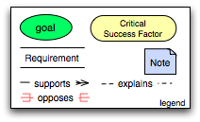
illustrates the key elements of the graphical notation. Goals are written in round ovals, critical success factors are written in round-ended rectangles and requirements are written using open-ended rectangles. The arrows show whether a CSF/goal/requirement is supported by another element or opposed by it. This highlights the potential for conflict in requirements.

American National Standards Institute
Institute of Electrical and Electronics Engineers
International Organization for Standardization
International Electrotechnical Commission
By business we refer to any activity that people are engaged in. We do not restrict the scope of SOA ecosystems to commercial applications.
American National Standards Institute
Institute of Electrical and Electronics Engineers
International Organization for Standardization
International Electrotechnical Commission
By business we mean to include any activity entered into whose goal is to satisfy some need or desire of the participant.
Note that there is potential confusion between the concept of Actor in UML2.0 and an actor in an ecosystem. Section 3.2.1 defines the concepts of role and an actor adopting a role.
Where speaking and listening includes electronic message sending and receiving.
Acting against a service should not be understood to mean acting to foil the effectiveness of the service; but simply as an action involving the normal operation of the service.
Social structures are sometimes referred to as social institutions.
We exclude here the special case of proposition known as a tautology. Tautologies are important in the study of logic; the kinds of propositions that we are primarily interested in are those which pertain to the world; and as such are only contingently true.
This is analogous to a WSDL 2.0 interface operation (WSDL 1.1 portType) having one or more defined bindings and the service identifies the endpoints (WSDL 1.1 ports) corresponding to the bindings.
The notion of “joint” in joint action implies that you have to have a speaker and a listener in order to interact.
There are cases when a response is not always desired and this would be an example of a “one-way” MEP. Similarly, while not shown here, there are cases when some type of “callback” MEP is required in which the consumer agent is actually exposed as a service itself and is able to process incoming messages from another service.
The term composition as used herein does not embrace the semantics of a UML composition binary relationship. Here we are referring to the relationship between services.
In practice, there are perceptions of security from all participants regardless of ownership boundaries. Satisfying security policy often requires asserting sensitive information about the message initiator. The perceptions of this participant about information privacy may be more important than actual security enforcement within the SOA for this stakeholder.

